

**FOUNDATION IN SCIENCE AND TECHNOLOGY**

**COURSEWORK COVER SHEET**

**SUBJECT TITLE : INTRODUCTION TO PROGRAMMING**

**SUBJECT CODE : FSTM3064**

**INTAKE** **: JULY 2021**

**COURSEWORK TITLE : REVIEW 2 – GROUP PROJECT**

**COURSEWORK** **:** **20%**

The objective of this assessment is:

* To apply adding graphical user interface design to Java application.
* To encourage students to think critically about the ways Java based mobile applications can enhance the lives of technology users.
* To expose students to various categories and types of mobile applications available in the market.
* To encourage students to design innovative mobile applications.

Instructions:

* Submit hardcopy and softcopy of your assignment.
* Please include a cover page, table of contents and references in your assignment.
* Font type to be used Times New Roman, 12 with 1.5 paragraph spacing.

**Group 3**

**App Name:** RightOnTrack

|  |  |
| --- | --- |
| **Group Members** | **Student ID** |
| Ong Hui Yan Kimberly | 21050406 |
| Michelle Lim Chee Ern | 21050349 |
| Lim Xiwei | 21045596 |
| Ruban A/L Vincent Xavier | 21060017 |

**ASSIGNMENT DURATION: 13/1/2022 – 12/2/2022**

**TASK 1**

Work in a group of 3 - 4 members.

You have been asked by the development company that you are working for to propose an innovative mobile application that will capture the target market of your choice. In your report:

* Problem statement
* State who will you be designing the mobile application for (some statistics about your market segment)
* Review THREE types of existing mobile applications from a similar category as your proposed application. Evaluate its interface design, functionalities, purpose and the aspects that can be improved.
* Describe your proposed application and how it solves the problem
* Monetizing strategy / market reach
* Create a mock-up design of your proposed mobile application and provide screenshots. Clearly describe the design and functionalities of your application. Describe the graphical user interface element used in each screen design. Elaborate the flow of functionalities of each screen and how it is connected to one another.

**TASK 2 – PRESENTATION AND CONTRIBUTION EVALUATION**

* Screencast a presentation about proposed app and its design.
* Students will be evaluated on their individual contribution and also their overall performance as a team based on the documentation submitted.

**CHECKLIST FOR SUBMISSION AND PRESENTATION**

1. Assignment cover page with group members’ names.
2. 1 softcopy of report per group which includes information on contributions by individual teammates must be submitted via eLearn.
3. Video of the screencast presentation must be shared via OneDrive to [preedhar@sunway.edu.my](mailto:preedhar@sunway.edu.my).

*Table of Contents*

Tasks and Delegations 4

Problem Statement 7

Target Audience 10

Application Reviews 13

Google Maps 13

KTMB Mobile 16

Moovit 18

Application Proposition and Description with Storyboard 20

Monetizing Strategy and Market Reach 35

Mock-up Design 38

Kimberly 38

Frame 1 38

Frame 2 45

Frame 3 52

Michelle 61

Frame 4 and 5 61

Frame 6 65

Frame 7 71

Xiwei 79

Frame 8, 9 and 10 79

Frame 11 111

Ruban 124

Frame 12 124

Frame 13 127

Frame 14 130

Map 133

References 134

# Tasks and Delegations

|  |  |
| --- | --- |
| **Group Members** | **Tasks** |
| Ong Hui Yan Kimberly | * Target Audience * Application Review: KTMB Mobile * Application Proposition and Description * Referencing * Compile Documentation * Compile codes and connect screens together * Proofreading * Application Proposition and Description:   + Display route, ETA, and price   + Journey History   + Online map navigation   + Empty seats monitoring   + FAQ page * Storyboard:   + Screen 3: Home Screen   + Screen 7: Display Route, ETA, and price   + Screen 8: Online Map   + Screen 15: Settings   + Screen 19: FAQ   + Screen 21: Seat Monitoring   + Screen 20: Journey History * Mock-up Design:   + Frame 1   + Frame 2   + Frame 3   + Map for relation |
| Michelle Lim Chee Ern | * Monetizing Strategy and Market Reach * Application Proposition and Description * Proofreading * Video Directing * Checking and debugging frames * Checking the document * Application Proposition and Description:   + Destination options, ETA and PAX   + Time adjustments and alert message   + Offline maps   + Events and redemption points   + Virtual assistance * Storyboard:   + Screen 6: Destination Options 2   + Screen 9: Offline Map   + Screen 10: Apology Message   + Screen 11: Alert Message   + Screen 16: Points and Redemptions   + Screen 22: Virtual Assistance * Mock-up Design:   + Frame 4   + Frame 5 (Helped by Kimberly)   + Frame 6   + Frame 7 (Helped by Xiwei) |
| Lim Xiwei | * Problem Statement (Intro, 2nd & 3rd Paragraph) * Application Review: Google Maps * Proofreading * Designed base design for storyboard and screens * Video recording and editing * Application Proposition and Description:   + Purchase ticket online   + Discounts   + Show payment method   + Lost & Found   + AR feature * Storyboard:   + Screen 5: Destination Options 1   + Screen 12: Price List   + Screen 13: QR Code Ticket   + Screen 14: Payment Methods   + Screen 17: Lost & Found Claiming   + Screen 18: Lost & Found Section   + Screen 23: AR Navigation * Mock-up Design:   + Frame 8   + Frame 9   + Frame 10   + Frame 11 |
| Ruban A/L Vincent Xavier | * Problem Statement (4th & 5th Paragraph) * Application Review: Moovit * Application Proposition and Description * Proofreading * Application Proposition and Description:   + App start up   + Login and logout   + Language Options   + Choose mode of transport * Storyboard:   + Screen 1: Language Options   + Screen 2: Login Page   + Screen 4: Mode of Transport * Mock-up Design:   + Frame 12 (Helped by Xiwei and Kimberly)   + Frame 13 (Helped by Xiwei)   + Frame 14 (Helped by Xiwei) |

# Problem Statement

We live in an era where technology is evolving at an unprecedented rate. The public transportation system is on the verge of a technological revolution, thanks to numerous technologies such as real-time data sharing from transit operators, Artificial Intelligence (AI), and smart algorithms that enable rapid data and information processing. Malaysia's public transportation system comprises many transit options such as Bus Rapid Transit (BRT), Light Rail Transit (LRT), and KL Monorail, which operate at scheduled times and are accessible to the public. Nevertheless, some problems, such as missed departures caused by incorrect real-time information, drive people to give up public transportation. Smartphone apps could be the game-changer in getting people out of their cars and onto public transportation. Most problems can be resolved by encouraging the development of apps that make commuting easier. Through smartphone applications, transit agencies will be able to provide customers with more information about their trips at a low cost. Without a doubt, mobile technology has enhanced the riders’ experience and made mass transit more attractive, hence encouraging people to opt for public transportation. Several apps have been developed to increase the operational efficiency of public transportation systems, and they are available on various digital distribution platforms, including Google Play. However, most apps only focus on one aspect, and no existing apps contain all features in one app for the time being.

The first issue with public transportation is its ticketing system. Judging by the current COVID-19 outbreak, a streamlined and touchless ticketing system is critical for the virus-sensitive public, but it has yet to be implemented. Moreover, people dislike having to wait and queue for a long time in a crowded line during peak hours to purchase public transit tokens. Although there are existing websites that assist users in determining the cost of public transportation from one station to another, users could not calculate the total route price accurately beforehand. The websites may provide an incomplete fare table, and the price computed may differ from the actual cost due to outdated information. Users might also miss out on money-saving opportunities because they are unaware of the discounts available due to a lack of relevant information on the websites or apps they used. For example, cashless card users, such as MyRapid and Touch n' Go cards, will receive up to 17% discount on public transportation fares. Public transport companies also provided personalized smartcards for dedicated groups. Prasarana, for example, offered concession cards to senior citizens, students, and the disabled, entitling them to a 50% cash fare discount on RapidKL Bus, BRT, LRT, Monorail, and MRT services.

The second problem that public transit users confront is that they are unable to estimate public transport arrival time precisely. People nowadays have less patience and can easily become frustrated because they have no idea when their public transport vehicle will arrive at their stop. Public transport delays and failure to communicate the cause of the delay to customers can leave commuters dissatisfied with public transportation, especially if they are in a hurry. In this situation, passengers who are unfamiliar with a particular public transportation service will have an unpleasant experience, leading them to exclude public transportation from their transportation options. The time spent waiting for public transport to arrive accounts for a significant portion of consumers' total transit time, and waiting for a bus in bad weather, such as heavy rain, can be aggravating. Not to mention that during rush hours, commuters may be unable to board the bus if it is completely full, and the next ride will most likely arrive within 30-45 minutes if the passenger is lucky.

In addition, time arrival delays in the Light Rail Transit (LRT) and Kereta Api Tanah Melayu Berhad (KTMB) public transport modes are the examples of issues faced by Malaysian public transportation users. Most of the users were dissatisfied with the service quality provided by this public transportation, particularly in terms of punctuality and train arrival frequencies. One factor contributing to this was a lack of capacity to carry more passengers, resulting in overcrowded train services. This problem arises even if public transport is modernized. The quality of service is still missing and poorly implemented. This will lead to negative perceptions and bring about frustration for public transport users. Other problems faced by commuters also include late buses. Despite schedules posted every 10 to 15 minutes, users often wait at least half an hour. These issues of punctuality are the norm that many passengers of the public transport in Malaysia face. Therefore, it is important for the services provided to meet the needs of users to ensure the satisfaction of overall passengers. Many KTM Komuter users face long waiting times and the waiting time is said to be 130 minutes. Some users who wish to board the first train during rush hour, which is in the morning and evening, had to wait until the third train to continue their journey. Arrival and departure times are important dominants of reliability service. Lack of punctuality has become a major problem for KTM these days. Most users are punctual, but the arrival times are awful. This issue often occurs during peak hours. Improving service reliability through punctuality reduces travel times, including in-vehicle and out-of-vehicle travel times during peak hours.

Lastly, most of the users face problems with the frequencies of the trains. The frequency of trains is important because they reduce congestion during peak hours. This is because KTM only arrives every 15 minutes during peak hours while every 30 minutes during normal hours, hence the peak hours trains are always sardine-packed when any trains have been delayed. These disrupted service issues have always existed and whenever this happens, the number of passengers who will be on the train is huge and it will be fully packed. If a passenger misses any train just 1 or 2 minutes late, they had to wait another 45 minutes for the next train. Whenever any of the coaches is full of passengers, the other passengers must wait for the next train. Furthermore, coaches full of passengers can cause some problems, such as discomfort and lack of security. This issue is especially prominent now due to the outbreak of the coronavirus.

# Target Audience

The application is targeted towards those who commute via public transportation such as trains and buses, hence it could range from those who do not own a vehicle to workers who commute to work by train. Simultaneously, the application is geared towards long term usage and encourages frequent use of public transportation to curb pollution and reduce the consumption of fossil fuels. In the year 2019, Switzerland-based pollution mapping service AirVisual ranked Kuala Lumpur as the seventh most polluted city in the world with an Air Quality Index (AQI) of 127, which meant “unhealthy for sensitive groups”. Further research revealed that private transportation was one of the main causes for such a result. On the other hand, in 2015, it was estimated that a total of 2,001,195 metric tonnes of Carbon Monoxide (CO) was release in Malaysia, where emission from motor vehicles made up 95% of it. This is represented by the pie chart below.

As evident by the data displayed, private transportation plays a significant part in causing air pollution in Malaysia. Hence, we hope that our proposed applications will be able to draw the attention of nature lovers to pick public transportation to commute rather than private transportation. According to Transport Minister Anthony Loke Siew Fook, 20% of the Malaysian population utilises public transport which when put into numbers, is roughly 6.47 million people. Based on a survey done at LRT stations of the Kelana Jaya Line with 904 respondents, students form the majority of public transport commuters, which is roughly 57%, while the rest are either workers or unemployed as shown by the table below.

|  |  |  |  |
| --- | --- | --- | --- |
| Description |  | Frequency | Percentage |
| Occupation | Unemployed | 34 | 3.8 |
|  | Student | 519 | 57.4 |
|  | Executive | 120 | 13.3 |
|  | Manager | 55 | 6.1 |
|  | Self-Employed | 53 | 5.9 |
|  | Technical/ Labour Intensive | 29 | 3.2 |
|  | Others | 94 | 10.4 |

In addition, there are more female commuters (53.4%) compared to male (46.6%), though not by a large margin.

|  |  |  |  |
| --- | --- | --- | --- |
| Description |  | Frequency | Percentage |
| Gender | Male | 421 | 46.6 |
|  | Female | 483 | 53.4 |

Besides, most of the commuters are aged 20 to 29 years (61.7%), the second largest age group being less than 20 years (19%). Hence, it is safe to assume the majority are young adults.

|  |  |  |  |
| --- | --- | --- | --- |
| Description |  | Frequency | Percentage |
| Age | < 20 | 172 | 19 |
|  | 20 – 29 | 558 | 61.7 |
|  | 30 – 39 | 109 | 12.1 |
|  | 40 – 49 | 37 | 4.1 |
|  | 50 – 59 | 21 | 2.3 |
|  | > 60 | 7 | 0.8 |

For working adults who commute via public transportation on the other hand, most earn less than MYR3,000 a month (48.7%), followed by those who earn between MYR3,000 to MYR4,900 a month (22.1%). Thus, the majority of working adults who take public transportation frequently belong in the B40 group.

|  |  |  |  |
| --- | --- | --- | --- |
| Description |  | Frequency | Percentage |
| Monthly | Under MYR2,999 | 440 | 48.7 |
| Income | MYR3,000 – MYR4,999 | 200 | 22.1 |
|  | MYR5,000 – MYR9,999 | 150 | 16.6 |
|  | MYR10,000 – MYR14,999 | 67 | 7.4 |
|  | Over MYR15,000 | 29 | 3.2 |

In conclusion, the target audience of our application are young students and working adults with low income who use public transportations to commute. The government aims to achieve 40% public transportation usage by the year 2030 in accordance with the National Transport Policy (NTP). However, due to the emergence of the COVID-19 pandemic in January 2020, the use of public transportation has seen a dip because of concerns regarding social distancing. Hence, our application aims to encourage the use of public transportation among the public while also encourage the safe practice of social distancing among public transport commuters to ward off the continuous spread of the coronavirus.

# Application Reviews

## Map Description automatically generatedGoogle Maps

Google Maps was the first mobile application we reviewed. Google Maps is a free navigation platform from Google and is accessible via a web browser or as a smartphone and tablet app. Google Maps comes pre-installed on all Android phones, while iOS users often use it because of the application's name recognition. Google Maps interface uses a minimalist style with white as the base colour and only a few colours utilised to convey info. For example, green indicates no traffic delays and darker red shows heavy traffic delays or stationary vehicles. Google Maps also keeps users up to date on the status of traffic at their destination. The application also used several vehicle symbols to represent estimated travel time for each mode of transportation in an easy-to-understand manner. Google Maps also supports user control and freedom by including a back button that allows users to re-enter the destination and the starting point and a flip button that swaps the starting point's location with the destination's location.

Google Maps can be used to obtain step-by-step directions and information about nearby businesses. It gives in-depth information about geographical regions and landmarks all around the world. Aside from traditional road maps, Google Maps provides aerial photography, satellite images, and street maps of numerous locations. Google Maps also offers 360° interactive panoramic views of streets in several cities, allowing users to view and move around horizontal and vertical scenic street-level imagery of cities worldwide. In addition, Google Maps makes it easy to share a user's real-time location with others for a set time period, ranging from 15 minutes to indefinitely until the user turns off the feature, to give an estimated arrival time or to notify friends and family of where the user is for security reasons. Google Maps now allows users to plan a route that includes many means of transportation. Instead of having users to piece together the travel route on their own, the app suggests different options for users to consider. The app will provide transit directions and the best way to get there by combining driving, walking, bicycling, or taking public transit after users enter a destination, making it easier to travel from one location to another. Google Maps also provides real-time traffic updates and travel time estimation. The shortest and fastest route from point A to point B is calculated and displayed when a user enters a starting point and a destination into the Google Maps interface. When the user edits the route shown by Google Maps, the journey time also changes to reflect the modifications made by the user, which are calculated and added to other aspects that affect the overall travel time. Google Maps features settings that enable users to customise and manage the app to their preferences. For example, by setting public transit and walking routing options, a user can instruct Google Maps to display routes with the lowest cost, the fewest transfers and wheelchair accessibility, or routes that avoid highways and tolls by specifying driving routing options. Hence, users can adjust their settings so that the app can find routeways that meet their requirements.

One impressive feature of Google Maps is its AR navigation. Finding a specific location can be troublesome whether one lives in a big city or is just visiting. It is easy to become lost after getting off the train, and the compass on the navigation app may not be much help indoors. As a solution to this problem, Google Maps offers an augmented reality (AR) mode for walking navigation, which can help show the way. AR navigation uses the camera and GPS on the user's phone to tell users exactly where they need to go, making it an attractive addition to the standard map-centric directions available in similar apps. Google Maps can recognise landmarks around the user to provide better assistance and a clearer idea of where the user is in a city. AR navigation can also be used alongside Google Maps' location sharing feature. In AR Mode, when a friend shares their location with the user, the user can see exactly where they are and get directions to meet them. Google Maps is a great mapping tool that is very familiar to the public, and most people will try it out. It is ideal for touring the neighbourhood of your future home or discovering more about places of interest. However, Google Maps has faults too, and some improvements are needed. Depending on their needs and interests, one may consider choosing an alternative app with additional functionality or a different approach.

First of all, some improvements on Google Maps’ AR feature have to be made. The AR feature is only available in places with recently released Street View images, and it will not work in low-light environments because the camera is necessary to recognise buildings. The actual pin locations can be off at times in AR mode. In mountainous terrain, the location pin can often be seen hovering high above the user's real destination in the app. Based on user experience, travel time estimated by Google Maps are far from accurate because they are generally overly optimistic. Due to unforeseen circumstances and varying travel speeds, the average time computed when users enter a route into Google Maps is not always an accurate estimate. In Google Maps Satellite View, location details are not always up to date. Google Maps updates their satellite street view image every one to three years, which is quite a long-time interval. Users will often be unable to observe live changes, and there may be a lag of several years between the satellite image shown on their screen and the way a location appears in real life. Before driving or walking to their destination, some people use Satellite Street View to familiarise themselves with the route by memorising the surrounding buildings, sceneries, landscapes, and road signs. Therefore, Google should update Google Maps’ satellite view imagery more frequently.

Furthermore, Google Maps makes mistakes at some point. It may take the user down a strange and dangerous road, lead the user to heavy traffic, a completely different destination that the user wanted or even a dead-end, and provide incorrect and misleading voice directions. SFGate reported that Google Maps guided drivers down sketchy, risky roads to their destinations, even though it is the snowiest December on record in the Lake Tahoe region. Google Maps appears unconcerned with road closures caused by bad weather. The route options suggested to users are essentially unmanaged mountain roads that become exceedingly dangerous in extreme weather conditions. The response or lack thereof of Google Maps to the weather at Lake Tahoe may be described as an absurd failure. Another incidence proving Google Maps is not 100% reliable is a woman was stranded in the Grand Canyon for five days after relying on Google Maps. Amber Vanhecke used Google Maps to navigate her way across the Grand Canyon, but it led her down the wrong path and directed her to a non-existent road, leaving her stranded when her car ran out of petrol. As she attempted to call the emergency services, her phone stopped working, and her call dropped. Fortunately, she was rescued just as she was about to run out of food and water, and she was treated for exposure and dehydration after 119 hours. Hence, Google should improve the Google Maps service to minimize errors to avoid incidents mentioned above from occurring again. Other improvements that can be implemented to the app include providing explanations of the traffic colour legend, allowing users to view the meaning of the coloured lines for public transit and having a table that explains the colours and symbols of the mini pins on the maps. These improvements will significantly improve user experience and reduce confusion among users who are unfamiliar with the app.

The next mobile application we reviewed was KTMB Mobile. KTMB Mobile is a mobile application used for booking train tickets for specific train lines in Malaysia. KTMB Mobile has a ticketing system where users can select based on their travel needs. The main purpose of this mobile application is to allow customers to purchase train ticket easily online without having to queue up at the station. The application was developed by Keretapi Tanah Melayu Berhad, which is known as the main railway operator in Peninsular Malaysia. The application was released on the 16th of August 2020 with its most recent update being version 1.2.1 on the 6th of October 2021.

KTMB Mobile offers a simple, minimalist interface with blue, yellow, and white being the three dominant colour palettes. The blue and white serves as the application’s main background colours while yellow is used to highlight important buttons. Users use the panel at the bottom of the screen to navigate between sections which are labelled accordingly such as the home screen, booking history, rail pass section, e-wallet, and the account section. Both the home screen and rail pass sections are used to book tickets while the booking history shows past and present tickets purchased. The e-wallet, dubbed the KTM Wallet in the application, shows the balance remaining and cashflow. The account section on the other hand, contains miscellaneous sections such as the FAQ and about us section while also containing info about the user’s profile and account.

The main attraction of the application is the QR code train ticketing system, which as proposed by the developers, “can greatly increase the efficiency of the boarding process”. Users can book train tickets online via the application, which will be shown in the form of a QR code that can then be used to board the train during boarding hours. During the booking process, users can select and enter their preferred departing station and destination as well as the number of tickets needed, which is shown in the form of Pax. and departure date. The application will then bring the user to a page where users can select their preferred ticket options, such as if it is a single journey, return journey or a weekly pass, before totalling up and displaying the price for payment purposes. There are multiple methods of which payment can be made, such as through credit card and debit card or through e-wallets such as Boost, Touch ‘n Go as well as the built-in KTM wallet. Other useful functions of KTMB Mobile involves it showing the ETA for journeys as well as empty seats available in the train.

Unfortunately, there are many flaws in KTMB Mobile in terms of its execution. One of the massive flaws of this application is the inconsistency in the application. This inconsistency is seen with the booking method, where the page to book tickets for the ETS is different from the page to book tickets for the KTM. The sudden change in style may confuse users and makes the application appear counterintuitive. Aside from that, unclear instructions and lack of details make navigating the application rather difficult especially for senior citizens who are not IT savvy. Departure time and arrival time for tickets are not shown clearly, which have caused many ticket purchasers to miss their trains. In addition, there are complaints from users saying that the ETAs provided are always inaccurate, resulting in difficulties while planning their journeys and trips. Besides that, although KTMB Mobile is supposedly meant to make ordering tickets hassle-free, standard discounts such as student discount and elderly discount are not implemented in the application. As a result, people would rather spend the time queueing up to order tickets at the counter to save money, which makes the whole existence of the application null.

All in all, KTMB Mobile is an app that does what it is meant to do but wasted a lot of potential of what it could do. For example, its sole function is only to purchase train tickets covering barely a few train lines, and yet frequent errors and lack of consideration for many different factors make the application fail in completing even its sole purpose.

## Moovit

The last mobile application we reviewed was Moovit. The application was developed by Roy Bick and Yaron Evron. Yaron is an expert in the public transportation industry while Roy is a computer graduate and technical prodigy, and together they had the idea to create a public transportation data for public. The application was released in the year of 2012. The Moovit app can be used on our mobile phones to provide us with maps and schedules for buses and trains. This app offers real-time information, and it supports 120 cities worldwide. It is extremely frustrating when we don’t have accurate schedules and maps of all the different routes and schedules when we are using a public transport. By having accurate information, we will be able to reach our destinations on time easily. This app provides options similar to Facebook Connect integration that allows users to check up on their friends by using the map option. This app also has a handy trip planner feature which helps to compare routes so that we know which route is the best to use for travelling. If the public transports are late, it will keep us updated and the static transport system helps us to figure out the routing information. When we launch the app, we will be able to see our current location after which it can provide us with transit information by simply keying in our destination and we will instantly be given suggested routes.

There are many helpful features in the app. The first one is that it uses our current location to provide us with route information. This makes the life of the users easier as they do not have to enter their location every time. We also get to compare the routes so that we can get a faster and easier way to reach our destinations. Maps are also provided for us to use when we are travelling to places. This app also always provides us with real time information so that we won’t miss out on any information about the public transportations.

There are also bad things about the app such as is it is not supported by all the cities. This causes some of the users to be unable to use this app in some of the locations. This app is also unusable offline unless we download the maps. This means that users who doesn’t have internet in their phone won’t be able to use the map feature. This app also has a lot of ads that will interrupts the users when they are using the app. Their customer service is also terrible because when we have any problems regarding the app, they do not provide a good example to solve it and if there are any misspelt words in our account, they won’t reply to us and do the changes for us, most of the users are forced to wait for a few months for the customer service to solve their problems. This app also doesn’t provide any greeting message when we log in or sign out. Sometimes the bus schedules are inaccurate and most of the bus are always late, and this makes most of the users frustrated while they are waiting for the bus. This causes most of the users to be unable to reach their workplace in time. Lastly, it doesn’t provide any rewards for using the app, whilst constantly pushing for the users to pay money and upgrade to premium roles to unlock better features.

# Application Proposition and Description with Storyboard

Our application is called RightOnTrack and the purpose of its existence is to help make the life of commuters easier by providing all the necessary information needed when boarding on a public transport. The application provides its users with relevant information such as ticket price, estimated time of arrival and destination of the public transport. With the help of our app, our users will no longer have to wait at the station in accordance with the unreliable time of arrival of public transport, but instead can use our app to plan for their journey. Our app is also useful for foreigners who are not used to the public transport in our country as our app provides a detailed offline map of all the public transport available in Malaysia. With that, the navigation in the city will become easier and the frequency of people getting lost in the stations would be lowered, thus contributing to the United Nation’s goal of building sustainable cities and communities.

Screen 1: Language Options

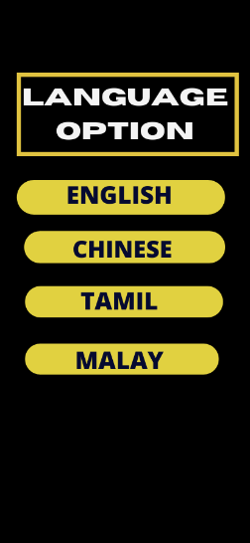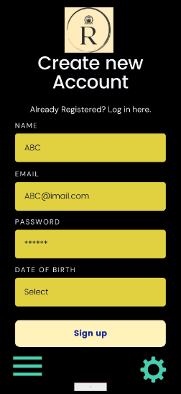

Screen 2: Login Page

When a user first starts up our app, the user is greeted with the application’s logo. The application’s logo will show at the top of the page. The users will then be greeted with the login page. The login page is provided with spaces for typing in the user ID and password for the user to log into the app. If there are new users, a sign-up option will be provided there which the user can register their new account through social media accounts such as Facebook, Google, and Twitter. They can even use their phone numbers if they are scared to link their personal social media accounts in the app. The password the user creates must contain at least eight characters, one uppercase letter, one number and one symbol. There is also a link in the event that the user forgets their password which would send them a code to reset their password. Clicking that link will send the user to the forgotten password page which will ask for the user’s email to send a confirmation code to reset their password. After pressing the send button, they will be directed to the confirmation code screen which they will key in the confirmation code. There is also a button to resend the code if there is any trouble in keying in the code. Once the user successfully logs into the app, they will be asked to use smartphone features like the fingerprint scanner or facial recognition to speed up the authentication process and to provide a safer login, but it is not compulsory. Then, the users will be asked to customize their profile by adding their profile picture, name, phone number, date of birth and email. Then, the app will display a screen that allows the users to choose the language they preferred. The languages provided are English, Malay, Tamil and Chinese. This is because we do not want any users to feel left out when they do not understand the language. The language option is particularly important since the user needs to understand every single word there for them to fully utilise the app. Once the user has selected the language they preferred, they are then greeted with the home page.

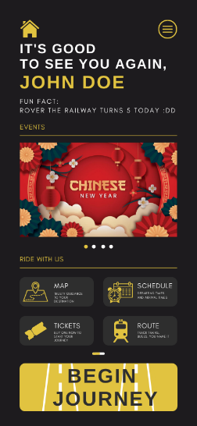

Screen 3: Home Screen

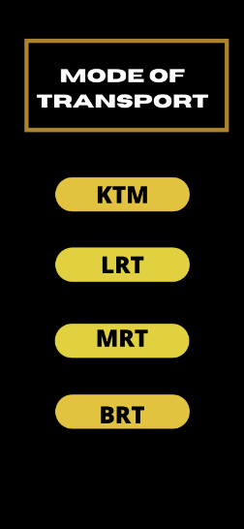

Screen 4: Mode of Transport

After logging in and selecting the preferred language, the user will be greeted by the home screen, where multiple options are made available for the user to tap on depending on their needs. Each button leads to a different screen and contains different features. The top right button with three bars leads to the settings screen, the map leads to the map screen, the schedule leads to the schedule screen, the tickets to the tickets screen and so on.

By tapping on the button that says Begin Journey, the user will see a page which shows the mode of public transport such as KTM, BRT, LRT and MRT. The users are then asked to choose the mode of transport first so that the next page will provide information according to the public transport they choose.

Screen 5: Destination Options 1

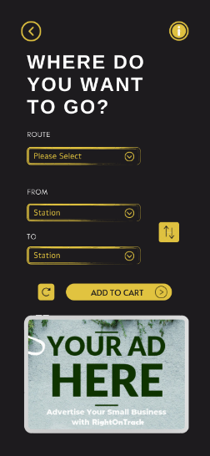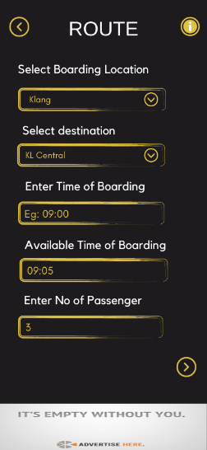

Screen 6: Destination Options 2

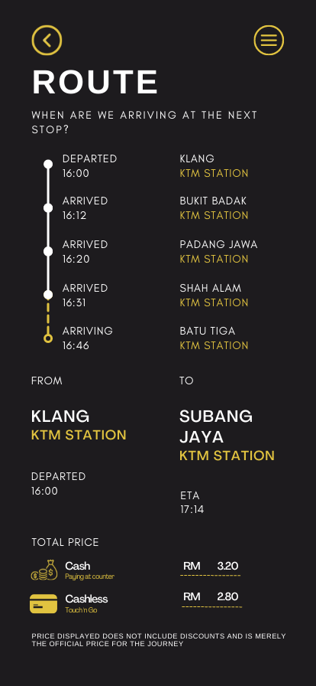 Users will then be prompted to select the boarding location, the destination they wish to go, the time they wish to board the public transport and the number of people that are going to board the public transport. The app will choose the closest time the public transport will arrive based on the time the user had inputted, and users can then type in the address of their destination, to which the application will then lead the users to said destination via the closest available public transport such as LRT, KTM and buses.

Screen 7: Display Route, ETA, and price

Next, the app will display the route of the selected public transport and ETA, which stand for the estimated time of arrival, where the ETA considers factors such as traffic jams if the choice of public transport turns out to be buses as well as delayed public vehicle arrival. Tapping on the ETA provided opens a list of departure and arrival times for each public vehicle involved in the route taken by the user, where the times are always updated depending on delays and occasional mistakes in scheduling. This ensures that users can accurately estimate the time they need to arrive at their destination and plan accordingly. In addition, the app also sums up the bus and train fare and displays the total for the users’ convenience in journey planning and making payments based on the number of passengers the user had inputted and the destination.

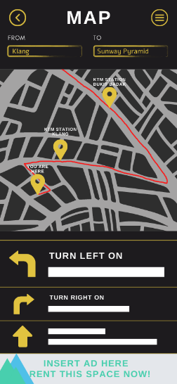

Screen 8: Online Map

Just like most navigation-based application, our application will lead and guide users through routes and station transfers so that they do not get lost nor miss their stops. If users select the Map button, they will be directed to the Map screen, which will guide users to their desitination. This is done through GPS where the user’s location is shown on an online map and the user’s location is constantly updated so that they are always aware of their location. The user’s location is represented via an icon on the online map, whereas the path that they are meant to take is highlighted in red, which will serve as a guideline for them. Friendly reminders are given via the use of notifications as well as via the application’s virtual assistant to the user to remind the user to get off the public vehicle when they have reached either their transfer stops or their destination. This function will prevent time wastage due to users missing station transfers and getting lost, which can ensure that users get to their intended destination on time. If the user still somehow missed their station, the application will either guide the user back to their original path, where the original red path branches off into a blue path to lead the user back to the red path or if possible, recommend a best new path for the user to take to still arrive at their destination. This will be given in the form of a choice, where the user can choose to head back to their original path or take the new path. The estimated time arrival for both paths will also be given so that the user can gauge the pros and cons of each path and choose wisely.

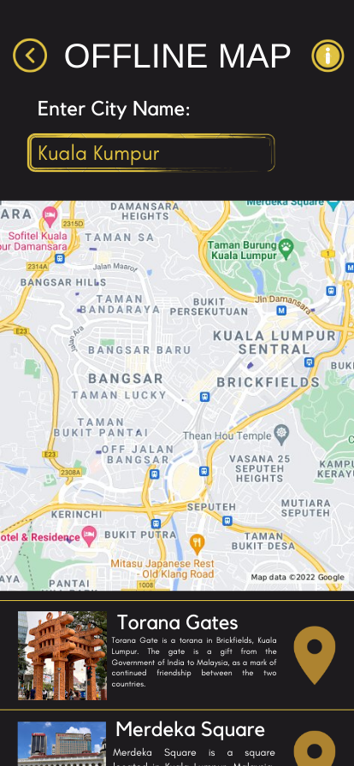 In addition, users can use this feature to track their public transport’s progression with the app. Users can track where their public transport is coming from, the time of arrival at the user’s station, the speed of the train and if the train is under maintenance. The tracking feature will send a notification to the user when the public transport they choose is nearing their station so that it enables the users to get ready to board their public transport on time. To use this feature, the user must connect to the Internet.

Screen 9: Offline Map

Besides that, our application also offers a detailed offline map of all the public transport in the country. The map will show all the public transport available and their routes and destination to help user navigate through the city. The map provided will also incorporate major landmarks of the area to make it easier for the users to navigate. That way, our users will no longer face the risks of getting lost and needing to stand in front of the information board for half an hour trying to figure out how to get to their desired location. This map function will also be available even when the user is not connected to any Wi-Fi or data services so that our user would not get lost even when they are not connected to the Internet. This function of our app is also helpful to foreign travellers as they could use the offline map to navigate these foreign lands without getting lost.

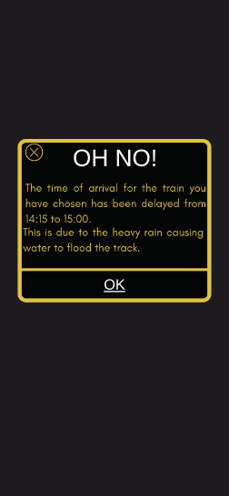

Screen 11: Alert Message

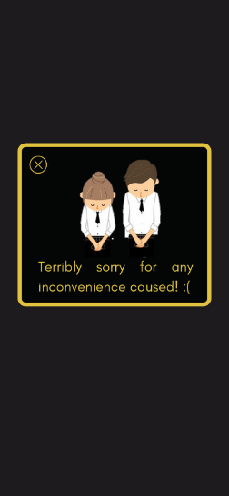

Screen 10: Apology Message

Our application will also let the user know if the public transport they have selected is delayed with an alert message. This can be done if the conductor of the public transport informs and notify our app if there is any delay to the schedule. Then our app will display the time adjustments for to the users together with the reason why the transport is late. Our application will also send in an apology message to appease the anger of the users. That way, communication between the passenger and the public transport will be made easier, thus allowing for a better customer service. Our user will no longer have to sit at the station and wait without a clear explanation of how long they must wait and why the transport is late. This function solves the issue a lot of passengers faced when boarding a public transport as most of the time in Malaysia, the public transport is never on time, and we had no explanation as to why they are late. This frustrating situation will no longer happen if everyone fully utilizes this function of our app.

The coronavirus outbreak has increased the demand for contactless payments, thus our app offers an e-ticketing system to replace other standard ticketing methods by merging QR code technology with the public transit ticketing system. We will collaborate with other public transit operators to integrate QR codes for tickets. An E-ticketing system in public transportation is not only a means of payment, but it also analyses a large volume of data, expanding the range of possibilities for making public transit easier to use and manage. Users can purchase an e-ticket in the form of a QR Code using our mobile application in the tickets screen Once purchased, QR code tickets can be activated via scanning them on a validation device in a vehicle such as a bus or at a gate. This mobile ticketing system is an example of a client-server system, which comprises an end-point device with an installed transit app, a server, and a scanning device in a vehicle or on a gate. A server will process a user's ticket purchase request, generate a QR code ticket, and return it.

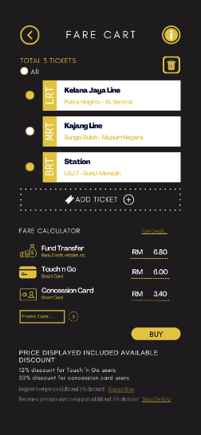

Screen 12: Price List

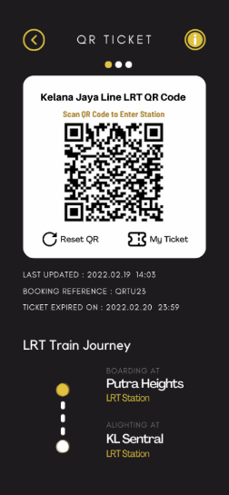

Screen 13: QR Code Ticket

Furthermore, users who purchase public transit tickets using our app will receive a 3% additional discount for regular users and an 8% additional discount for premium users. Promo codes and discounts are an effective marketing strategy that encourages people to download our application. Users can use promo codes offered by selected companies who sponsor or partner with our app to receive a discounted price when buying e-tickets. However, these promotional codes are only applicable for heavy rail trains, such as ETS trains, which represent "Electric Train Service", and some of them come with terms and conditions. For example, a train ticket discount code that offers up to 50% off return trips with the same operator. In addition, users will receive a 15% cashback for every RM 50 accumulated amount spent on our app.

Screen 14: Payment Methods

Besides, our application offers users various payment methods, including debit cards, credit cards, electronic bank transfers, and e-wallets, by integrating payment gateways and app payment systems. Payment gateways are essential to make the online purchase process safe and secure for users, authorise transactions and help encrypt data. The use of e-wallets is one of the forthcoming trends because it is considered an advanced and instant digital payment method. Users must first sign up before they are allowed to select e-wallets as their payment method. It is optional for users to link their transit application account to their e-wallet and bank account. Moreover, our application also accepts payment methods via smartcards such as the Touch 'n Go card and concession cards. Users will be needed to input a 10-digit card serial number to link the smartcards with their account. The user will gain the same discount as if they tapped their smartcards on the fare gates. To proceed with the payment, users must provide a 6-digit PIN, and the ticket fee will be deducted automatically from their card balance.

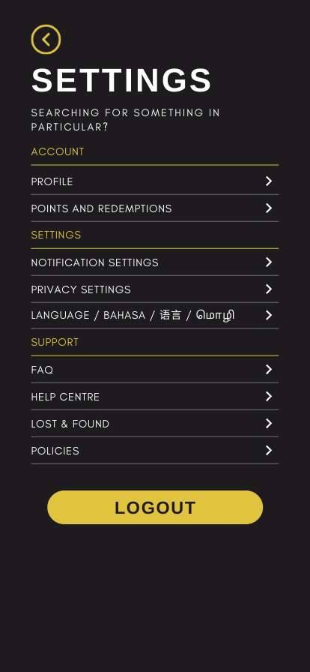 If users tap on the circle with three bars in the home screen, they will be led to the settings screen, where they can access other options and pages such as the FAQ, lost & section, and the like.

Screen 15: Settings

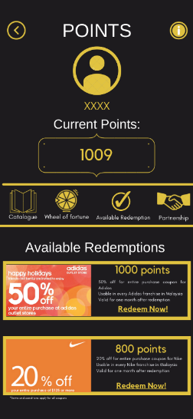

Screen 16: Points and Redemptions

Our application will have a point redemption function where users can earn points by using our apps. For example, when a user buys a ticket using our app, they will earn different points based on the ticket price. Once they have accumulated enough points, they can then redeem those points at stores that have sponsored our companies. Our app will have a page that will display the total amount of points collected by the user and the number of items and rewards they can redeem using those points. There will also be a catalogue page that will display all the items and rewards that a user can redeem. There will also be a page that will display all the companies we are currently in sponsorship with. This will help users easily identify which brand that they can get coupons and other discounts for. We can also incorporate mini games occasionally that helps user earn points to give them more incentive to earn more points. One example of the mini games is the Wheel of Fortune, where users can spin a wheel and depending on where the needle land, they can earn different number of points. With that, we will be able to encourage users to purchase tickets from our app, thus increasing our profit.

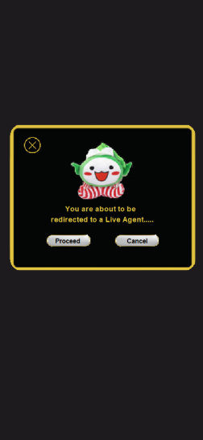

Screen 17: Lost & Found Claiming

Screen 18: Lost & Found Section

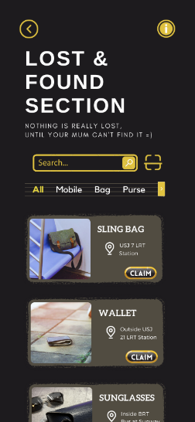

In addition, our application handles lost and found items at transit stations and in transit vehicles. Lost and found is an often-neglected aspect of customer service that may make or break brand loyalty. We offer a Lost and Found service to deal with unclaimed, lost, or abandoned belongings. The purpose of this service is to return any lost property to its rightful owner as soon as possible. Our app will have a Lost and Found section that will show a list of lost items found with a brief description and picture to app users. This section also informs passengers on how to turn in found items. Important information such as area found, station name, and route number will be requested when a passenger turns in found items. The owner of the lost item may claim it through the lost and found section. The user will be directed to a live chat, where a customer service agent will assist the user by asking detailed questions about the item to verify that the user is the rightful owner. Before handing over an item, our app will document every item picked up, and ID and a signature of the person claiming the item are required.

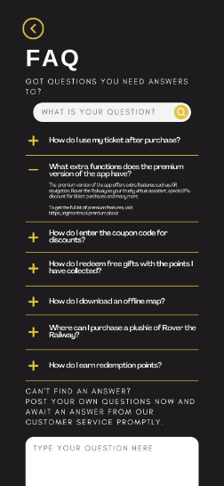

Screen 19: FAQ

Besides that, our application has a FAQ page, where FAQ stands for Frequently Asked Questions. Living up to its name, the FAQ page will contain several questions frequently asked by users as well as the correct answers to them to dispel any confusion the users might have. When users are confused as to how the application functions, they can easily access the FAQ to quickly have their doubts and confusion dispersed. For example, users confused about how to earn redemption points can access the FAQ and tap on the relevant questions displayed to easily receive a solution to their problem. However, if a user does not find their intended question in the provided list, they would have the option to post their own questions and await an answer from our trusty customer service. The FAQ page will be imperative to gauge users understanding of the application and can serve as a temporary solution while optimization of the application is underway.

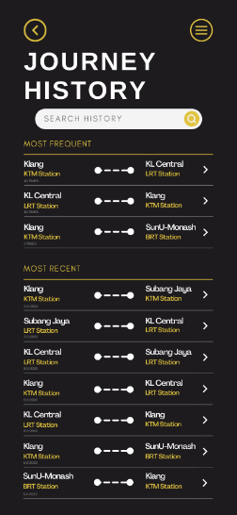

Screen 20: Journey History

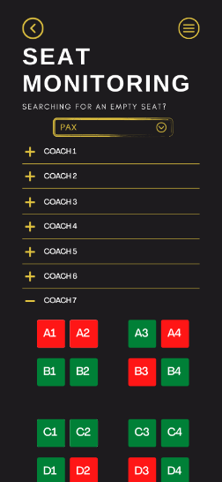

Screen 21: Seat Monitoring

Our application memorises routes usually taken by users and keeps record of places frequented by users. This is done in the form of search history, which records addresses recently searched up by the user, as well as a journey history list, which records each journey taken by the user. In addition, the application allows users to bookmark routes frequently taken by them for easy access. The bookmarked routes will show up at the top of the journey history list, where the user can easily tap on for faster and quicker set-up instead of having to scroll down the long list.

Our application will also feature real time monitoring of seats in public vehicles so that the users can easily know where to find empty seats. This feature will be particularly useful in trains as there are many coaches with scattered seats. With this feature, users will no longer need to go through each coach in search of empty seats and can quickly find and secure empty seats for themselves. This feature will show seats in a coach from a top view, where seats that are occupied are coloured red while seats that are empty and available will be coloured green. The coach and seat numbers are labelled clearly in the application so that users will know exactly which coach and seat they are looking for. Users can type in the number of empty seats they want, which the app will quickly sieve through multiple coaches to find the wanted number of seats, where the seats are all in close with each other proximity, if possible. If users who own the premium version of the application tap on a green empty seat in the application, the application will open the phone’s camera and guide the user to that seat via the AR feature. A glowing line in the camera view will show the user the way to their wanted seat. 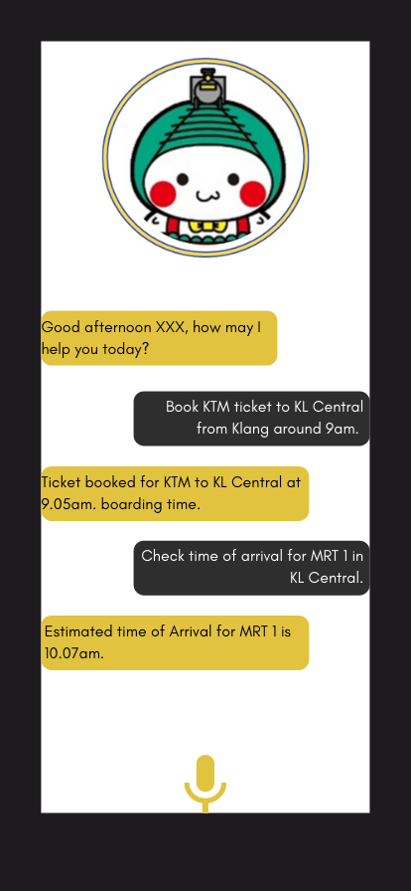

Screen 22: Virtual Assistance

Besides that, our application will also provide a virtual assistance like Siri from Apple to our premium user. This function allows user to use our app hand-free and easily. The user will not need to type out the specifics of their travels and can instead speak aloud and our virtual assistance will then pick up the information given and helps the carry out the tasks. Our virtual assistance, “Rover the Railway” which doubles as our mascot can help the user do different tasks to make the life of our user easier. “Rover the Railway” can be activated by calling out his nickname “Rover” which will summon Rover to the user’s side immediately. Having Rover the Railway will also make the navigation of our app easier. This is because our app provides a variety of different function, and it may be slightly overwhelming to new users to get used to them. Therefore, by having a virtual assistance by their sides, they would be able to grasp the how our app functions quickly and easily. Due to its wide variety of uses and importance, Rover will only be available to our premium users to make sure it is not overworked.

Our application also has an augmented reality feature to assist people who have a poor sense of direction. Using 2D maps to navigate unfamiliar places can be challenging. For instance, there are dual side platform stations in an LRT station, one for each direction of travel, which can be confusing. If you go to the wrong side of the platform and board the wrong LRT, you'll end up getting further and further away from your destination. The AR feature is full-scaled and can display a route overlay in the real-world environment to facilitate navigation. When a user activates AR mode, route instructions are shown and spoken. As the user proceeds along the route, new directions will be given until the user arrives. This AR feature is functional indoors, however, it is only available to premium users.

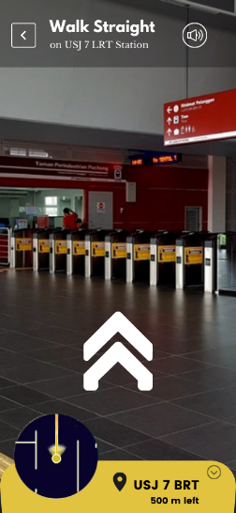

Screen 23: AR Navigation

# Monetizing Strategy and Market Reach

Our application will be made available for everyone to download for free however we will also be incorporating a premium subscription model into our application. That way, users will still be able to enjoy the basic function of our app without needing to pay and once they have had a chance to test our app, they can then opt to purchase our premium membership subscription to get more perks. This is because research has shown that people were more willing to download free apps instead of paying for an app without testing it out first. For the free version, advertisement will be shown to the user to generate revenues. The application will have an advertisement bar at the bottom of the screen that display ads of companies that are sponsoring us. That way, the app will still be able to function normally whilst displaying advertisement. However, for those that believe advertisement ruin the quality of their life, they can opt to buy a premium membership for the app which will remove all bothering advertisements and give them additional perks. We will also be giving a one-month free trial of the premium membership for users to test out and decide if they would like to purchase the premium membership. For example, premium members can enjoy special premium seats specifically reserved for them in all public transports that are in collaboration with our app. Our premium members will no longer have to spend their precious time to look for a free spot to sit, nor do they have to squeeze in with other passengers. In other words, our premium members will be able to enjoy a first-class experience when riding on public transports that are working together with our app. Besides that, premium members can also enjoy additional features in our app such as the AR function and the virtual assistance function to help make the user’s navigation through the app and city seamless and easy.

The second monetizing strategy is to create a mascot to garner the attention of the public. Having a mascot that is relevant to our app is a great way to make people pay attention and remember our app. This is because research has shown that repeated use of a memorable character is able connect with the users and increase brand recognition. A user is more likely to remember a cute cartoony face than a catchy name. Therefore, our mascot ‘Rover the Railway’, as shown on the right, will certainly be able to garner the attention of many and thus increasing our market reach. In that sense, we can create and put posters with our mascot on it that have QR code that can allow them to download our app in different stations throughout the country. Besides that, we can make special limited-edition merchandise of ‘Rover the Railway’ during special events such as the Chinese New Year, Christmas, or our app anniversary. With that we can not only promote our app but also generate additional income for our company.



Rover the Railway

The third monetizing strategy is to have sponsorships deal with other companies. Users can earn points when they buy tickets with our app and when they have accumulated enough points, they can then use those points to exchange items or coupons with companies that are in collaboration with our app. That way we can give incentive to our users to purchase tickets via our platform and thus increasing our overall revenue. Besides that, we can also encourage customers of famous brands to use our app so that they can get coupons to spend by using our app. With that we will be able to gain customer from famous brands and encourage more people to try out our app. Famous companies which we can collaborate with are big brands such as Adidas, Nike, and Uniqlo. These brands are especially popular among young adults which makes up of half our customer base, therefore by having collaboration with these companies we will be able to encourage our existing users to buy tickets to their respective mode of public transport.

The next monetizing strategy is to have partnership with public transport companies in Malaysia. This is because most of our app’s function depends on the public transport itself therefore having a close relationship and good communication with them is extremely necessary to provide the best experience for the user. Some examples of the companies we can have partnership with are Star Shuttle, Prasarana Malaysia Berhad, Mass Rapid Transit Corporation Sdn Bhd (MRT Corp) and many more. The more partnership we have with other companies, the completer and more accurate the data of our app will be. Therefore, it is extremely important to maintain a good relationship with these companies. Once we have a partnership with these private company, we can then incorporate different premium membership perks into the public transport itself such as the reserved seats for premium users. This partnership will be beneficial to both the companies and the users as the users are now able to accurately see the time of arrival of each public transport and communication between the user and companies would be much easier than before. Thus, more users will be willing to use their mode of transport making it a win-win situation for both parties.

Besides that, we will also be using emails and SMS to increase our market reach. This can be done by sending various updates and news to our users via their emails and send SMS to potential customers regarding information about our app. That way, our existing customers will be able to receive up to date news about our apps, making sure that they would not miss out any new functions. Besides that, by sending SMS to potential customers we will be able to let more people know about our app and thus increasing our customer base.

Apart from that, we will also be making use of social media to promote about our app. For example, we would set up a page on major social media such as the Instagram and Facebook and post various contents and updates there. We can also create promotion videos for our app and post it on social media, so that more people will become interested in our app. Using social media as our marketing platform is effective as the majority of our targeted audience are extremely active in social medias. Thus, we will be able to connect to them, making them more willing to use our app. They could also use the social media as a platform to ask us questions regarding the app, allowing for a better customer service and preventing any confusion when using the app.

Finally, we plan to reach out to local newspapers and billboard company to set up advertisement pages for us. For example, we will contact a local newspaper agency and rent out a page of their newspaper to post advertisement of our app there. With that we will be able to let people who are not tech savvy to know about our app. Besides that, we will also rent out billboards that are near to a public transport station to advertise for our app. That way, while people are stuck waiting for their respective public transport to arrive, our advertisement can become their saving grace, allowing them to get more information about the public transport, preventing them from needing to wait hours for their transport to arrive.

# Mock-up Design

## Kimberly

### Frame 1

Serves as the home screen where users can access features of the application.

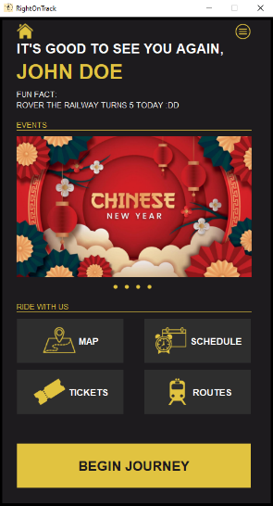

Frame 1: Home Screen

/* Screen Functions as a home screen to connect to other screens

* Home screen of the application where users can access multiple features of the application

* Utilizes components such as JFrame, JPanel, JLabel and JButton

* Things involved in independent learning include:

* 1. Calling another class

* settingsButton.addActionListener (new ActionListener() {

public void actionPerformed (ActionEvent press) {

new Settings();

homeFrame.dispose();

}

});

- to connect one screen to another

* Coded by Kimberly

*/

**import** javax.swing.*;

**import** javax.swing.border.Border;

**import** java.awt.*;

**import** java.awt.event.*;

**public** **class** Home {

**public** Home() {

//Set ImageIcon

ImageIcon homeSign = **new** ImageIcon (Home.**class**.getResource ("homeSign.png"));

ImageIcon settingsSign = **new** ImageIcon (Home.**class**.getResource ("settingsSign.png"));

ImageIcon mapSign = **new** ImageIcon (Home.**class**.getResource ("mapSign.png"));

ImageIcon scheduleSign = **new** ImageIcon (Home.**class**.getResource ("scheduleSign.png"));

ImageIcon ticketsSign = **new** ImageIcon (Home.**class**.getResource ("ticketSign.png"));

ImageIcon routeSign = **new** ImageIcon (Home.**class**.getResource ("routeSign.png"));

ImageIcon event1 = **new** ImageIcon (Home.**class**.getResource ("event1.png"));

ImageIcon event2 = **new** ImageIcon (Home.**class**.getResource ("event2.png"));

ImageIcon event3 = **new** ImageIcon (Home.**class**.getResource ("event3.png"));

ImageIcon event4 = **new** ImageIcon (Home.**class**.getResource ("event4.png"));

ImageIcon dot = **new** ImageIcon (Home.**class**.getResource ("dot.png"));

ImageIcon appLogo = **new** ImageIcon (Home.**class**.getResource ("appLogo.png"));

//Declare variables

String username = "JOHN DOE";

//Set JFrame

**final** JFrame homeFrame = **new** JFrame ();

//Set JPanel

JPanel homePanel = **new** JPanel ();

//Preset Fonts and Colors

Font homeFont1 = **new** Font ("Helveticish", Font.***BOLD***, 24);

Font homeFont2 = **new** Font ("Helveticish", Font.***BOLD***, 36);

Font homeFont3 = **new** Font ("Glacial Indifference", Font.***PLAIN***, 14);

Font homeFont4 = **new** Font ("Glacial Indifference", Font.***BOLD***, 17);

Color darkGray = **new** Color (29,27,30);

Color gray = **new** Color (46,46,46);

Color gold = **new** Color (225,195,64);

//Preset Borders

Border homeFrameBorder = BorderFactory.*createLineBorder* (Color.***black***, 5);

Border homeBottom = BorderFactory.*createMatteBorder* (0,0,1,0, gold);

Border buttonBorder = BorderFactory.*createLineBorder* (darkGray, 1);

//Set JComponents

JLabel greetingCard = **new** JLabel ("IT'S GOOD TO SEE YOU AGAIN,");

JLabel usernameLabel = **new** JLabel (username);

JLabel homeSubtitle = **new** JLabel ("<html>FUN FACT:<br>"

+ "ROVER THE RAILWAY TURNS 5 TODAY :DD </html>");

JLabel eventsLabel = **new** JLabel ("EVENTS");

JLabel rideLabel = **new** JLabel ("RIDE WITH US");

**final** JLabel event1Label = **new** JLabel (event1);

**final** JLabel event2Label = **new** JLabel (event2);

**final** JLabel event3Label = **new** JLabel (event3);

**final** JLabel event4Label = **new** JLabel (event4);

JButton mapButton = **new** JButton ("MAP", mapSign);

JButton scheduleButton = **new** JButton ("SCHEDULE", scheduleSign);

JButton ticketsButton = **new** JButton ("TICKETS", ticketsSign);

JButton routesButton = **new** JButton ("ROUTES", routeSign);

JButton beginButton = **new** JButton ("BEGIN JOURNEY");

JButton settingsButton = **new** JButton ("", settingsSign);

JButton homeButton = **new** JButton ("", homeSign);

JButton dot1 = **new** JButton ("", dot);

JButton dot2 = **new** JButton ("", dot);

JButton dot3 = **new** JButton ("", dot);

JButton dot4 = **new** JButton ("", dot);

//Customizations and setBounds

homeButton.setBackground (darkGray);

homeButton.setBounds (30, 10, 30, 30);

homeButton.setBorder (buttonBorder);

settingsButton.setBackground (darkGray);

settingsButton.setBounds (415, 10, 30, 30);

settingsButton.setBorder (buttonBorder);

greetingCard.setFont (homeFont1);

greetingCard.setForeground (Color.***white***);

greetingCard.setBounds (30, 30, 450, 50);

usernameLabel.setFont (homeFont2);

usernameLabel.setForeground (gold);

usernameLabel.setBounds (30, 70, 450, 50);

homeSubtitle.setFont (homeFont3);

homeSubtitle.setForeground (Color.***white***);

homeSubtitle.setBounds (30, 120, 450, 50);

eventsLabel.setFont (homeFont3);

eventsLabel.setForeground (gold);

eventsLabel.setBounds (30, 180, 415, 20);

eventsLabel.setBorder(homeBottom);

event1Label.setBounds (30, 210, 415, 248);

event2Label.setBounds (30, 210, 415, 248);

event3Label.setBounds (30, 210, 415, 248);

event4Label.setBounds (30, 210, 415, 248);

dot1.setBackground (darkGray);

dot1.setBounds (200, 470, 10, 10);

dot1.setBorder (buttonBorder);

dot2.setBackground (darkGray);

dot2.setBounds (220, 470, 10, 10);

dot2.setBorder (buttonBorder);

dot3.setBackground (darkGray);

dot3.setBounds (240, 470, 10, 10);

dot3.setBorder (buttonBorder);

dot4.setBackground (darkGray);

dot4.setBounds (260, 470, 10, 10);

dot4.setBorder (buttonBorder);

rideLabel.setFont (homeFont3);

rideLabel.setForeground (gold);

rideLabel.setBounds (30, 500, 415, 20);

rideLabel.setBorder(homeBottom);

mapButton.setBackground (gray);

mapButton.setForeground (Color.***white***);

mapButton.setFont (homeFont4);

mapButton.setBounds (30, 530, 190, 80);

mapButton.setBorder (buttonBorder);

scheduleButton.setBackground (gray);

scheduleButton.setForeground (Color.***white***);

scheduleButton.setFont (homeFont4);

scheduleButton.setBounds (255, 530, 190, 80);

scheduleButton.setBorder (buttonBorder);

ticketsButton.setBackground (gray);

ticketsButton.setForeground (Color.***white***);

ticketsButton.setFont (homeFont4);

ticketsButton.setBounds (30, 620, 190, 80);

ticketsButton.setBorder (buttonBorder);

routesButton.setBackground (gray);

routesButton.setForeground (Color.***white***);

routesButton.setFont (homeFont4);

routesButton.setBounds (255, 620, 190, 80);

routesButton.setBorder (buttonBorder);

beginButton.setBackground (gold);

beginButton.setForeground (darkGray);

beginButton.setFont (homeFont1);

beginButton.setBounds (30, 750, 415, 80);

beginButton.setBorder (buttonBorder);

//Actions and results

dot1.addActionListener (**new** ActionListener() {

**public** **void** actionPerformed (ActionEvent press) {

event1Label.setVisible (**true**);

event2Label.setVisible (**false**);

event3Label.setVisible (**false**);

event4Label.setVisible (**false**);

}

});

dot2.addActionListener (**new** ActionListener() {

**public** **void** actionPerformed (ActionEvent press) {

event1Label.setVisible (**false**);

event2Label.setVisible (**true**);

event3Label.setVisible (**false**);

event4Label.setVisible (**false**);

}

});

dot3.addActionListener (**new** ActionListener() {

**public** **void** actionPerformed (ActionEvent press) {

event1Label.setVisible (**false**);

event2Label.setVisible (**false**);

event3Label.setVisible (**true**);

event4Label.setVisible (**false**);

}

});

dot4.addActionListener (**new** ActionListener() {

**public** **void** actionPerformed (ActionEvent press) {

event1Label.setVisible (**false**);

event2Label.setVisible (**false**);

event3Label.setVisible (**false**);

event4Label.setVisible (**true**);

}

});

settingsButton.addActionListener (**new** ActionListener() {

**public** **void** actionPerformed (ActionEvent press) {

**new** Settings();

homeFrame.dispose();

}

});

mapButton.addActionListener (**new** ActionListener() {

**public** **void** actionPerformed (ActionEvent press) {

**new** OfflineMap();

homeFrame.dispose();

}

});

ticketsButton.addActionListener (**new** ActionListener() {

**public** **void** actionPerformed (ActionEvent press) {

**new** test2();

homeFrame.dispose();

}

});

beginButton.addActionListener (**new** ActionListener() {

**public** **void** actionPerformed (ActionEvent press) {

**new** mode();

homeFrame.dispose();

}

});

//Add to panel

homePanel.setBorder (homeFrameBorder);

homePanel.setLayout (**null**);

homePanel.setBackground (darkGray);

homePanel.add (greetingCard);

homePanel.add (usernameLabel);

homePanel.add (homeSubtitle);

homePanel.add (eventsLabel);

homePanel.add (rideLabel);

homePanel.add (mapButton);

homePanel.add (scheduleButton);

homePanel.add (ticketsButton);

homePanel.add (routesButton);

homePanel.add (beginButton);

homePanel.add (settingsButton);

homePanel.add (homeButton);

homePanel.add (event1Label);

homePanel.add (event2Label);

homePanel.add (event3Label);

homePanel.add (event4Label);

homePanel.add (dot1);

homePanel.add (dot2);

homePanel.add (dot3);

homePanel.add (dot4);

//Add to frame

homeFrame.add (homePanel);

homeFrame.setTitle ("RightOnTrack");

homeFrame.setDefaultCloseOperation (JFrame.***EXIT_ON_CLOSE***);

homeFrame.setSize (500,900);

homeFrame.setVisible (**true**);

homeFrame.setLocationRelativeTo (**null**);

homeFrame.setIconImage (appLogo.getImage());

homeFrame.setResizable (**false**);

}

//Main Method

**public** **static** **void** main (String [] args) {

**new** Home();

}

}

### Frame 2

Settings screen where users can access customer support and adjust settings based on needs.

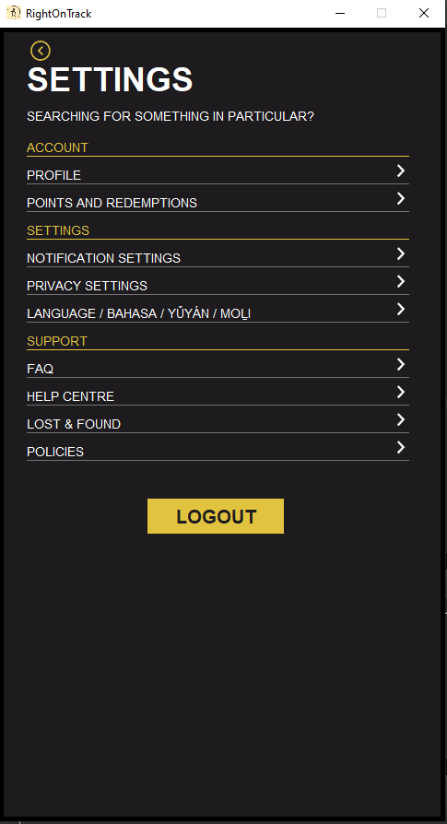

Frame 2: Settings

/* Screen serves more as a gateway to other screens

* Serves as a settings screen where users can change settings according to their liking as well as access customer support such as the Lost & Found section

* Utilizes components such as JFrame, JPanel, JLabel and JButton

* Things involved in independent learning include:

* 1. MatteBorder

* Border subSettingsBottom = BorderFactory.createMatteBorder (0,0,1,0, lightGray);

* - to set bottom border

* 2. Calling another class

* back.addActionListener (new ActionListener() {

public void actionPerformed (ActionEvent press) {

new Home();

settingsFrame.dispose();

}

});

- to connect one screen to another

* Coded by Kimberly

*/

**import** javax.swing.*;

**import** javax.swing.border.Border;

**import** java.awt.*;

**import** java.awt.event.ActionEvent;

**import** java.awt.event.ActionListener;

**public** **class** Settings {

**public** Settings() {

//Set ImageIcon

ImageIcon backSign = **new** ImageIcon (Settings.**class**.getResource ("backSign.png"));

ImageIcon arrowSign = **new** ImageIcon (Settings.**class**.getResource ("arrowSign.png"));

ImageIcon appLogo = **new** ImageIcon (Settings.**class**.getResource ("appLogo.png"));

//Set JFrame

**final** JFrame settingsFrame = **new** JFrame ();

//Set JPanel

JPanel settingsPanel = **new** JPanel ();

//Preset Fonts and Colors

Font settingsFont1 = **new** Font ("Helveticish", Font.***BOLD***, 36);

Font settingsFont2 = **new** Font ("Glacial Indifference", Font.***PLAIN***, 14);

Font settingsFont3 = **new** Font ("Helveticish", Font.***BOLD***, 20);

Color darkGray = **new** Color (29,27,30);

Color lightGray = **new** Color (113,114,115);

Color gold = **new** Color (225,195,64);

//Preset Borders

Border settingsFrameBorder = BorderFactory.*createLineBorder* (Color.***black***, 5);

Border settingsBottom = BorderFactory.*createMatteBorder* (0,0,1,0, gold);

Border subSettingsBottom = BorderFactory.*createMatteBorder* (0,0,1,0, lightGray);

Border buttonBorder = BorderFactory.*createLineBorder* (darkGray, 1);

//Set JComponents

JLabel settingsTitle = **new** JLabel ("SETTINGS");

JLabel settingsSubtitle = **new** JLabel ("SEARCHING FOR SOMETHING IN PARTICULAR?");

JLabel account = **new** JLabel ("ACCOUNT");

JLabel profile = **new** JLabel ("PROFILE");

JLabel pointsAndRedemptions = **new** JLabel ("POINTS AND REDEMPTIONS");

JLabel settings = **new** JLabel ("SETTINGS");

JLabel notification = **new** JLabel ("NOTIFICATION SETTINGS");

JLabel privacy = **new** JLabel ("PRIVACY SETTINGS");

JLabel language = **new** JLabel ("LANGUAGE / BAHASA / YǓYÁN / MOḺI");

JLabel support = **new** JLabel ("SUPPORT");

JLabel FAQButton = **new** JLabel ("FAQ");

JLabel helpCentre = **new** JLabel ("HELP CENTRE");

JLabel lostAndFound = **new** JLabel ("LOST & FOUND");

JLabel policies = **new** JLabel ("POLICIES");

JButton logout = **new** JButton ("LOGOUT");

JButton back = **new** JButton ("", backSign);

JButton arrow1 = **new** JButton ("", arrowSign);

JButton arrow2 = **new** JButton ("", arrowSign);

JButton arrow3 = **new** JButton ("", arrowSign);

JButton arrow4 = **new** JButton ("", arrowSign);

JButton arrow5 = **new** JButton ("", arrowSign);

JButton arrow6 = **new** JButton ("", arrowSign);

JButton arrow7 = **new** JButton ("", arrowSign);

JButton arrow8 = **new** JButton ("", arrowSign);

JButton arrow9 = **new** JButton ("", arrowSign);

//Customizations and setBounds

back.setBackground (darkGray);

back.setBounds (30, 10, 30, 30);

back.setBorder (buttonBorder);

settingsTitle.setFont (settingsFont1);

settingsTitle.setForeground (Color.***white***);

settingsTitle.setBounds (30, 30, 450, 50);

settingsSubtitle.setFont (settingsFont2);

settingsSubtitle.setForeground (Color.***white***);

settingsSubtitle.setBounds (30, 70, 450, 50);

account.setFont (settingsFont2);

profile.setFont (settingsFont2);

pointsAndRedemptions.setFont (settingsFont2);

settings.setFont (settingsFont2);

notification.setFont (settingsFont2);

privacy.setFont (settingsFont2);

language.setFont (settingsFont2);

support.setFont (settingsFont2);

FAQButton.setFont (settingsFont2);

helpCentre.setFont (settingsFont2);

lostAndFound.setFont (settingsFont2);

policies.setFont (settingsFont2);

account.setForeground (gold);

settings.setForeground (gold);

support.setForeground (gold);

account.setBorder (settingsBottom);

settings.setBorder (settingsBottom);

support.setBorder (settingsBottom);

profile.setForeground (Color.***white***);

pointsAndRedemptions.setForeground (Color.***white***);

notification.setForeground (Color.***white***);

privacy.setForeground (Color.***white***);

language.setForeground (Color.***white***);

FAQButton.setForeground (Color.***white***);

helpCentre.setForeground (Color.***white***);

lostAndFound.setForeground (Color.***white***);

policies.setForeground (Color.***white***);

profile.setBorder (subSettingsBottom);

pointsAndRedemptions.setBorder (subSettingsBottom);

notification.setBorder (subSettingsBottom);

privacy.setBorder (subSettingsBottom);

language.setBorder (subSettingsBottom);

FAQButton.setBorder (subSettingsBottom);

helpCentre.setBorder (subSettingsBottom);

lostAndFound.setBorder (subSettingsBottom);

policies.setBorder (subSettingsBottom);

account.setBounds (30, 120, 415, 20);

profile.setBounds (30, 150, 415, 20);

pointsAndRedemptions.setBounds (30, 180, 415, 20);

settings.setBounds (30, 210, 415, 20);

notification.setBounds (30, 240, 415, 20);

privacy.setBounds (30, 270, 415, 20);

language.setBounds (30, 300, 415, 20);

support.setBounds (30, 330, 415, 20);

FAQButton.setBounds (30, 360, 415, 20);

helpCentre.setBounds (30, 390, 415, 20);

lostAndFound.setBounds (30, 420, 415, 20);

policies.setBounds (30, 450, 415, 20);

logout.setBackground (gold);

logout.setForeground (darkGray);

logout.setBounds (160, 510, 150, 40);

logout.setFont (settingsFont3);

logout.setBorder (buttonBorder);

arrow1.setBorder (buttonBorder);

arrow2.setBorder (buttonBorder);

arrow3.setBorder (buttonBorder);

arrow4.setBorder (buttonBorder);

arrow5.setBorder (buttonBorder);

arrow6.setBorder (buttonBorder);

arrow7.setBorder (buttonBorder);

arrow8.setBorder (buttonBorder);

arrow9.setBorder (buttonBorder);

arrow1.setBackground (darkGray);

arrow2.setBackground (darkGray);

arrow3.setBackground (darkGray);

arrow4.setBackground (darkGray);

arrow5.setBackground (darkGray);

arrow6.setBackground (darkGray);

arrow7.setBackground (darkGray);

arrow8.setBackground (darkGray);

arrow9.setBackground (darkGray);

arrow1.setBounds (425, 145, 20, 20);

arrow2.setBounds (425, 175, 20, 20);

arrow3.setBounds (425, 235, 20, 20);

arrow4.setBounds (425, 265, 20, 20);

arrow5.setBounds (425, 295, 20, 20);

arrow6.setBounds (425, 355, 20, 20);

arrow7.setBounds (425, 385, 20, 20);

arrow8.setBounds (425, 415, 20, 20);

arrow9.setBounds (425, 445, 20, 20);

//Actions and Results

back.addActionListener (**new** ActionListener() {

**public** **void** actionPerformed (ActionEvent press) {

**new** Home();

settingsFrame.dispose();

}

});

arrow6.addActionListener (**new** ActionListener() {

**public** **void** actionPerformed (ActionEvent press) {

**new** FAQ();

settingsFrame.dispose();

}

});

arrow8.addActionListener (**new** ActionListener() {

**public** **void** actionPerformed (ActionEvent press) {

**new** A2_LFS();

settingsFrame.dispose();

}

});

logout.addActionListener (**new** ActionListener() {

**public** **void** actionPerformed (ActionEvent press) {

**new** aa();

settingsFrame.dispose();

}

});

//Add to panel

settingsPanel.setBorder (settingsFrameBorder);

settingsPanel.setLayout (**null**);

settingsPanel.setBackground (darkGray);

settingsPanel.add (settingsTitle);

settingsPanel.add (settingsSubtitle);

settingsPanel.add (account);

settingsPanel.add (profile);

settingsPanel.add (pointsAndRedemptions);

settingsPanel.add (settings);

settingsPanel.add (notification);

settingsPanel.add (privacy);

settingsPanel.add (language);

settingsPanel.add (support);

settingsPanel.add (FAQButton);

settingsPanel.add (helpCentre);

settingsPanel.add (lostAndFound);

settingsPanel.add (policies);

settingsPanel.add (logout);

settingsPanel.add (back);

settingsPanel.add (arrow1);

settingsPanel.add (arrow2);

settingsPanel.add (arrow3);

settingsPanel.add (arrow4);

settingsPanel.add (arrow5);

settingsPanel.add (arrow6);

settingsPanel.add (arrow7);

settingsPanel.add (arrow8);

settingsPanel.add (arrow9);

//Add to frame

settingsFrame.add (settingsPanel);

settingsFrame.setTitle ("RightOnTrack");

settingsFrame.setDefaultCloseOperation (JFrame.***EXIT_ON_CLOSE***);

settingsFrame.setSize (500,900);

settingsFrame.setVisible (**true**);

settingsFrame.setLocationRelativeTo (**null**);

settingsFrame.setIconImage (appLogo.getImage());

settingsFrame.setResizable (**false**);

}

//Main Method

**public** **static** **void** main (String [] args) {

**new** Settings();

}

}

### Frame 3

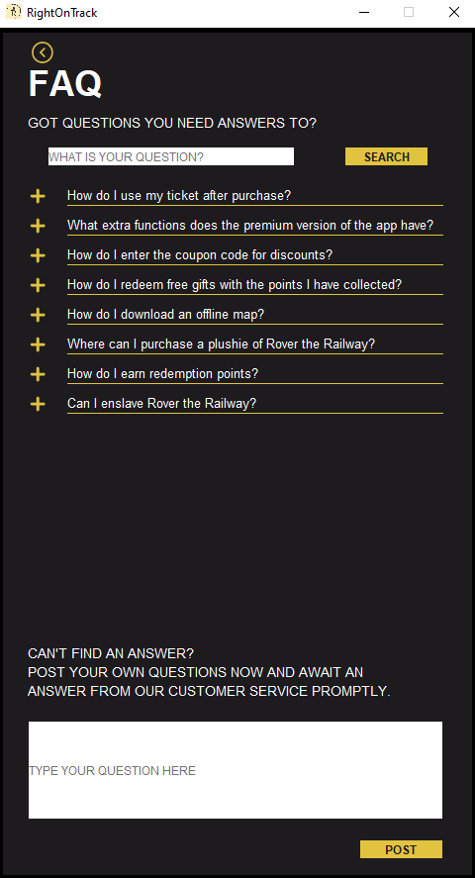FAQ screen where customers can find answers to their questions regarding the application or upload questions themselves.

Frame 3: FAQ Screen

/* Screen has no actual functionality and working buttons are just for video purpose

* Serves as an FAQ screen where users can receive answers to their questions

* Utilizes components such as JFrame, JPanel, JLabel and JButton

* Things involved in independent learning include:

* 1. MatteBorder

* final Border FAQQuestionBottom = BorderFactory.createMatteBorder (0,0,1,0, gold);

* - to set bottom border

* 2. Calling another class

* back.addActionListener (new ActionListener() {

public void actionPerformed (ActionEvent press) {

new Settings();

FAQFrame.dispose();

}

});

- to connect one screen to another

3. FAQPanel.setLayout (null);

- to allow setBounds to work and remove FlowLayout as the default

4. posted.setVisible (true);

- toggle item visibility to simulate item functionality

5. html tag

JLabel FAQQuestion = new JLabel ("<html>CAN'T FIND AN ANSWER? <br>"

+ "POST YOUR OWN QUESTIONS NOW AND AWAIT AN ANSWER FROM OUR CUSTOMER SERVICE PROMPTLY.</html>");

- for text wrapping and formatting

* Coded by Kimberly

*/

**import** javax.swing.*;

**import** javax.swing.border.Border;

**import** java.awt.*;

**import** java.awt.event.ActionEvent;

**import** java.awt.event.ActionListener;

**import** java.awt.event.MouseEvent;

**import** java.awt.event.MouseAdapter;

**public** **class** FAQ {

**public** FAQ () {

//Set ImageIcon

ImageIcon plusSign = **new** ImageIcon (FAQ.**class**.getResource ("plusSign.png"));

ImageIcon minusSign = **new** ImageIcon (FAQ.**class**.getResource ("minusSign.png"));

ImageIcon backSign = **new** ImageIcon (FAQ.**class**.getResource ("backSign.png"));

ImageIcon appLogo = **new** ImageIcon (FAQ.**class**.getResource ("appLogo.png"));

//SetJFrame

**final** JFrame FAQFrame = **new** JFrame ();

//SetJPanel

JPanel FAQPanel = **new** JPanel ();

//Preset Fonts and Colors

Font FAQFont1 = **new** Font ("Helveticish", Font.***BOLD***, 36);

Font FAQFont2 = **new** Font ("Glacial Indifference", Font.***PLAIN***, 14);

Font FAQFont3 = **new** Font ("Agrandir Medium", Font.***PLAIN***, 13);

Font FAQFont4 = **new** Font ("Agrandir Medium", Font.***PLAIN***, 12);

Font FAQFont5 = **new** Font ("Glacial Indifference", Font.***PLAIN***, 10);

Color darkGray = **new** Color (29,27,30);

Color lightGray = **new** Color (113,114,115);

Color gold = **new** Color (225,195,64);

//Preset Borders

Border FAQFrameBorder = BorderFactory.*createLineBorder* (Color.***black***, 5);

**final** Border FAQQuestionBottom = BorderFactory.*createMatteBorder* (0,0,1,0, gold);

Border buttonBorder = BorderFactory.*createLineBorder* (darkGray, 1);

//Set JComponents

JLabel FAQTitle = **new** JLabel ("FAQ");

JLabel FAQSubtitle = **new** JLabel ("GOT QUESTIONS YOU NEED ANSWERS TO?");

**final** JTextField FAQSearchField = **new** JTextField (20);

JButton FAQSearchButton = **new** JButton ("SEARCH");

**final** JLabel question1 = **new** JLabel ("How do I use my ticket after purchase?");

**final** JLabel question2 = **new** JLabel ("What extra functions does the premium version of the app have?");

**final** JLabel question3 = **new** JLabel ("How do I enter the coupon code for discounts?");

**final** JLabel question4 = **new** JLabel ("How do I redeem free gifts with the points I have collected?");

**final** JLabel question5 = **new** JLabel ("How do I download an offline map?");

**final** JLabel question6 = **new** JLabel ("Where can I purchase a plushie of Rover the Railway?");

**final** JLabel question7 = **new** JLabel ("How do I earn redemption points?");

**final** JLabel answer8 = **new** JLabel ("No. Rover has rights too :cc");

**final** JLabel question8 = **new** JLabel ("Can I enslave Rover the Railway?");

JLabel FAQQuestion = **new** JLabel ("<html>CAN'T FIND AN ANSWER? <br>"

+ "POST YOUR OWN QUESTIONS NOW AND AWAIT AN ANSWER FROM OUR CUSTOMER SERVICE PROMPTLY.</html>");

**final** JTextField FAQPostField = **new** JTextField (20);

JButton FAQPostButton = **new** JButton ("POST");

**final** JButton expand1 = **new** JButton ("", plusSign);

**final** JButton expand2 = **new** JButton ("", plusSign);

**final** JButton expand3 = **new** JButton ("", plusSign);

**final** JButton expand4 = **new** JButton ("", plusSign);

**final** JButton expand5 = **new** JButton ("", plusSign);

**final** JButton expand6 = **new** JButton ("", plusSign);

**final** JButton expand7 = **new** JButton ("", plusSign);

**final** JButton expand8 = **new** JButton ("", plusSign);

**final** JButton shrink2 = **new** JButton ("", minusSign);

**final** JButton shrink8 = **new** JButton ("", minusSign);

JButton back = **new** JButton ("", backSign);

**final** JLabel posted = **new** JLabel ("<html>YOUR QUESTION HAS BEEN POSTED."

+ "<br>KINDLY AWAIT AN ANSWER FROM OUR CUSTOMER SERVICE.</html>");

//Customizations and setBounds

back.setBackground (darkGray);

back.setBounds (30, 10, 30, 30);

back.setBorder (buttonBorder);

FAQTitle.setFont (FAQFont1);

FAQTitle.setForeground (Color.***white***);

FAQTitle.setBounds (30, 30, 450, 50);

FAQSubtitle.setFont (FAQFont2);

FAQSubtitle.setForeground (Color.***white***);

FAQSubtitle.setBounds (30, 70, 450, 50);

FAQSearchField.setBounds (50, 120, 250, 20);

FAQSearchField.setText ("WHAT IS YOUR QUESTION?");

FAQSearchField.setForeground (lightGray);

FAQSearchField.setBorder (buttonBorder);

FAQSearchButton.setForeground (darkGray);

FAQSearchButton.setBackground (gold);

FAQSearchButton.setBounds (350, 120, 85, 20);

FAQSearchButton.setBorder (buttonBorder);

FAQQuestion.setFont (FAQFont2);

FAQQuestion.setForeground (Color.***white***);

FAQQuestion.setBounds (30, 600, 400, 100);

FAQPostField.setBounds (30, 700, 420, 100);

FAQPostField.setText ("TYPE YOUR QUESTION HERE");

FAQPostField.setForeground (lightGray);

FAQPostField.setBorder (buttonBorder);

FAQPostButton.setForeground (darkGray);

FAQPostButton.setBackground (gold);

FAQPostButton.setBounds (365, 820, 85, 20);

FAQPostButton.setBorder (buttonBorder);

question1.setFont (FAQFont3);

question2.setFont (FAQFont3);

question3.setFont (FAQFont3);

question4.setFont (FAQFont3);

question5.setFont (FAQFont3);

question6.setFont (FAQFont3);

question7.setFont (FAQFont3);

question8.setFont (FAQFont3);

question1.setForeground (Color.***white***);

question2.setForeground (Color.***white***);

question3.setForeground (Color.***white***);

question4.setForeground (Color.***white***);

question5.setForeground (Color.***white***);

question6.setForeground (Color.***white***);

question7.setForeground (Color.***white***);

question8.setForeground (Color.***white***);

question1.setBorder (FAQQuestionBottom);

question2.setBorder (FAQQuestionBottom);

question3.setBorder (FAQQuestionBottom);

question4.setBorder (FAQQuestionBottom);

question5.setBorder (FAQQuestionBottom);

question6.setBorder (FAQQuestionBottom);

question7.setBorder (FAQQuestionBottom);

question8.setBorder (FAQQuestionBottom);

expand1.setBounds (30, 160, 20, 20);

expand1.setBackground (darkGray);

expand1.setBorder (buttonBorder);

question1.setBounds (70, 160, 380, 20);

expand2.setBounds (30, 190, 20, 20);

expand2.setBackground (darkGray);

expand2.setBorder (buttonBorder);

question2.setBounds (70, 190, 380, 20);

shrink2.setBounds (31, 190, 20, 20);

shrink2.setBackground (darkGray);

shrink2.setBorder (buttonBorder);

shrink2.setVisible (**false**);

expand3.setBounds (30, 220, 20, 20);

expand3.setBackground (darkGray);

expand3.setBorder (buttonBorder);

question3.setBounds (70, 220, 380, 20);

expand4.setBounds (30, 250, 20, 20);

expand4.setBackground (darkGray);

expand4.setBorder (buttonBorder);

question4.setBounds (70, 250, 380, 20);

expand5.setBounds (30, 280, 20, 20);

expand5.setBackground (darkGray);

expand5.setBorder (buttonBorder);

question5.setBounds (70, 280, 380, 20);

expand6.setBounds (30, 310, 20, 20);

expand6.setBackground (darkGray);

expand6.setBorder (buttonBorder);

question6.setBounds (70, 310, 380, 20);

expand7.setBounds (30, 340, 20, 20);

expand7.setBackground (darkGray);

expand7.setBorder (buttonBorder);

question7.setBounds (70, 340, 380, 20);

expand8.setBounds (30, 370, 20, 20);

expand8.setBackground (darkGray);

expand8.setBorder (buttonBorder);

shrink8.setBounds (31, 370, 20, 20);

shrink8.setBackground (darkGray);

shrink8.setBorder (buttonBorder);

shrink8.setVisible (**false**);

question8.setBounds (70, 370, 380, 20);

answer8.setFont (FAQFont4);

answer8.setForeground (Color.***white***);

answer8.setBorder (FAQQuestionBottom);

answer8.setBounds (70, 390, 380, 20);

answer8.setVisible (**false**);

posted.setFont (FAQFont5);

posted.setForeground (Color.***white***);

posted.setBounds (30, 805, 380, 40);

posted.setVisible (**false**);

//Actions and Results

back.addActionListener (**new** ActionListener() {

**public** **void** actionPerformed (ActionEvent press) {

**new** Settings();

FAQFrame.dispose();

}

});

expand8.addActionListener (**new** ActionListener() {

**public** **void** actionPerformed (ActionEvent press) {

question8.setBorder (**null**);

expand8.setVisible (**false**);

shrink8.setVisible (**true**);

answer8.setVisible (**true**);

}

});

shrink8.addActionListener (**new** ActionListener() {

**public** **void** actionPerformed (ActionEvent press) {

question8.setBorder (FAQQuestionBottom);

expand8.setVisible (**true**);

shrink8.setVisible (**false**);

answer8.setVisible (**false**);

}

});

FAQPostField.addMouseListener (**new** MouseAdapter() {

**public** **void** mouseClicked (MouseEvent click) {

FAQPostField.setText ("");

}

});

FAQPostButton.addActionListener (**new** ActionListener() {

**public** **void** actionPerformed (ActionEvent press) {

posted.setVisible (**true**);

}

});

FAQSearchField.addMouseListener (**new** MouseAdapter() {

**public** **void** mouseClicked (MouseEvent click) {

FAQSearchField.setText ("");

}

});

FAQSearchButton.addActionListener (**new** ActionListener() {

**public** **void** actionPerformed (ActionEvent press) {

question1.setVisible (**false**);

question2.setVisible (**false**);

question3.setVisible (**false**);

question4.setVisible (**false**);

question5.setVisible (**false**);

question7.setVisible (**false**);

expand3.setVisible (**false**);

expand4.setVisible (**false**);

expand5.setVisible (**false**);

expand6.setVisible (**false**);

expand7.setVisible (**false**);

expand8.setVisible (**false**);

question6.setBounds (70, 160, 380, 20);

question8.setBounds (70, 190, 380, 20);

}

});

expand2.addActionListener (**new** ActionListener() {

**public** **void** actionPerformed (ActionEvent press) {

question8.setBorder (**null**);

expand2.setVisible (**false**);

shrink2.setVisible (**true**);

answer8.setBounds (70, 210, 380, 20);

answer8.setVisible (**true**);

}

});

shrink2.addActionListener (**new** ActionListener() {

**public** **void** actionPerformed (ActionEvent press) {

question8.setBorder (FAQQuestionBottom);

expand2.setVisible (**true**);

shrink2.setVisible (**false**);

answer8.setVisible (**false**);

}

});

//Add to panel

FAQPanel.setBorder (FAQFrameBorder);

FAQPanel.setLayout (**null**);

FAQPanel.setBackground (darkGray);

FAQPanel.add (FAQTitle);

FAQPanel.add (FAQSubtitle);

FAQPanel.add (FAQSearchField);

FAQPanel.add (FAQSearchButton);

FAQPanel.add (question1);

FAQPanel.add (question2);

FAQPanel.add (question3);

FAQPanel.add (question4);

FAQPanel.add (question5);

FAQPanel.add (question6);

FAQPanel.add (question7);

FAQPanel.add (question8);

FAQPanel.add (FAQQuestion);

FAQPanel.add (FAQPostField);

FAQPanel.add (FAQPostButton);

FAQPanel.add (expand1);

FAQPanel.add (expand2);

FAQPanel.add (expand3);

FAQPanel.add (expand4);

FAQPanel.add (expand5);

FAQPanel.add (expand6);

FAQPanel.add (expand7);

FAQPanel.add (expand8);

FAQPanel.add (shrink8);

FAQPanel.add (back);

FAQPanel.add (answer8);

FAQPanel.add (posted);

FAQPanel.add (shrink2);

//Add to frame

FAQFrame.add (FAQPanel);

FAQFrame.setTitle ("RightOnTrack");

FAQFrame.setDefaultCloseOperation (JFrame.***EXIT_ON_CLOSE***);

FAQFrame.setSize (500,900);

FAQFrame.setVisible (**true**);

FAQFrame.setLocationRelativeTo (**null**);

FAQFrame.setIconImage (appLogo.getImage());

FAQFrame.setResizable (**false**);

}

//Main Method

**public** **static** **void** main (String [] args) {

**new** FAQ();

}

}

## Michelle

### A screenshot of a video game Description automatically generated with low confidenceGraphical user interface, text Description automatically generatedFrame 4 and 5

Frame 4: Apology Message

Frame 5: Alert Message

/* Serves as an alert message for when there is a delay in schedule and estimated time of arrival

* An apology message is included to appease the anger of commuters waiting for their public transport

* Things involved in independent learning:

* 1. html tag

* Message1.setText( "<html>The time of arrival for the train you have chosen "

+ "has been delayed from 14:15 to 15:00.<br />"

+ "This is due to the heavy rain causing water to flood the track.</html>");

- text wrapping and formatting

* Coded by Michelle

* Aided by Kimberly to fix initial issues pertaining setBounds

*/

**import** java.awt.Color;

**import** java.awt.Font;

**import** java.awt.event.ActionEvent;

**import** java.awt.event.ActionListener;

**import** javax.swing.*;

**public** **class** AlertMessage **implements** ActionListener{

JPanel panel;

JButton OK;

JLabel Message1,Title1;

Font TitleFont = **new** Font("Helveticish",Font.***BOLD***,26);

Font SubTitleFont= **new** Font("Glacial Indifference", Font.***PLAIN***,16);

Font BodyTextFont = **new** Font ("Argrandir Medium", Font.***PLAIN***,16);

Color darkGray = **new** Color(29,27,30);

Color lightGrey = **new** Color (113,114,115);

Color gold = **new** Color (225,195,64);

ImageIcon AppIcon = **new** ImageIcon(AlertMessage.**class**.getResource ("AppIcon.png"));

**public** AlertMessage() {

OK = **new** JButton("OK");

panel = **new** JPanel();

panel.add(OK);

OK.setBounds(200,170,80,30);

OK.setBackground(darkGray);

OK.setForeground(gold);

OK.setBorder(BorderFactory.*createLineBorder*(gold));

panel.setBackground(darkGray);

panel.setLayout(**null**);

OK.addActionListener(**this**);

Title1 = **new** JLabel();

Title1.setText("~~~~~~~~~~~~~OH NO!~~~~~~~~~~~~~");

Title1.setFont(TitleFont);

Title1.setForeground(gold);

Title1.setBounds(0,-100,500,250);

Message1 = **new** JLabel();

Message1.setText( "<html>The time of arrival for the train you have chosen "

+ "has been delayed from 14:15 to 15:00.<br />"

+ "This is due to the heavy rain causing water to flood the track.</html>");

Message1.setForeground(**new** Color(255,255,255));

Message1.setFont(SubTitleFont);

Message1.setBounds(0,-40,500,250);

JFrame frame = **new** JFrame();

frame.setTitle("ALERT MESSAGE!");

frame.setSize(500,250);

frame.setIconImage(AppIcon.getImage());

frame.setLocationRelativeTo(**null**);

frame.setDefaultCloseOperation(JFrame.***EXIT_ON_CLOSE*** );

frame.setVisible(**true**);

frame.add(Title1);

frame.add(Message1);

frame.add(panel);

frame.getContentPane().setBackground(darkGray);

}

**public** **void** ApologyMessage(){

ImageIcon Apology = **new** ImageIcon(AlertMessage.**class**.getResource ("bowing1.jpg"));

JButton Image = **new** JButton(Apology);

Image.setBounds(50,100,388,402);

Image.setBorder(BorderFactory.*createLineBorder*(darkGray));

Image.setVisible(**true**);

Image.setBackground(darkGray);

JLabel Message1 = **new** JLabel();

Message1.setText("<html> Terribly sorry for any <br /> "

+ "<html> inconvenience caused! :( <br />");

Message1.setIcon(Apology);

Message1.setHorizontalTextPosition(JLabel.***CENTER***);

Message1.setVerticalTextPosition(JLabel.***BOTTOM***);

Message1.setForeground(**new** Color(255,255,255));

Message1.setFont(SubTitleFont);

Message1.setVerticalAlignment(JLabel.***CENTER***);

JButton Button1 = **new** JButton("Its fine..");

JPanel Panel1 = **new** JPanel();

Panel1.add(Button1);

Button1.setForeground(gold);

Button1.setBorder(BorderFactory.*createLineBorder*(gold));

Button1.setBackground(darkGray);

Button1.setBounds(320,550,80,30);

Panel1.setBackground(darkGray);

Panel1.setLayout(**null**);

Button1.addActionListener(**this**);

JButton Button2 = **new** JButton("File a complaint");

JPanel Panel2 = **new** JPanel();

Panel2.add(Button2);

Button2.setForeground(gold);

Button2.setBorder(BorderFactory.*createLineBorder*(gold));

Button2.setBackground(darkGray);

Button2.setBounds(70,550,130,30);

Panel2.setLayout(**null**);

Button2.addActionListener(**this**);

JFrame frame1 = **new** JFrame();

frame1.setTitle("ALERT MESSAGE!");

frame1.setLayout(**null**);

frame1.setIconImage(AppIcon.getImage());

frame1.setDefaultCloseOperation(JFrame.***EXIT_ON_CLOSE***);

frame1.setSize(500,630);

frame1.setVisible(**true**);

frame1.setLocationRelativeTo(**null**);

frame1.getContentPane().setBackground(**new** Color(0-0-0));

frame1.add(Button1);

frame1.add(Button2);

frame1.add(Message1);

frame1.add(Image);

}

**public** **void** actionPerformed(ActionEvent e) {

**if**(e.getSource()==OK) {

ApologyMessage();

}

}

**public** **static** **void** main(String[]args) {

**new** AlertMessage();

}

}

### Frame 6

Offline map which users can use when in areas with no wifi signal.

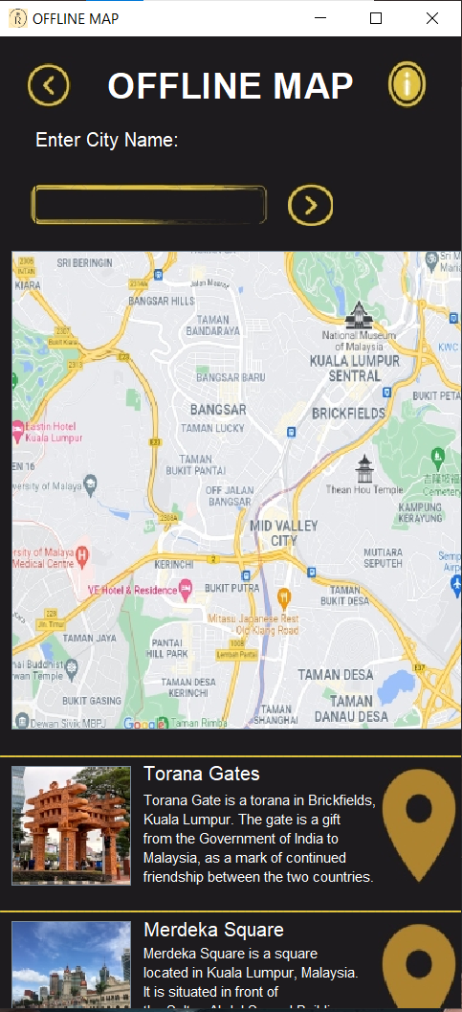

Frame 6: Offline Map Screen

/* A downloadable offline map where users can utilize when in an area with not wifi signal

* Things involved in independent learning:

* 1. html tag

* description2.setText("<html>Merdeka Square is a square <br />"

+ "<html> located in Kuala Lumpur, Malaysia. <br />"

+ "<html>It is situated in front of <br />"

+ "<html> the Sultan Abdul Samad Building.<br />");

- for text wrapping and formatting

* Coded by Michelle

*/

**import** java.awt.Color;

**import** java.awt.Font;

**import** java.awt.event.ActionEvent;

**import** java.awt.event.ActionListener;

**import** javax.swing.*;

**public** **class** OfflineMap {

Font TitleFont = **new** Font("Helveticish",Font.***BOLD***,30);

Font SubTitleFont= **new** Font("Glacial Indifference", Font.***PLAIN***,16);

Font BodyTextFont = **new** Font ("Argrandir Medium", Font.***PLAIN***,12);

Color darkGray = **new** Color(29,27,30);

Color lightGrey = **new** Color (113,114,115);

Color gold = **new** Color (225,195,64);

Color white = **new** Color (255,255,255);

ImageIcon LeftButton = **new** ImageIcon(OfflineMap.**class**.getResource ("left arrow.jpg"));

ImageIcon RightButton = **new** ImageIcon(OfflineMap.**class**.getResource ("right arrow.jpg"));

ImageIcon InfoButton = **new** ImageIcon(OfflineMap.**class**.getResource ("Info button.jpg"));

ImageIcon DownButton = **new** ImageIcon(OfflineMap.**class**.getResource ("down button.jpg"));

ImageIcon AppIcon = **new** ImageIcon(OfflineMap.**class**.getResource ("AppIcon.png"));

ImageIcon KualaLumpur = **new** ImageIcon(OfflineMap.**class**.getResource ("KualaLumpur Map.jpg"));

ImageIcon ToranaGate = **new** ImageIcon(OfflineMap.**class**.getResource ("Torana Gates.jpg"));

ImageIcon LocationButton = **new** ImageIcon(OfflineMap.**class**.getResource ("LocationButton.jpg"));

ImageIcon MerdekaSquare = **new** ImageIcon(OfflineMap.**class**.getResource ("MerdekaSquare.jpg"));

ImageIcon Border = **new** ImageIcon(SELECTION.**class**.getResource ("border.png"));

**public** OfflineMap() {

JLabel Title = **new** JLabel();

Title.setText("OFFLINE MAP");

Title.setBounds(90,-360,500,800);

Title.setFont(TitleFont);

Title.setForeground(white);

Title.setVisible(**true**);

JButton leftButton = **new** JButton(LeftButton);

leftButton.setBackground(darkGray);

leftButton.setBorder(BorderFactory.*createLineBorder*(darkGray));

leftButton.setVisible(**true**);

leftButton.setBounds(0,0,80,80);

JButton infoButton = **new** JButton(InfoButton);

infoButton.setBackground(darkGray);

infoButton.setBorder(BorderFactory.*createLineBorder*(darkGray));

infoButton.setVisible(**true**);

infoButton.setBounds(300,0,80,80);

JButton rightButton = **new** JButton(RightButton);

rightButton.setBackground(darkGray);

rightButton.setBorder(BorderFactory.*createLineBorder*(darkGray));

rightButton.setVisible(**true**);

rightButton.setBounds(240,120,40,40);

JLabel Border1 = **new** JLabel(Border);

Border1.setVisible(**true**);

Border1.setBounds(0,120,250,40);

JLabel CityName = **new** JLabel();

CityName.setText("Enter City Name:");

CityName.setBounds(30,60,400,50);

CityName.setFont(SubTitleFont);

CityName.setForeground(white);

JTextField cityName = **new** JTextField();

cityName.setBounds(30,120,250,40);

cityName.setBackground(darkGray);

cityName.setFont(BodyTextFont);

cityName.setForeground(gold);

cityName.setBorder(BorderFactory.*createLineBorder*(darkGray));

cityName.setOpaque(**false**);

cityName.setVisible(**true**);

JButton map = **new** JButton(KualaLumpur);

map.setBounds(10,180,400,400);

map.setBackground(darkGray);

map.setVisible(**true**);

JLabel line = **new** JLabel();

line.setText("___________________________________________________________________");

line.setBounds(0,570,400,50);

line.setForeground(gold);

JButton toranaGates = **new** JButton(ToranaGate);

toranaGates.setBounds(10,610,100,100);

toranaGates.setBackground(darkGray);

toranaGates.setVisible(**true**);

JLabel landmark1 = **new** JLabel();

landmark1.setText("Torana Gates");

landmark1.setBounds(120,590,400,50);

landmark1.setForeground(white);

landmark1.setFont(SubTitleFont);

JLabel description1 = **new** JLabel();

description1.setText("<html>Torana Gate is a torana in Brickfields, <br />"

+ "<html>Kuala Lumpur. The gate is a gift <br />"

+ "<html>from the Government of India to<br />"

+ "<html> Malaysia, as a mark of continued <br />"

+ " <html>friendship between the two countries. <br />" );

description1.setBounds(120,620,250,100);

description1.setForeground(white);

description1.setFont(BodyTextFont);

JButton Location1 = **new** JButton(LocationButton);

Location1.setBounds(315,610,70,100);

Location1.setBackground(darkGray);

Location1.setBorder(BorderFactory.*createLineBorder*(darkGray));

Location1.setVisible(**true**);

JLabel line2 = **new** JLabel();

line2.setText("___________________________________________________________________");

line2.setBounds(0,700,400,50);

line2.setForeground(gold);

JButton merdekaSquare = **new** JButton(MerdekaSquare);

merdekaSquare.setBounds(10,740,100,100);

merdekaSquare.setBackground(darkGray);

merdekaSquare.setVisible(**true**);

JLabel landmark2 = **new** JLabel();

landmark2.setText("Merdeka Square");

landmark2.setBounds(120,720,400,50);

landmark2.setForeground(white);

landmark2.setFont(SubTitleFont);

JLabel description2 = **new** JLabel();

description2.setText("<html>Merdeka Square is a square <br />"

+ "<html> located in Kuala Lumpur, Malaysia. <br />"

+ "<html>It is situated in front of <br />"

+ "<html> the Sultan Abdul Samad Building.<br />");

description2.setBounds(120,740,250,100);

description2.setForeground(white);

description2.setFont(BodyTextFont);

JButton Location2 = **new** JButton(LocationButton);

Location2.setBounds(315,740,70,100);

Location2.setBackground(darkGray);

Location2.setBorder(BorderFactory.*createLineBorder*(darkGray));

Location2.setVisible(**true**);

**final** JFrame frame = **new** JFrame();

frame.setTitle("OFFLINE MAP");

frame.setIconImage(AppIcon.getImage());

frame.setLayout(**null**);

frame.setSize(400,850);

frame.setLocationRelativeTo(**null**);

frame.setDefaultCloseOperation(JFrame.***EXIT_ON_CLOSE***);

frame.setVisible(**true**);

frame.getContentPane().setBackground(darkGray);

frame.add(Title);

frame.add(leftButton);

frame.add(infoButton);

frame.add(CityName);

frame.add(cityName);

frame.add(rightButton);

frame.add(map);

frame.add(line);

frame.add(toranaGates);

frame.add(landmark1);

frame.add(description1);

frame.add(Location1);

frame.add(line2);

frame.add(merdekaSquare);

frame.add(landmark2);

frame.add(description2);

frame.add(Location2);

frame.add(Border1);

leftButton.addActionListener (**new** ActionListener() {

**public** **void** actionPerformed (ActionEvent press) {

**new** Home();

frame.dispose();

}

});

}

**public** **static** **void** main(String[]args) {

**new** OfflineMap();

}

}

### Frame 7

Route screen where users can choose their destination and boarding location to start their journey.

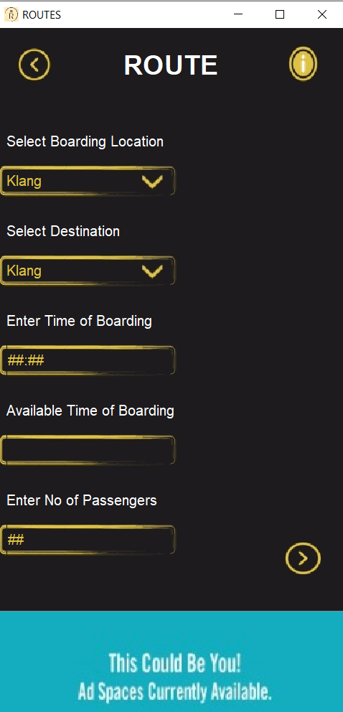

Frame 7: Route Screen

/* Screen where users can enter their boarding location, destination and PAX

* Based on boarding time input, the screen will display the estimated time of arrival

* Things involved in independent learning:

* 1. Formatted JTextField

* JFormattedTextField noPassenger = new JFormattedTextField();

* - allow only numbers to be typed

* 2. MaskFormatter

* MaskFormatter mf = new MaskFormatter("##:##");

* - set placeholder text in text field

* 3. Custom JComboBox

* - allow JComboBox to fit in with the background

* 4. setOpaque

* LocationComboBox.setOpaque(false);

* - toggle object transparency

* - for designing purposes and to customize JComboBox

* Coded by Michelle

* Aided by Xiwei to customise JComboBox and fix issues related to available time of boarding not showing up properly

*/

**import** java.awt.Color;

**import** java.awt.Font;

**import** java.awt.event.ActionListener;

**import** java.awt.event.ActionEvent;

**import** javax.swing.text.*;

**import** javax.swing.*;

**import** javax.swing.DefaultListCellRenderer;

**import** javax.swing.JComboBox;

**import** javax.swing.JFrame;

**import** javax.swing.JLabel;

**import** javax.swing.JList;

**import** javax.swing.plaf.basic.BasicComboBoxUI;

**import** java.awt.Component;

**public** **class** SELECTION **implements** ActionListener {

Font TitleFont = **new** Font("Helveticish",Font.***BOLD***,30);

Font SubTitleFont= **new** Font("Glacial Indifference", Font.***PLAIN***,16);

Font BodyTextFont = **new** Font ("Argrandir Medium", Font.***PLAIN***,16);

Color darkGray = **new** Color(29,27,30);

Color lightGrey = **new** Color (113,114,115);

Color gold = **new** Color (225,195,64);

Color white = **new** Color (255,255,255);

ImageIcon LeftButton = **new** ImageIcon(SELECTION.**class**.getResource ("left arrow.jpg"));

ImageIcon RightButton = **new** ImageIcon(SELECTION.**class**.getResource ("right arrow.jpg"));

ImageIcon InfoButton = **new** ImageIcon(SELECTION.**class**.getResource ("Info button.jpg"));

ImageIcon DownButton = **new** ImageIcon(SELECTION.**class**.getResource ("down button.jpg"));

ImageIcon AppIcon = **new** ImageIcon(SELECTION.**class**.getResource ("AppIcon.png"));

ImageIcon Ads = **new** ImageIcon(SELECTION.**class**.getResource ("Advertisement.jpg"));

ImageIcon Border = **new** ImageIcon(SELECTION.**class**.getResource ("border.png"));

JFormattedTextField TOB = **new** JFormattedTextField();

JTextField ATOB = **new** JTextField();

**class** test4 **extends** DefaultListCellRenderer {

//custom combo box list + drop down button

JLabel a = **new** JLabel();

**public** test4() {

a.setOpaque(**true**);

a.setFont(**new** Font("Calibri",Font.***PLAIN***,16));

a.setBackground(**new** Color(46,46,46));

a.setForeground(**new** Color(223,195,64));

}

**public** Component getListCellRendererComponent(JList list, Object value, **int** index, **boolean** isSelected, **boolean** cellHasFocus) {

a.setText(value.toString());

**return** a;

}

}

**class** CbUI **extends** BasicComboBoxUI {

**protected** JButton createArrowButton() {

**final** JButton button = **new** JButton(**new** ImageIcon("DownButton"));

button.setName("ComboBox.arrowButton"); //Mandatory

button.setOpaque(**false**);

button.setContentAreaFilled(**false**); //no fill

button.setBorder(**null**); //no border

button.setFocusable(**false**);

button.setFocusPainted(**false**);

**return** button;

}

}

**public** SELECTION() {

JLabel Title = **new** JLabel();

Title.setText("ROUTE");

Title.setBounds(140,-360,500,800);

Title.setFont(TitleFont);

Title.setForeground(white);

Title.setVisible(**true**);

JLabel BoardingLocation = **new** JLabel();

BoardingLocation.setText("Select Boarding Location");

BoardingLocation.setBounds(10,100,400,50);

BoardingLocation.setFont(SubTitleFont);

BoardingLocation.setForeground(white);

JLabel Destination = **new** JLabel();

Destination.setText("Select Destination");

Destination.setBounds(10,200,400,50);

Destination.setFont(SubTitleFont);

Destination.setForeground(white);

JLabel DesiredTOB = **new** JLabel();

DesiredTOB.setText("Enter Time of Boarding");

DesiredTOB.setBounds(10,300,400,50);

DesiredTOB.setFont(SubTitleFont);

DesiredTOB.setForeground(white);

JLabel AvailableTOB = **new** JLabel();

AvailableTOB.setText("Available Time of Boarding");

AvailableTOB.setBounds(10,400,400,50);

AvailableTOB.setFont(SubTitleFont);

AvailableTOB.setForeground(white);

JLabel NoPassenger = **new** JLabel();

NoPassenger.setText("Enter No of Passengers");

NoPassenger.setBounds(10,500,400,50);

NoPassenger.setFont(SubTitleFont);

NoPassenger.setForeground(white);

JButton leftButton = **new** JButton(LeftButton);

leftButton.setBackground(darkGray);

leftButton.setBorder(BorderFactory.*createLineBorder*(darkGray));

leftButton.setVisible(**true**);

leftButton.setBounds(0,0,80,80);

JButton infoButton = **new** JButton(InfoButton);

infoButton.setBackground(darkGray);

infoButton.setBorder(BorderFactory.*createLineBorder*(darkGray));

infoButton.setVisible(**true**);

infoButton.setBounds(300,0,80,80);

JButton rightButton = **new** JButton(RightButton);

rightButton.setBackground(darkGray);

rightButton.setBorder(BorderFactory.*createLineBorder*(darkGray));

rightButton.setVisible(**true**);

rightButton.setBounds(300,550,80,80);

rightButton.addActionListener(**this**);

JButton downButton1 = **new** JButton(DownButton);

downButton1.setBackground(darkGray);

downButton1.setBorder(BorderFactory.*createLineBorder*(darkGray));

downButton1.setVisible(**true**);

downButton1.setBounds(160,160,25,25);

String Location[]= {"Klang","KL Sentral","Batu Caves","Kajang",

"Port Klang","Tanjung Malim","Nilai","Seremban","Sungai Buloh",

"Subang Jaya","Shah Alam"};

JLabel Border1 = **new** JLabel(Border);

Border1.setVisible(**true**);

Border1.setBounds(0,150,200,40);

JLabel Border2 = **new** JLabel(Border);

Border2.setVisible(**true**);

Border2.setBounds(0,250,200,40);

JLabel Border3 = **new** JLabel(Border);

Border3.setVisible(**true**);

Border3.setBounds(0,350,200,40);

JLabel Border4 = **new** JLabel(Border);

Border4.setVisible(**true**);

Border4.setBounds(0,450,200,40);

JLabel Border5 = **new** JLabel(Border);

Border5.setVisible(**true**);

Border5.setBounds(0,550,200,40);

JComboBox LocationComboBox = **new** JComboBox(Location);

LocationComboBox.setRenderer(**new** test4());

LocationComboBox.setUI(**new** CbUI());

LocationComboBox.setEditable(**true**);

LocationComboBox.getEditor().getEditorComponent().setFont(**new** Font ("Calibri",Font.***PLAIN***,17));

LocationComboBox.getEditor().getEditorComponent().setForeground(gold);

LocationComboBox.getEditor().getEditorComponent().setBackground(**null**);

((JTextField) LocationComboBox.getEditor().getEditorComponent()).setBorder(**null**);

((JTextField) LocationComboBox.getEditor().getEditorComponent()).setOpaque(**false**);

LocationComboBox.getEditor().getEditorComponent().setFocusable(**false**);

LocationComboBox.setBounds(10,150,200,40);

LocationComboBox.setBackground(**null**);

LocationComboBox.setFont(BodyTextFont);

LocationComboBox.setForeground(gold);

LocationComboBox.setOpaque(**false**);

JComboBox DestinationComboBox = **new** JComboBox(Location);

DestinationComboBox.setRenderer(**new** test4());

DestinationComboBox.setUI(**new** CbUI());

DestinationComboBox.setEditable(**true**);

DestinationComboBox.getEditor().getEditorComponent().setFont(**new** Font ("Calibri",Font.***PLAIN***,17));

DestinationComboBox.getEditor().getEditorComponent().setForeground(gold);

DestinationComboBox.getEditor().getEditorComponent().setBackground(**null**);

((JTextField) DestinationComboBox.getEditor().getEditorComponent()).setBorder(**null**);

((JTextField) DestinationComboBox.getEditor().getEditorComponent()).setOpaque(**false**);

DestinationComboBox.getEditor().getEditorComponent().setFocusable(**false**);

DestinationComboBox.setBounds(10,250,200,40);

DestinationComboBox.setBackground(darkGray);

DestinationComboBox.setFont(BodyTextFont);

DestinationComboBox.setForeground(gold);

DestinationComboBox.setOpaque(**false**);

JButton downButton2 = **new** JButton(DownButton);

downButton2 .setBackground(darkGray);

downButton2.setBorder(BorderFactory.*createLineBorder*(darkGray));

downButton2.setVisible(**true**);

downButton2.setBounds(160,260,25,25);

**try** {

MaskFormatter mf = **new** MaskFormatter("##:##");

mf.setPlaceholderCharacter('#');

TOB = **new** JFormattedTextField(mf);

TOB.setColumns(4);

}**catch**(Exception e) {

e.printStackTrace();

}

TOB.setBounds(10,350,200,40);

TOB.setBackground(darkGray);

TOB.setFont(BodyTextFont);

TOB.setForeground(gold);

TOB.setOpaque(**false**);

TOB.setVisible(**true**);

TOB.setBorder(BorderFactory.*createLineBorder*(darkGray));

ATOB.setBounds(10,450,200,40);

ATOB.setBackground(darkGray);

ATOB.setFont(BodyTextFont);

ATOB.setForeground(gold);

ATOB.setBorder(BorderFactory.*createLineBorder*(darkGray));

ATOB.setVisible(**true**);

ATOB.setOpaque(**false**);

JFormattedTextField noPassenger = **new** JFormattedTextField();

**try** {

MaskFormatter mf1 = **new** MaskFormatter("##");

mf1.setPlaceholderCharacter('#');

noPassenger = **new** JFormattedTextField(mf1);

noPassenger.setColumns(2);

}**catch**(Exception a) {

a.printStackTrace();

}

noPassenger.setBounds(10,550,200,40);

noPassenger.setBackground(darkGray);

noPassenger.setFont(BodyTextFont);

noPassenger.setForeground(gold);

noPassenger.setBorder(BorderFactory.*createLineBorder*(darkGray));

noPassenger.setVisible(**true**);

noPassenger.setOpaque(**false**);

JButton ads = **new** JButton(Ads);

ads.setBounds(0,650,400,150);

ads.setBackground(darkGray);

ads.setVisible(**true**);

**final** JFrame frame = **new** JFrame();

frame.setTitle("ROUTES");

frame.setIconImage(AppIcon.getImage());

frame.setLayout(**null**);

frame.setSize(400,800);

frame.setLocationRelativeTo(**null**);

frame.setDefaultCloseOperation(JFrame.***EXIT_ON_CLOSE***);

frame.setVisible(**true**);

frame.add(rightButton);

frame.add(infoButton);

frame.add(BoardingLocation);

frame.add(Destination);

frame.add(DesiredTOB);

frame.add(AvailableTOB);

frame.add(NoPassenger);

frame.add(LocationComboBox);

frame.add(leftButton);

frame.add(Title);

frame.add(downButton1);

frame.add(DestinationComboBox);

frame.add(downButton2);

frame.add(TOB);

frame.add(ATOB);

frame.add(noPassenger);

frame.add(ads);

frame.add(Border1);

frame.add(Border2);

frame.add(Border3);

frame.add(Border4);

frame.add(Border5);

frame.getContentPane().setBackground(darkGray);

leftButton.addActionListener (**new** ActionListener() {

**public** **void** actionPerformed (ActionEvent press) {

**new** Home();

frame.dispose();

}

});

}

**public** **void** actionPerformed(ActionEvent e) {

String Time = TOB.getText();

**if**(Time.trim().equals("09:00")) {

ATOB.setText("09:04");

}

}

**public** **static** **void** main(String[]args) {

**new** SELECTION();

}

}

## Xiwei

### Frame 8, 9 and 10

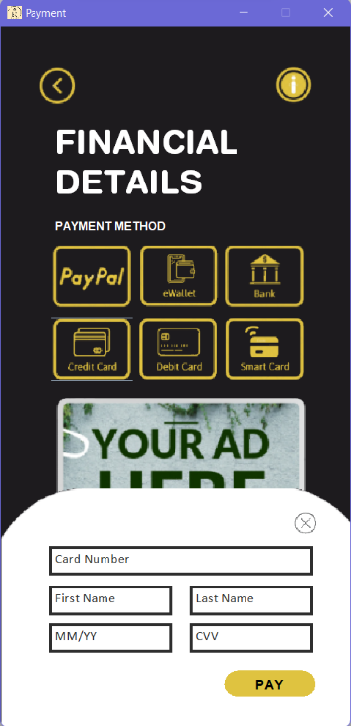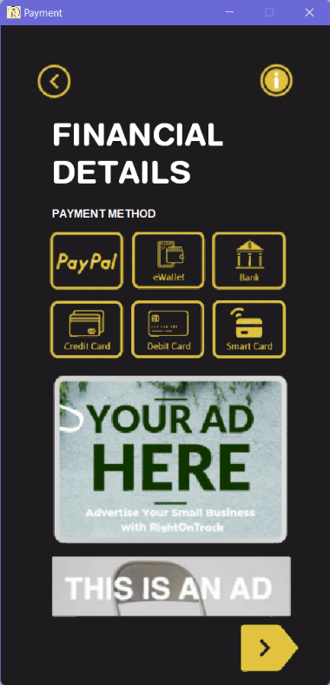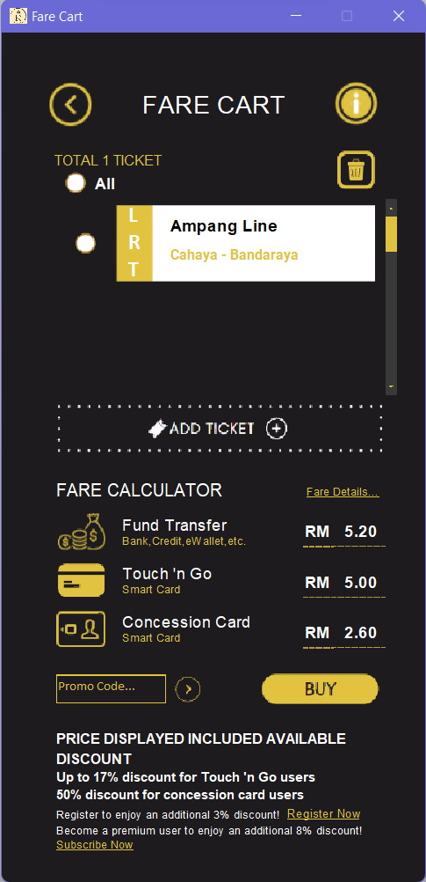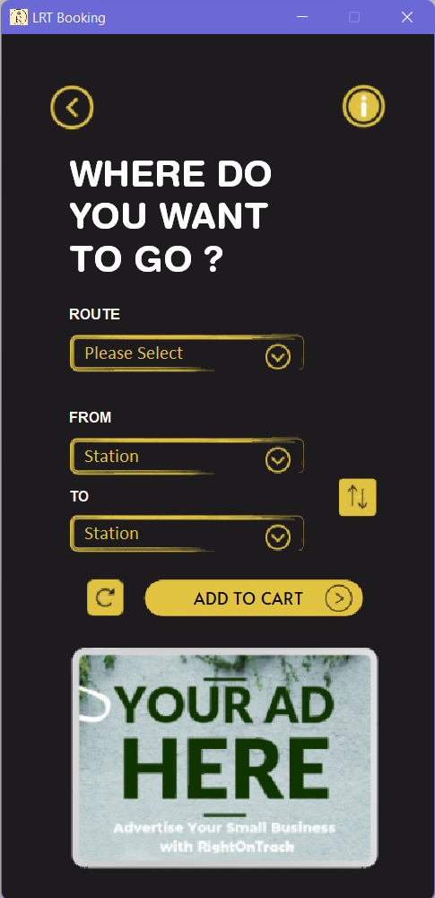Ticket purchasing screens including payment methods and financial details.

Frame 8: Financial Details Screen to Select Payment Methods and Complete Transactions

Frame 9: Add Ticket to Cart

Frame 10: Select Destination of Ticket

/* The tickets screen of the application where users can purchase tickets

* The price of the tickets varies based on the destination as well as boarding station

* A financial details screen is provided to make possible transactions

* Things involved in independent learning includes:

* 1. Timer

* Timer timer = new Timer(10, new ActionListener() {

public void actionPerformed(ActionEvent e) {

long duration = System.currentTimeMillis() - startTime;

double progress = (double)duration / (double)runTime;

if (progress > 1f) {

progress = 1f;

((Timer)e.getSource()).stop();

}

* - to animate

* 2. Custom JComboBox

* - to allow JComboBox to fit in with the background

* 3. JScrollPane

* JScrollPane ticket = new JScrollPane(mainInScroll);

* - to allow scrolling and custom scrollbar colour to match the

* theme

* 4. int diff = Math.abs(fromI - toI);

* - to convert negative number to positive

* 5. HashMap

* Map<TextAttribute, Integer> fontAttributes = new HashMap<TextAttribute, Integer>();

* - to store values

* Coded by Xiwei

*/

**import** java.util.Map;

**import** java.util.HashMap;

**import** java.awt.Font;

**import** java.awt.Color;

**import** java.awt.Component;

**import** java.awt.Dimension;

**import** java.awt.FlowLayout;

**import** java.awt.GridLayout;

**import** java.awt.Point;

**import** java.awt.Rectangle;

**import** java.awt.event.ActionListener;

**import** java.awt.event.ActionEvent;

**import** java.awt.event.MouseAdapter;

**import** java.awt.event.MouseEvent;

**import** java.awt.font.TextAttribute;

**import** java.text.NumberFormat;

**import** java.text.DecimalFormat;

**import** javax.swing.ImageIcon;

**import** javax.swing.JButton;

**import** javax.swing.JComboBox;

**import** javax.swing.JFrame;

**import** javax.swing.JLabel;

**import** javax.swing.JLayeredPane;

**import** javax.swing.JList;

**import** javax.swing.JOptionPane;

**import** javax.swing.JPanel;

**import** javax.swing.JRadioButton;

**import** javax.swing.JScrollPane;

**import** javax.swing.JTextField;

**import** javax.swing.Timer;

**import** javax.swing.UIManager;

**import** javax.swing.border.LineBorder;

**import** javax.swing.plaf.ColorUIResource;

**import** javax.swing.DefaultComboBoxModel;

**import** javax.swing.DefaultListCellRenderer;

**import** javax.swing.plaf.basic.BasicComboBoxUI;

**import** javax.swing.plaf.basic.BasicScrollBarUI;

**public** **class** test2 **extends** JFrame{

ImageIcon logo = **new** ImageIcon("src/applogo.png");

JButton back = **new** JButton(**new** ImageIcon("src/backButton.png"));

JButton info = **new** JButton(**new** ImageIcon("src/info.png"));

JFrame fare = **new** JFrame();

JFrame pay = **new** JFrame();

String b,b2,b3;

String LRTroute[]={" Please Select", " Ampang Line", " Sri Petaling Line", " Kelana Jaya Line"};

JComboBox routeCB=**new** JComboBox(LRTroute);

JComboBox toCB =**new** JComboBox();

JComboBox fromCB =**new** JComboBox();

JTextField error = **new** JTextField("*Invalid Promo Code");

**int** e = 0 , f = 0;

**int** fromI,toI;

**double** oriPrice, price12, price50;

**public** test2() {

JButton swap = **new** JButton(**new** ImageIcon("src/swap.png"));

JButton reset = **new** JButton(**new** ImageIcon("src/reset.png"));

JButton addB = **new** JButton(**new** ImageIcon("src/addButton.png"));

JLabel heading = **new** JLabel("<html>WHERE DO <br> YOU WANT <br> TO GO ? </html>"), body = **new** JLabel("ROUTE"), body2 = **new** JLabel("FROM"),

body3 = **new** JLabel("TO"), cart = **new** JLabel("ADD TO CART");

JLabel cbBox = **new** JLabel((**new** ImageIcon("src/cb.png"))), cbBox2 = **new** JLabel((**new** ImageIcon("src/cb.png"))), cbBox3 = **new** JLabel((**new** ImageIcon("src/cb.png"))),

ad = **new** JLabel((**new** ImageIcon("src/ad1.png")));

//label

heading.setForeground(**new** Color(255,255,255));

heading.setFont(**new** Font("Helvetica Rounded",Font.***BOLD***,32));

heading.setBounds(60, 37, 300, 250 );

body.setForeground(**new** Color(255,255,255));

body.setFont(**new** Font("Glacial Indifference",Font.***BOLD***,13));

body.setBounds(60, 225, 100, 50 );

body2.setForeground(**new** Color(255,255,255));

body2.setFont(**new** Font("Glacial Indifference",Font.***BOLD***,13));

body2.setBounds(60, 317, 100, 50);

body3.setForeground(**new** Color(255,255,255));

body3.setFont(**new** Font("Glacial Indifference",Font.***BOLD***,13));

body3.setBounds(60, 387, 100, 50);

cart.setForeground(**new** Color(0,0,0));

cart.setFont(**new** Font("Alata",Font.***PLAIN***,15));

cart.setBounds(171, 486, 210, 35);

cbBox.setBounds(56, 260, 220, 50);

cbBox2.setBounds(56, 352, 220, 50);

cbBox3.setBounds(56, 421, 220, 50);

ad.setBounds(60, 548, 280, 197);

//combo box

fromCB.addItem(" Station");

fromCB.setBounds(66, 360, 200, 40);

fromCB.setOpaque(**false**);

fromCB.setBorder(**null**);

fromCB.setUI(**new** CbUI());

fromCB.setRenderer(**new** test4());

fromCB.setEditable(**true**);

fromCB.getEditor().getEditorComponent().setFont(**new** Font("Calibri",Font.***PLAIN***,17));

fromCB.getEditor().getEditorComponent().setForeground(**new** Color(223,195,64));

fromCB.getEditor().getEditorComponent().setBackground(**null**);

((JTextField) fromCB.getEditor().getEditorComponent()).setBorder(**null**);

((JTextField) fromCB.getEditor().getEditorComponent()).setOpaque(**false**);

fromCB.getEditor().getEditorComponent().setFocusable(**false**);

toCB.addItem(" Station");

toCB.setBounds(66, 429, 200, 40);

toCB.setOpaque(**false**);

toCB.setBorder(**null**);

toCB.setUI(**new** CbUI());

toCB.setRenderer(**new** test4());

toCB.setEditable(**true**);

toCB.getEditor().getEditorComponent().setFont(**new** Font("Calibri",Font.***PLAIN***,17));

toCB.getEditor().getEditorComponent().setForeground(**new** Color(223,195,64));

toCB.getEditor().getEditorComponent().setBackground(**null**);

((JTextField) toCB.getEditor().getEditorComponent()).setBorder(**null**);

((JTextField) toCB.getEditor().getEditorComponent()).setOpaque(**false**);

toCB.getEditor().getEditorComponent().setFocusable(**false**);

routeCB.setBounds(66, 268, 200, 40);

routeCB.setOpaque(**false**);

routeCB.setBorder(**null**);

routeCB.setUI(**new** CbUI());

routeCB.setRenderer(**new** test4()); //important for to implement the custom jcombobox

routeCB.setEditable(**true**);

routeCB.getEditor().getEditorComponent().setFont(**new** Font("Calibri",Font.***PLAIN***,17));

routeCB.getEditor().getEditorComponent().setForeground(**new** Color(223,195,64));

routeCB.getEditor().getEditorComponent().setBackground(**null**);

((JTextField) routeCB.getEditor().getEditorComponent()).setBorder(**null**);

((JTextField) routeCB.getEditor().getEditorComponent()).setOpaque(**false**);

routeCB.getEditor().getEditorComponent().setFocusable(**false**);

routeCB.addActionListener( **new** ActionListener() {

**public** **void** actionPerformed(ActionEvent e) {

String s = (String) routeCB.getSelectedItem();//get the selected item

**switch** (s) {//check for a match

**case** " Kelana Jaya Line":

String From1[] = {" Station", " Putra Heigths", " Subang Alam", " Alam Megah", " USJ 21", " Wawasan", " Taipan", " USJ 7",

" SS18", " SS15", " Subang Jaya", " Glenmarie", " Ara Damansara", " Lembah Subang", " Kelana Jaya", " Taman Bahagia",

" Taman Paramount", " Asia Jaya", " Taman Jaya", " Universiti", " Kerinchi", " Abdullah Hukum", " Bangsar", " KL Sentral",

" Pasar Seni", " Masjid Jamek", " Dang Wangi", " Kampung Baru", " KLCC", " Ampang Park", " Damai", " Dato' Keramat", " Jelatek" ,

" Setiawangsa", " Sri Rampai", " Wangsa Melayu", " Taman Melati", " Gombak" };

String To1[] = {" Station", " Putra Heigths", " Subang Alam", " Alam Megah", " USJ 21", " Wawasan", " Taipan", " USJ 7",

" SS18", " SS15", " Subang Jaya", " Glenmarie", " Ara Damansara", " Lembah Subang", " Kelana Jaya", " Taman Bahagia",

" Taman Paramount", " Asia Jaya", " Taman Jaya", " Universiti", " Kerinchi", " Abdullah Hukum", " Bangsar", " KL Sentral",

" Pasar Seni", " Masjid Jamek", " Dang Wangi", " Kampung Baru", " KLCC", " Ampang Park", " Damai", " Dato' Keramat", " Jelatek" ,

" Setiawangsa", " Sri Rampai", " Wangsa Melayu", " Taman Melati", " Gombak" };

fromCB.setModel(**new** DefaultComboBoxModel(From1));

toCB.setModel(**new** DefaultComboBoxModel(To1));

**break**;

**case** " Sri Petaling Line":

String From2[] = {" Station", " Putra Heigths", " Puchong Prima", " Puchong Perdana", " Bandar Puteri", " Taman Perindustrian Puchong",

" Pusat Bandar Puchong", " IOI Puchong Jaya", " Kinrara", " Alam Sutera", " Muhibbah", " Awan Besar", " Sri Petaling",

" Bukit Jalil", " Sungai Besi", " Bandar Tasik Selatan", " Bandar Tun Razak", " Salak Selatan", " Cheras", " Chan Sow Lin",

" Pudu", " Hang Tuah", " Plaza Rakyat", " Masjid Jamek", " Bandaraya", " Sultan Ismail", " PWTC", " Titiwangsa", " Sentul",

" Sentul Timur" };

String To2[] = {" Station", " Putra Heigths", " Puchong Prima", " Puchong Perdana", " Bandar Puteri", " Taman Perindustrian Puchong",

" Pusat Bandar Puchong", " IOI Puchong Jaya", " Kinrara", " Alam Sutera", " Muhibbah", " Awan Besar", " Sri Petaling",

" Bukit Jalil", " Sungai Besi", " Bandar Tasik Selatan", " Bandar Tun Razak", " Salak Selatan", " Cheras", " Chan Sow Lin",

" Pudu", " Hang Tuah", " Plaza Rakyat", " Masjid Jamek", " Bandaraya", " Sultan Ismail", " PWTC", " Titiwangsa", " Sentul",

" Sentul Timur" };

fromCB.setModel(**new** DefaultComboBoxModel(From2));

toCB.setModel(**new** DefaultComboBoxModel(To2));

**break**;

**case** " Ampang Line":

String From3[] = {" Station", " Ampang", " Cahaya", " Cempaka", " Pandan Indah", " Pandan Jaya", " Maluri", " Miharja",

" Chan Sow Lin", " Pudu", " Hang Tuah", " Plaza Rakyat", " Masjid Jamek", " Bandaraya", " Sultan Ismail", " PWTC",

" Titiwangsa", " Sentul", " Sentul Timur" };

String To3[] = {" Station", " Ampang", " Cahaya", " Cempaka", " Pandan Indah", " Pandan Jaya", " Maluri", " Miharja",

" Chan Sow Lin", " Pudu", " Hang Tuah", " Plaza Rakyat", " Masjid Jamek", " Bandaraya", " Sultan Ismail", " PWTC",

" Titiwangsa", " Sentul", " Sentul Timur" };

fromCB.setModel(**new** DefaultComboBoxModel(From3));

toCB.setModel(**new** DefaultComboBoxModel(To3));

**break**;

**default** :

fromCB.removeAllItems();

toCB.removeAllItems();

fromCB.addItem(" Station");

toCB.addItem(" Station");

**break**;

}

}

});

//button

back.setBounds(40, 43, 45, 45 );

back.setOpaque(**false**);

back.setContentAreaFilled(**false**); //no fill

back.setBorder(**null**); //no border

info.setBounds(300, 43, 45, 45 );

info.setOpaque(**false**);

info.setContentAreaFilled(**false**); //no fill

info.setBorder(**null**); //no border

swap.setBounds(295, 390, 45, 45 );

swap.setOpaque(**false**);

swap.setContentAreaFilled(**false**); //no fill

swap.setBorder(**null**); //no border

swap.addActionListener(**new** ActionListener() {

**public** **void** actionPerformed(ActionEvent e) {

Object i = fromCB.getSelectedItem();

Object i2 = toCB.getSelectedItem();

fromCB.setSelectedItem(i2);

toCB.setSelectedItem(i);

}

});

reset.setBounds(75, 485, 35, 35 );

reset.setOpaque(**false**);

reset.setContentAreaFilled(**false**); //no fill

reset.setBorder(**null**); //no border

reset.addActionListener(**new** ActionListener() {

**public** **void** actionPerformed(ActionEvent e) {

routeCB.setSelectedIndex(0);

fromCB.removeAllItems();

toCB.removeAllItems();

fromCB.addItem(" Station");

toCB.addItem(" Station");

}

});

addB.setBounds(127, 485, 210, 35 );

addB.setOpaque(**false**);

addB.setContentAreaFilled(**false**); //no fill

addB.setBorder(**null**); //no border

addB.addActionListener(**new** ActionListener() {

**public** **void** actionPerformed(ActionEvent e) {

Object i = fromCB.getSelectedItem();

Object i2 = toCB.getSelectedItem();

Object i3 = routeCB.getSelectedItem();

UIManager.*put*("OptionPane.background",**new** ColorUIResource(29,27,30));

UIManager.*put*("Panel.background",**new** ColorUIResource(29,27,30));

JLabel label = **new** JLabel();

label.setFont(**new** Font("Arial", Font.***BOLD***, 13));

label.setForeground(**new** Color(225,225,225));

JButton button = **new** JButton("OK");

button.setBackground(Color.***WHITE***);

button.setForeground(Color.***BLACK***);

button.setFocusable(**false**);

button.addActionListener(**new** ActionListener() {

**public** **void** actionPerformed(ActionEvent actionEvent) {

JOptionPane.*getRootFrame*().dispose();

}

});

JButton[] buttons = { button };

**if** (i == " Station" | i2 == " Station")

{

label.setText("Error: Please select station");

JOptionPane.*showOptionDialog*(**null**, label, "Error", JOptionPane.***OK_OPTION***, JOptionPane.***ERROR_MESSAGE***, **null**, buttons, buttons[0]);

}

**else**

{

dispose();

FareCart();

}

}

});

back.addActionListener (**new** ActionListener() {

**public** **void** actionPerformed (ActionEvent press) {

**new** Home();

dispose();

}

});

add(ad);

add(back);

add(routeCB);

add(fromCB);

add(toCB);

add(cart);

add(body);

add(body2);

add(body3);

add(cbBox);

add(cbBox2);

add(cbBox3);

add(info);

add(heading);

add(swap);

add(reset);

add(addB);

setLayout(**null**);

setTitle("LRT Booking");

setSize(400, 810);

setResizable(**false**);

setLocationRelativeTo(**null**);

setDefaultCloseOperation(JFrame.***EXIT_ON_CLOSE***);

getContentPane().setBackground(**new** Color(29,27,30));

setVisible(**true**);

setIconImage(logo.getImage());

}

**public** **void** FareCart() {

back.addActionListener( **new** ActionListener() {

**public** **void** actionPerformed(ActionEvent e) {

fare.dispose();

add(back);

add(info);

setVisible(**true**);

}

});

JLabel title = **new** JLabel("FARE CART");

title.setForeground(**new** Color(255,255,255));

title.setFont(**new** Font("Glacial Indifference",Font.***PLAIN***,23));

title.setBounds(128, 43, 200, 45);

JLabel miniTitle = **new** JLabel("FARE CALCULATOR");

miniTitle.setForeground(**new** Color(255,255,255));

miniTitle.setFont(**new** Font("Glacial Indifference",Font.***PLAIN***,16));

miniTitle.setBounds(50, 393, 200, 45);

JLabel total = **new** JLabel("TOTAL 1 TICKET");

total.setForeground(**new** Color(223,195,64));

total.setFont(**new** Font("Glacial Indifference",Font.***PLAIN***,13));

total.setBounds(48, 96, 100, 40 );

//ticket part

JPanel mainInScroll = **new** JPanel();

mainInScroll.setBounds(0, 0, 300, 800);

mainInScroll.setVisible(**true**);

mainInScroll.setLayout(**new** FlowLayout());

mainInScroll.setOpaque(**false**);

mainInScroll.setPreferredSize(**new** Dimension(300, 800));

JLayeredPane t2 = **new** JLayeredPane();

t2.setPreferredSize(**new** Dimension(286, 70));

t2.setVisible(**true**);

t2.setLayout(**null**);

t2.setOpaque(**false**);

JScrollPane ticket = **new** JScrollPane(mainInScroll);

ticket.setBounds(45, 152, 315, 178);

ticket.setOpaque(**false**);

ticket.getViewport().setOpaque(**true**);

ticket.setBorder(**null**);

ticket.setViewportBorder(**null**);

ticket.setVisible(**true**);

ticket.getVerticalScrollBar().setPreferredSize(**new** Dimension(10, 197));

ticket.getHorizontalScrollBar().setPreferredSize(**new** Dimension(0, 0));

ticket.getVerticalScrollBar().setUI(**new** ScrollUI());

ticket.getViewport().setBackground(**new** Color(29,27,30));

**final** JRadioButton a1 = **new** JRadioButton();

a1.setBounds(8,23,28,25);

a1.setBackground(**new** Color(29,27,30));

a1.setIcon(**new** ImageIcon("src/rb1.png"));

a1.setSelectedIcon(**new** ImageIcon("src/rb2.png"));

**final** JRadioButton all = **new** JRadioButton();

all.setBounds(53,125,28,25);

all.setBackground(**new** Color(29,27,30));

all.setIcon(**new** ImageIcon("src/rb1.png"));

all.setSelectedIcon(**new** ImageIcon("src/rb2.png"));

all.addActionListener( **new** ActionListener() {

**public** **void** actionPerformed(ActionEvent e) {

**if**(all.isSelected())

a1.setSelected(**true**);

**else**

a1.setSelected(**false**);

}

});

JButton dustbin = **new** JButton(**new** ImageIcon("src/bin.png"));

dustbin.setBounds(305,108,35,35);

dustbin.setOpaque(**false**);

dustbin.setContentAreaFilled(**false**); //no fill

dustbin.setBorder(**null**); //no border

JButton tadd = **new** JButton(**new** ImageIcon("src/addTButton.png"));

tadd.setBounds(50, 337, 300, 45 );

tadd.setOpaque(**false**);

tadd.setContentAreaFilled(**false**); //no fill

tadd.setBorder(**null**); //no border

tadd.addActionListener( **new** ActionListener() {

**public** **void** actionPerformed(ActionEvent e) {

fare.dispose();

back.removeActionListener(**this**);

add(back);

add(info);

setVisible(**true**);

}

});

JLabel bg = **new** JLabel(**new** ImageIcon("src/ticket.png"));

bg.setBounds(50,0,250,70);

JLabel jrAll = **new** JLabel("All");

jrAll.setForeground(**new** Color(255,255,255));

jrAll.setFont(**new** Font("Glacial Indifference",Font.***BOLD***,15));

jrAll.setBounds(85, 117, 100, 40 );

//take the first time select only

**if** (e == f) {

b = (String) routeCB.getItemAt(routeCB.getSelectedIndex());

b2 = (String) fromCB.getItemAt(fromCB.getSelectedIndex());

b3 = (String) toCB.getItemAt(toCB.getSelectedIndex());

fromI = fromCB.getSelectedIndex();

toI = toCB.getSelectedIndex();

e++;

}

routeCB.setSelectedIndex(0);

JLabel head = **new** JLabel(b);

head.setFont(**new** Font("Agrandir Medium",Font.***BOLD***,15));

head.setVisible(**true**);

head.setForeground(**new** Color(0,0,0));

head.setBounds(92,5,200,27);

JLabel sub = **new** JLabel("<html>" + b2 + " -" + b3 + "</html>");

sub.setFont(**new** Font("Roboto",Font.***BOLD***,13));

sub.setForeground(**new** Color(223,195,64));

sub.setBounds(100,25,190,40);

JLabel mode = **new** JLabel("<html>L R T</html>");

mode.setFont(**new** Font("Calibri",Font.***BOLD***,20));

mode.setForeground(**new** Color(255,255,255));

mode.setBounds(61,0,18,65);

t2.add(head,Integer.*valueOf*(2));

t2.add(mode,Integer.*valueOf*(2));

t2.add(sub,Integer.*valueOf*(2));

t2.add(a1,Integer.*valueOf*(2));

t2.add(bg,Integer.*valueOf*(0));

mainInScroll.add(t2);

//ticket part end

//determine price

**double** minPrice = 0.8;

**int** diff = Math.*abs*(fromI - toI); //convert negative num to positive

**if**(diff == 0) {

oriPrice = minPrice;

price12 = minPrice ;

price50 = minPrice;

}

**else** {

oriPrice = minPrice + 0.4*(diff);

price12 = oriPrice - 0.20 ;

price50 = oriPrice * 50/100;

}

//determine price end

//calculator part

JPanel fareCal = **new** JPanel();

fareCal.setBounds(50, 435, 45, 128);

fareCal.setVisible(**true**);

fareCal.setLayout(**new** GridLayout(3,1,0,5));

fareCal.setOpaque(**false**);

JLabel funds = **new** JLabel(**new** ImageIcon("src/money.png"));

JLabel card = **new** JLabel(**new** ImageIcon("src/card.png"));

JLabel concesCard = **new** JLabel(**new** ImageIcon("src/conCard.png"));

fareCal.add(funds);

fareCal.add(card);

fareCal.add(concesCard);

JLabel payType = **new** JLabel("Fund Transfer");

payType.setFont(**new** Font("Agrandir Medium",Font.***PLAIN***,15));

payType.setForeground(**new** Color(255,255,255));

payType.setBounds(110,422,150,50);

JLabel etc = **new** JLabel("Bank,Credit,eWallet,etc.");

etc.setFont(**new** Font("Agrandir Narrow",Font.***PLAIN***,10));

etc.setForeground(**new** Color(223,195,64));

etc.setBounds(110,437,150,50);

JLabel payType2 = **new** JLabel("Touch 'n Go");

payType2.setFont(**new** Font("Agrandir Medium",Font.***PLAIN***,15));

payType2.setForeground(**new** Color(255,255,255));

payType2.setBounds(110,466,150,50);

JLabel etc2 = **new** JLabel("Smart Card");

etc2.setFont(**new** Font("Agrandir Narrow",Font.***PLAIN***,10));

etc2.setForeground(**new** Color(223,195,64));

etc2.setBounds(110,481,140,50);

JLabel payType3 = **new** JLabel("Concession Card");

payType3.setFont(**new** Font("Agrandir Medium",Font.***PLAIN***,15));

payType3.setForeground(**new** Color(255,255,255));

payType3.setBounds(110,510,140,50);

JLabel etc3 = **new** JLabel("Smart Card");

etc3.setFont(**new** Font("Agrandir Narrow",Font.***PLAIN***,10));

etc3.setForeground(**new** Color(223,195,64));

etc3.setBounds(110,525,140,50);

JLabel bodyText = **new** JLabel("<html>PRICE DISPLAYED INCLUDED AVAILABLE DISCOUNT</html>");

bodyText.setFont(**new** Font("Helvetica Regular",Font.***BOLD***,13));

bodyText.setForeground(**new** Color(255,255,255));

bodyText.setBounds(50,625,300,50);

JLabel bodyText2 = **new** JLabel("<html>Up to 17% discount for Touch 'n Go users<br>50% discount for concession card users</html>");

bodyText2.setFont(**new** Font("Glacial Indifference",Font.***BOLD***,12));

bodyText2.setForeground(**new** Color(255,255,255));

bodyText2.setBounds(50,659,300,50);

JLabel bodyText3 = **new** JLabel("<html>Register to enjoy an additional 3% discount!<br>Become a premium user to enjoy an additional 8% discount!</html>");

bodyText3.setFont(**new** Font("Agrandir Narrow",Font.***PLAIN***,10));

bodyText3.setForeground(**new** Color(255,255,255));

bodyText3.setBounds(50,693,300,50);

JLabel dottedLine = **new** JLabel(**new** ImageIcon("src/line.png"));

dottedLine.setBounds(275,462,75,10);

JLabel dottedLine2 = **new** JLabel(**new** ImageIcon("src/line.png"));

dottedLine2.setBounds(275,508,75,10);

JLabel dottedLine3 = **new** JLabel(**new** ImageIcon("src/line.png"));

dottedLine3.setBounds(275,554,75,10);

//mapping between a key and a value

Map<TextAttribute, Integer> fontAttributes = **new** HashMap<TextAttribute, Integer>();

fontAttributes.put(TextAttribute.***UNDERLINE***, TextAttribute.***UNDERLINE_ON***);

JButton details = **new** JButton("Fare Details...");

details.setBounds(246,405,130,25);

details.setOpaque(**false**);

details.setContentAreaFilled(**false**); //no fill

details.setBorder(**null**); //no border

details.setFocusable(**false**);

details.setForeground(**new** Color(223,195,64));

details.setFont(**new** Font("Agrandir Narrow",Font.***PLAIN***,10).deriveFont(fontAttributes));

JButton register = **new** JButton("Register Now");

register.setBounds(243,697,100,25);

register.setOpaque(**false**);

register.setContentAreaFilled(**false**); //no fill

register.setBorder(**null**); //no border

register.setFocusable(**false**);

register.setForeground(**new** Color(223,195,64));

register.setFont(**new** Font("Agrandir Narrow",Font.***PLAIN***,11).deriveFont(fontAttributes));

JButton subscribe = **new** JButton("Subscribe Now");

subscribe.setBounds(50,726,70,25);

subscribe.setOpaque(**false**);

subscribe.setContentAreaFilled(**false**); //no fill

subscribe.setBorder(**null**); //no border

subscribe.setFocusable(**false**);

subscribe.setForeground(**new** Color(223,195,64));

subscribe.setFont(**new** Font("Agrandir Narrow",Font.***PLAIN***,10).deriveFont(fontAttributes));

JButton buy = **new** JButton(**new** ImageIcon("src/buy.png"));

buy.setBounds(220,580,135,35);

buy.setOpaque(**false**);

buy.setContentAreaFilled(**false**); //no fill

buy.setBorder(**null**); //no border

buy.setFocusable(**false**);

buy.addActionListener( **new** ActionListener() {

**public** **void** actionPerformed(ActionEvent e) {

fare.dispose();

Payment();

}

});

**final** JTextField promo = **new** JTextField();

promo.setBounds(50, 584, 100, 26);

promo.setBackground(**new** Color(29,27,30));

promo.setBorder(**new** LineBorder(**new** Color(223,195,64)));

promo.setText("Promo Code...");

promo.setFont(**new** Font("Calibri",Font.***PLAIN***,12));

promo.setForeground(**new** Color(223,195,64));

promo.setCaretColor(**new** Color(223,195,64));

promo.addMouseListener(**new** MouseAdapter(){

**public** **void** mouseClicked(MouseEvent e){

promo.setText("");

promo.getCaret().setVisible(**true**);

promo.setEditable(**true**);

}

});

JButton next = **new** JButton(**new** ImageIcon("src/nxt2.png"));

next.setBounds(157,584,25,25);

next.setOpaque(**false**);

next.setContentAreaFilled(**false**); //no fill

next.setBorder(**null**); //no border

next.addActionListener(**new** ActionListener() {

**public** **void** actionPerformed(ActionEvent e) {

error.setFont(**new** Font("Agrandir Narrow",Font.***PLAIN***,10));

error.setForeground(**new** Color(255,106,106));

error.setBounds(50, 612, 100, 20);

error.getCaret().setVisible(**false**);

error.setEditable(**false**);

error.setBorder(**null**);

error.setBackground(**new** Color(29,27,30));

**if**(promo.getText().equals("")| promo.getText().equals(" ") | promo.getText().equals("Promo Code...")){

error.setText("");

}

**else**

error.setText("*Invalid Promo Code");

}

});

NumberFormat nf = **new** DecimalFormat("#0.00"); // setting 2 decimal

JTextField price1 = **new** JTextField("RM " + nf.format(oriPrice));

price1.setBounds(276,438,100, 30);

price1.setBackground(**new** Color(29,27,30));

price1.setBorder(**null**);

price1.setFont(**new** Font("Agrandir Medium",Font.***BOLD***,15));

price1.setForeground(**new** Color(255,255,255));

price1.getCaret().setVisible(**false**);

price1.setEditable(**false**);

JTextField price2 = **new** JTextField("RM " + nf.format(price12));

price2.setBounds(276,484,100, 30);

price2.setBackground(**new** Color(29,27,30));

price2.setBorder(**null**);

price2.setFont(**new** Font("Agrandir Medium",Font.***BOLD***,15));

price2.setForeground(**new** Color(255,255,255));

price2.getCaret().setVisible(**false**);

price2.setEditable(**false**);

JTextField price3 = **new** JTextField("RM " + nf.format(price50));

price3.setBounds(276,530,100, 30);

price3.setBackground(**new** Color(29,27,30));

price3.setBorder(**null**);

price3.setFont(**new** Font("Agrandir Medium",Font.***BOLD***,15));

price3.setForeground(**new** Color(255,255,255));

price3.getCaret().setVisible(**false**);

price3.setEditable(**false**);

//calculator part end

//frame add & settings

fare.setLayout(**null**);

fare.setTitle("Fare Cart");

fare.setSize(400, 810);

fare.setResizable(**false**);

fare.setLocationRelativeTo(**null**);

fare.setDefaultCloseOperation(JFrame.***EXIT_ON_CLOSE***);

fare.getContentPane().setBackground(**new** Color(29,27,30));

fare.setVisible(**true**);

fare.setIconImage(logo.getImage());

fare.addMouseListener(**new** MouseAdapter(){

**public** **void** mouseClicked(MouseEvent e){

promo.getCaret().setVisible(**false**);

promo.setEditable(**false**);

**if** (promo.getText().equals("")| promo.getText().equals(" "))

promo.setText("Promo Code...");

}

});

fare.add(details);

fare.add(register);

fare.add(subscribe);

fare.add(bodyText);

fare.add(bodyText2);

fare.add(bodyText3);

fare.add(dottedLine);

fare.add(dottedLine2);

fare.add(dottedLine3);

fare.add(price1);

fare.add(price2);

fare.add(price3);

fare.add(buy);

fare.add(next);

fare.add(miniTitle);

fare.add(dustbin);

fare.add(jrAll);

fare.add(all);

fare.add(tadd);

fare.add(total);

fare.add(info);

fare.add(back);

fare.add(ticket);

fare.add(title);

fare.add(fareCal);

fare.add(promo);

fare.add(payType);

fare.add(etc);

fare.add(payType2);

fare.add(etc2);

fare.add(payType3);

fare.add(etc3);

fare.add(error);

}

**public** **void** Payment() {

pay.setLayout(**null**);

pay.setTitle("Payment");

pay.setSize(400, 810);

pay.setResizable(**false**);

pay.setLocationRelativeTo(**null**);

pay.setDefaultCloseOperation(JFrame.***EXIT_ON_CLOSE***);

pay.getContentPane().setBackground(**new** Color(29,27,30));

pay.setVisible(**true**);

pay.setIconImage(logo.getImage());

JButton back2 = **new** JButton(**new** ImageIcon("src/backButton.png"));

back2.setBounds(40, 43, 45, 45 );

back2.setOpaque(**false**);

back2.setContentAreaFilled(**false**); //no fill

back2.setBorder(**null**); //no border

back2.setFocusable(**false**);

back2.addActionListener( **new** ActionListener() {

**public** **void** actionPerformed(ActionEvent e) {

pay.dispose();

FareCart();

}

});

//attempt animation start

JPanel credit = **new** JPanel();

credit.setBackground(**null**);

credit.setOpaque(**false**);

credit.setVisible(**true**);

credit.setLayout(**null**);

credit.setBounds(50,810,398,300);

JLabel bg2 = **new** JLabel(**new** ImageIcon("src/bg2.png"));

bg2.setBounds(0,0,398,266);

JLabel text = **new** JLabel("PAY");

text.setFont(**new** Font("Agrandir Medium",Font.***BOLD***,15));

text.setForeground(**new** Color(0,0,0));

text.setBounds(280, 200, 50, 30 );

JButton payy = **new** JButton();

payy.setBounds(246, 200, 100, 30 );

payy.setOpaque(**false**);

payy.setContentAreaFilled(**false**); //no fill

payy.setVisible(**true**);

payy.setBorder(**new** LineBorder(**new** Color(223,195,64), 30, **true**));

**final** JTextField cardNum = **new** JTextField(" Card Number");

**final** JTextField fName = **new** JTextField(" First Name");

**final** JTextField lName = **new** JTextField(" Last Name");

**final** JTextField expDate = **new** JTextField(" MM/YY");

**final** JTextField cvv = **new** JTextField(" CVV");

cardNum.setBounds(53, 64, 290, 32);

cardNum.setBackground(**new** Color(255,255,255));

cardNum.setBorder(**new** LineBorder(**new** Color(46,46,46), 3));

cardNum.setFont(**new** Font("Calibri",Font.***PLAIN***,15));

cardNum.setForeground(**new** Color(46,46,46));

cardNum.setCaretColor(**new** Color(46,46,46));

cardNum.addMouseListener(**new** MouseAdapter(){

**public** **void** mouseClicked(MouseEvent e){

cardNum.setText(" ");

cardNum.getCaret().setVisible(**true**);

cardNum.setEditable(**true**);

**if** (fName.getText().equals("") | fName.getText().equals(" ") | cvv.getText().equals("")|cvv.getText().equals("")|

lName.getText().equals("")|lName.getText().equals("")| expDate.getText().equals("")|expDate.getText().equals("")) {

fName.setText(" First Name");

cvv.setText(" CVV");

lName.setText(" Last Name");

expDate.setText(" MM/YY");

}

}

});

fName.setBounds(53, 107, 135, 32);

fName.setBackground(**new** Color(255,255,255));

fName.setBorder(**new** LineBorder(**new** Color(46,46,46), 3));

fName.setFont(**new** Font("Calibri",Font.***PLAIN***,15));

fName.setForeground(**new** Color(46,46,46));

fName.setCaretColor(**new** Color(46,46,46));

fName.addMouseListener(**new** MouseAdapter(){

**public** **void** mouseClicked(MouseEvent e){

fName.setText(" ");

fName.getCaret().setVisible(**true**);

fName.setEditable(**true**);

**if** (cardNum.getText().equals("") | cardNum.getText().equals(" ") | cvv.getText().equals("")|cvv.getText().equals("")|

lName.getText().equals("")|lName.getText().equals("")| expDate.getText().equals("")|expDate.getText().equals("")) {

cardNum.setText(" Card Number");

cvv.setText(" CVV");

lName.setText(" Last Name");

expDate.setText(" MM/YY");

}

}

});

lName.setBounds(208, 107, 135, 32);

lName.setBackground(**new** Color(255,255,255));

lName.setBorder(**new** LineBorder(**new** Color(46,46,46), 3));

lName.setFont(**new** Font("Calibri",Font.***PLAIN***,15));

lName.setForeground(**new** Color(46,46,46));

lName.setCaretColor(**new** Color(46,46,46));

lName.addMouseListener(**new** MouseAdapter(){

**public** **void** mouseClicked(MouseEvent e){

lName.setText(" ");

lName.getCaret().setVisible(**true**);

lName.setEditable(**true**);

**if** (cardNum.getText().equals("") | cardNum.getText().equals(" ") | fName.getText().equals("")|fName.getText().equals(" ")|

cvv.getText().equals("")|cvv.getText().equals(" ")| expDate.getText().equals("")|expDate.getText().equals(" ")) {

cardNum.setText(" Card Number");

fName.setText(" First Name");

cvv.setText(" CVV");

expDate.setText(" MM/YY");

}

}

});

expDate.setBounds(53, 149, 135, 32);

expDate.setBackground(**new** Color(255,255,255));

expDate.setBorder(**new** LineBorder(**new** Color(46,46,46), 3));

expDate.setFont(**new** Font("Calibri",Font.***PLAIN***,15));

expDate.setForeground(**new** Color(46,46,46));

expDate.setCaretColor(**new** Color(46,46,46));

expDate.addMouseListener(**new** MouseAdapter(){

**public** **void** mouseClicked(MouseEvent e){

expDate.setText(" ");

expDate.getCaret().setVisible(**true**);

expDate.setEditable(**true**);

**if** (cardNum.getText().equals("") | cardNum.getText().equals(" ") | fName.getText().equals("")|fName.getText().equals(" ")|

cvv.getText().equals("")|cvv.getText().equals(" ")| lName.getText().equals("")|lName.getText().equals(" ")) {

cardNum.setText(" Card Number");

fName.setText(" First Name");

lName.setText(" Last Name");

cvv.setText(" CVV");

}

}

});

cvv.setBounds(208, 149, 135, 32);

cvv.setBackground(**new** Color(255,255,255));

cvv.setBorder(**new** LineBorder(**new** Color(46,46,46), 3));

cvv.setFont(**new** Font("Calibri",Font.***PLAIN***,15));

cvv.setForeground(**new** Color(46,46,46));

cvv.setCaretColor(**new** Color(46,46,46));

cvv.addMouseListener(**new** MouseAdapter(){

**public** **void** mouseClicked(MouseEvent e){

cvv.setText(" ");

cvv.getCaret().setVisible(**true**);

cvv.setEditable(**true**);

**if** (cardNum.getText().equals("") | cardNum.getText().equals(" ") | fName.getText().equals("")|fName.getText().equals(" ")|

lName.getText().equals("")|lName.getText().equals(" ")| expDate.getText().equals("")|expDate.getText().equals(" ")) {

cardNum.setText(" Card Number");

fName.setText(" First Name");

lName.setText(" Last Name");

expDate.setText(" MM/YY");

}

}

});

Dimension size = **new** Dimension(398,300);

Rectangle from = **new** Rectangle(0, 810, size.width, size.height);

Rectangle to = **new** Rectangle(1, 510, size.width, size.height);

**final** AnimateUp animateUp = **new** AnimateUp(credit, from, to);

JButton close = **new** JButton(**new** ImageIcon("src/cross.png"));

close.setBounds(323, 25, 25, 25 );

close.setOpaque(**false**);

close.setContentAreaFilled(**false**); //no fill

close.setVisible(**true**);

close.setBorder(**null**);

close.addActionListener(**new** ActionListener() {

**public** **void** actionPerformed(ActionEvent e) {

animateUp.exit();

}

});

credit.add(close);

credit.add(text);

credit.add(payy);

credit.add(fName);

credit.add(lName);

credit.add(cvv);

credit.add(expDate);

credit.add(cardNum);

credit.add(bg2);

//attempt animation end

JLabel heading = **new** JLabel("<html>FINANCIAL<br>DETAILS </html>");

heading.setForeground(**new** Color(255,255,255));

heading.setFont(**new** Font("Helvetica Rounded",Font.***BOLD***,37));

heading.setBounds(60, 49, 200, 200 );

JLabel body = **new** JLabel("PAYMENT METHOD");

body.setForeground(**new** Color(255,255,255));

body.setFont(**new** Font("Glacial Indifference",Font.***BOLD***,13));

body.setBounds(60, 195, 200, 50 );

JButton type1 = **new** JButton(**new** ImageIcon("src/p1.png"));

type1.setOpaque(**false**);

type1.setContentAreaFilled(**false**); //no fill

type1.setBorder(**null**); //no border

JButton type2 = **new** JButton(**new** ImageIcon("src/p2.png"));

type2.setOpaque(**false**);

type2.setContentAreaFilled(**false**); //no fill

type2.setBorder(**null**); //no border

JButton type3 = **new** JButton(**new** ImageIcon("src/p3.png"));

type3.setOpaque(**false**);

type3.setContentAreaFilled(**false**); //no fill

type3.setBorder(**null**); //no border

JButton type4 = **new** JButton(**new** ImageIcon("src/p4.png"));

type4.setOpaque(**false**);

type4.setContentAreaFilled(**false**); //no fill

type4.setBorder(**null**); //no border

type4.addActionListener(**new** ActionListener() {

**public** **void** actionPerformed(ActionEvent e) {

animateUp.start();

}

});

JButton type5 = **new** JButton(**new** ImageIcon("src/p5.png"));

type5.setOpaque(**false**);

type5.setContentAreaFilled(**false**); //no fill

type5.setBorder(**null**); //no border

type5.addActionListener(**new** ActionListener() {

**public** **void** actionPerformed(ActionEvent e) {

animateUp.start();

}

});

JButton type6 = **new** JButton(**new** ImageIcon("src/p6.png"));

type6.setOpaque(**false**);

type6.setContentAreaFilled(**false**); //no fill

type6.setBorder(**null**); //no border

JPanel type = **new** JPanel();

type.setLayout(**new** GridLayout(2,3,5,0));

type.setVisible(**true**);

type.setBounds(56, 236, 280, 160);

type.setBackground(**null**);

type.add(type1);

type.add(type2);

type.add(type3);

type.add(type4);

type.add(type5);

type.add(type6);

JLabel ad = **new** JLabel(**new** ImageIcon("src/ad1.png"));

JLabel ad2 = **new** JLabel(**new** ImageIcon("src/ad2.png"));

JPanel advert = **new** JPanel();

advert.setLayout(**new** FlowLayout(FlowLayout.***CENTER***, 10, 5));

advert.setVisible(**true**);

advert.setBounds(60, 405, 280, 290);

advert.setBackground(**null**);

advert.add(ad);

advert.add(ad2);

JButton next = **new** JButton(**new** ImageIcon("src/nxt.png"));

next.setOpaque(**false**);

next.setContentAreaFilled(**false**); //no fill

next.setBorder(**null**); //no border

next.setBounds(280, 690, 70, 72);

pay.add(credit);

pay.add(advert);

pay.add(type);

pay.add(heading);

pay.add(body);

pay.add(next);

pay.add(info);

pay.add(back2);

}

**public** **static** **void** main(String[] args) {

**new** test2();

}

}

**class** test4 **extends** DefaultListCellRenderer {

//custom combo box list + drop down button

JLabel a = **new** JLabel();

**public** test4() {

a.setOpaque(**true**);

a.setFont(**new** Font("Calibri",Font.***PLAIN***,16));

a.setBackground(**new** Color(46,46,46));

a.setForeground(**new** Color(223,195,64));

}

**public** Component getListCellRendererComponent(JList list, Object value, **int** index, **boolean** isSelected, **boolean** cellHasFocus) {

a.setText(value.toString());

**return** a;

}

}

**class** CbUI **extends** BasicComboBoxUI {

**protected** JButton createArrowButton() {

**final** JButton button = **new** JButton(**new** ImageIcon("src/down.png"));

button.setName("ComboBox.arrowButton"); //Mandatory

button.setOpaque(**false**);

button.setContentAreaFilled(**false**); //no fill

button.setBorder(**null**); //no border

button.setFocusable(**false**);

button.setFocusPainted(**false**);

**return** button;

}

}

**class** ScrollUI **extends** BasicScrollBarUI {

//custom scroll bar

**public** ScrollUI() {

UIManager.*put*("ScrollBar.trackHighlightForeground", (**new** Color(57,57,57)));

UIManager.*put*("ScrollBar.thumb", **new** ColorUIResource(**new** Color(223,195,64)));

UIManager.*put*("ScrollBar.thumbDarkShadow", **new** ColorUIResource(**new** Color(223,195,64)));

UIManager.*put*("ScrollBar.thumbShadow", **new** ColorUIResource(**new** Color(223,195,64)));

UIManager.*put*("ScrollBar.thumbHighlight", **new** ColorUIResource(**new** Color(223,195,64)));

UIManager.*put*("ScrollBar.trackForeground", **new** ColorUIResource(**new** Color(57,57,57)));

UIManager.*put*("ScrollBar.trackHighlight", **new** ColorUIResource(**new** Color(57,57,57)));

UIManager.*put*("ScrollBar.track", **new** ColorUIResource(**new** Color(57,57,57)));

UIManager.*put*("ScrollBar.shadow", **new** ColorUIResource(**new** Color(57,57,57)));

UIManager.*put*("ScrollBar.highlight", **new** ColorUIResource(**new** Color(57,57,57)));

}

**protected** JButton createDecreaseButton(**int** orientation) {

JButton button = **super**.createDecreaseButton(orientation);

button.setBorder(**new** LineBorder(**new** Color(57,57,57)));

button.setBackground(**new** Color(57,57,57));

**return** button;

}

**protected** JButton createIncreaseButton(**int** orientation) {

JButton button = **super**.createIncreaseButton(orientation);

button.setBorder(**new** LineBorder(**new** Color(57,57,57)));

button.setBackground(**new** Color(57,57,57));

**return** button;

}

}

**class** AnimateUp {

**static** **final** **int** ***runTime*** = 400;

JPanel panel;

Rectangle from;

Rectangle to;

**long** startTime;

**public** AnimateUp(JPanel paymentType, Rectangle from, Rectangle to) {

**this**.panel = paymentType;

**this**.from = from;

**this**.to = to;

}

**public** **void** start() {

panel.setVisible(**true**);

//timer for the animation (delay time in milliseconds, listener)

Timer timer = **new** Timer(10, **new** ActionListener() {

**public** **void** actionPerformed(ActionEvent e) {

**long** duration = System.*currentTimeMillis*() - startTime; //duration = animation happened time point - start time

**double** progress = (**double**)duration / (**double**)***runTime***; //to keep track of the animation ran time

**if** (progress > 1f) {

progress = 1f;

((Timer)e.getSource()).stop(); //stop animation

}

Rectangle target = *calculateProgress*(from, to, progress); //setting position each milliseconds

panel.setBounds(target);

}

});

timer.setRepeats(**true**);

//timer.setCoalesce(true);

timer.setInitialDelay(0);

startTime = System.*currentTimeMillis*();

timer.start();

}

**public** **void** remove() {

panel.setVisible(**false**);

}

**public** **void** exit() {

panel.setVisible(**true**);

Timer timer = **new** Timer(10, **new** ActionListener() {

**public** **void** actionPerformed(ActionEvent e) {

**long** duration = System.*currentTimeMillis*() - startTime;

**double** progress = (**double**)duration / (**double**)***runTime***;

**if** (progress > 1f) {

progress = 1f;

((Timer)e.getSource()).stop();

}

Rectangle target = *calculateProgress*(to, from, progress);

panel.setBounds(target);

}

});

timer.setRepeats(**true**);

timer.setInitialDelay(0);

startTime = System.*currentTimeMillis*();

timer.start();

}

//from, to, progress refer up

**public** **static** Rectangle calculateProgress(Rectangle start, Rectangle end, **double** progress) {

Rectangle bounds = **new** Rectangle();

**if** (start != **null** && end != **null**) {

bounds.setLocation(*calculateProgress*(start.getLocation(), end.getLocation(), progress));

bounds.setSize(*calculateProgress*(start.getSize(), end.getSize(), progress));

}

**return** bounds; //exit method with the value

}

//location

**public** **static** Point calculateProgress(Point startPoint, Point targetPoint, **double** progress) {

Point point = **new** Point();

**if** (startPoint != **null** && targetPoint != **null**) {

point.x = *calculateProgress*(startPoint.x, targetPoint.x, progress);

point.y = *calculateProgress*(startPoint.y, targetPoint.y, progress);

}

**return** point;

}

//distance move each time interval

**public** **static** **int** calculateProgress(**int** startValue, **int** endValue, **double** fraction) {

**int** value = 0;

**int** distance = endValue - startValue;

value = (**int**)Math.*round*((**double**)distance * fraction);

value += startValue;

**return** value;

}

**public** **static** Dimension calculateProgress(Dimension startSize, Dimension targetSize, **double** progress) {

Dimension size = **new** Dimension();

**if** (startSize != **null** && targetSize != **null**) {

size.width = *calculateProgress*(startSize.width, targetSize.width, progress);

size.height = *calculateProgress*(startSize.height, targetSize.height, progress);

}

**return** size;

}}

### Frame 11

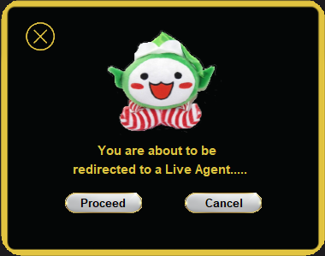Lost and Found Section where users can scroll through items found in public transport to find their lost belongings for claiming.

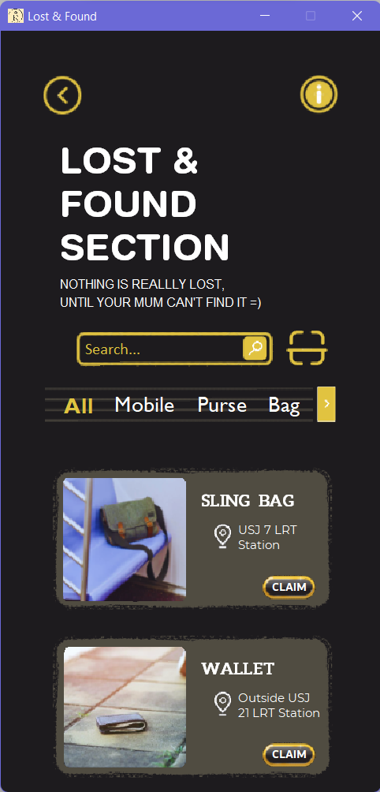

Frame 11: Lost and Found Section

/* Lost & Found Section where users can try their luck in searching for their lost belongings in public transport

* Users can claim the displayed objects once their ownership is proven

* Things involved in independent learning includes:

* 1. JScrollPane

* - to allow scrolling

* 2. JLayeredPane

* JLayeredPane pane = new JLayeredPane();

* 3. html tag

* heading.setText("<html>LOST & <br> FOUND <br> SECTION </html>");

* - for text wrapping and formatting

* Coded by Xiwei

*/

**import** javax.swing.JFrame;

**import** javax.swing.ImageIcon;

**import** javax.swing.ButtonGroup;

**import** javax.swing.JButton;

**import** javax.swing.JLabel;

**import** javax.swing.JTextField;

**import** javax.swing.JToggleButton;

**import** javax.swing.JLayeredPane;

**import** javax.swing.JScrollPane;

**import** java.awt.Color;

**import** java.awt.Dimension;

**import** java.awt.Font;

**import** java.awt.geom.RoundRectangle2D;

**import** java.awt.event.ActionEvent;

**import** java.awt.event.ActionListener;

**import** java.awt.event.ItemEvent;

**import** java.awt.event.ItemListener;

**import** java.awt.event.MouseAdapter;

**import** java.awt.event.MouseEvent;

**public** **class** A2_LFS **implements** ItemListener {

JButton back = **new** JButton(**new** ImageIcon("src/backButton.png")), info = **new** JButton(**new** ImageIcon("src/info.png")),

sIcon = **new** JButton(**new** ImageIcon("src/sIcon.png")), scan = **new** JButton(**new** ImageIcon("src/scan.png")),

next = **new** JButton(**new** ImageIcon("src/next.png")), claim = **new** JButton(**new** ImageIcon("src/cbutton.png")), claim2 = **new** JButton(**new** ImageIcon("src/cbutton.png")),

claim3 = **new** JButton(**new** ImageIcon("src/cbutton.png"));

JLabel heading = **new** JLabel(), subhead = **new** JLabel(), minihead2 = **new** JLabel(), minihead = **new** JLabel(), minihead3 = **new** JLabel(),

mini = **new** JLabel(), mini2 = **new** JLabel(), mini3 = **new** JLabel(), claimT = **new** JLabel("CLAIM"), claimT2 = **new** JLabel("CLAIM"), claimT3 = **new** JLabel("CLAIM");

JLabel search = **new** JLabel(**new** ImageIcon("src/search.png")), search2 = **new** JLabel(**new** ImageIcon("src/search2.png")),

box = **new** JLabel(**new** ImageIcon("src/box.png")), box2 = **new** JLabel(**new** ImageIcon("src/box.png")), box3 = **new** JLabel(**new** ImageIcon("src/box.png")),

bag = **new** JLabel(**new** ImageIcon("src/bag.png")), wallet = **new** JLabel(**new** ImageIcon("src/wallet.png")), glasses = **new** JLabel(**new** ImageIcon("src/glasses.png")),

locate = **new** JLabel(**new** ImageIcon("src/locate.png")),locate2 = **new** JLabel(**new** ImageIcon("src/locate.png")),locate3 = **new** JLabel(**new** ImageIcon("src/locate.png"));

**static** ImageIcon *logo* = **new** ImageIcon("src/applogo.png");

**static** JTextField *searchbar* = **new** JTextField("Search...");

JToggleButton menu1 = **new** JToggleButton("All",**true**), menu2 = **new** JToggleButton("Mobile",**false**),

menu3 = **new** JToggleButton("Purse",**false**), menu4 = **new** JToggleButton("Bag",**false**);

JLayeredPane pane = **new** JLayeredPane();

JScrollPane scroll = **new** JScrollPane(pane);

**public** A2_LFS() {

//jtextfield

*searchbar*.setBounds(86, 316, 150, 20);

*searchbar*.setBackground(**new** Color(29,27,30));

*searchbar*.setBorder(**null**);

*searchbar*.setFont(**new** Font("Calibri",Font.***PLAIN***,16));

*searchbar*.setForeground(**new** Color(223,195,64));

*searchbar*.setCaretColor(**new** Color(223,195,64));

*searchbar*.addMouseListener(**new** MouseAdapter(){

**public** **void** mouseClicked(MouseEvent e){

*searchbar*.setText("");

*searchbar*.getCaret().setVisible(**true**);

*searchbar*.setEditable(**true**);

}

});

//jbutton

back.setBounds(40, 43, 45, 45 );

back.setOpaque(**false**);

back.setContentAreaFilled(**false**); //no fill

back.setBorder(**null**); //no border

back.setVisible(**true**);

info.setBounds(300, 43, 45, 45 );

info.setOpaque(**false**);

info.setContentAreaFilled(**false**); //no fill

info.setBorder(**null**); //no border

sIcon.setBounds(244,308,28,28);

sIcon.setOpaque(**false**);

sIcon.setContentAreaFilled(**false**); //no fill

sIcon.setBorder(**null**); //no border

scan.setBounds(288,299,45,45);

scan.setOpaque(**false**);

scan.setContentAreaFilled(**false**); //no fill

scan.setBorder(**null**); //no border

next.setBounds(316,360,30,39);

next.setOpaque(**false**);

next.setContentAreaFilled(**false**); //no fill

next.setBorder(**null**); //no border

//jlabel

heading.setText("<html>LOST & <br> FOUND <br> SECTION </html>");

heading.setForeground(**new** Color(255,255,255));

heading.setFont(**new** Font("Helvetica Rounded",Font.***BOLD***,37));

heading.setBounds(60, 50, 200, 250 );

subhead.setText("<html>NOTHING IS REALLLY LOST,<br>UNTIL YOUR MUM CAN'T FIND IT =)</html>");

subhead.setForeground(**new** Color(255,255,255));

subhead.setFont(**new** Font("Glacial Indifference",Font.***PLAIN***,13));

subhead.setBounds(60, 140, 230, 250 );

search.setBounds(70, 300, 235, 46);

search2.setBounds(45,354,272,48);

//jtogglebutton

ButtonGroup bg = **new** ButtonGroup();

menu1.setBounds(54,370,50,20);

menu1.setOpaque(**false**);

menu1.setContentAreaFilled(**false**); //no fill

menu1.setBorder(**null**); //no border

menu1.setFocusPainted(**false**); //no border when selected

menu1.setForeground(**new** Color(223,195,64));

menu1.setFont(**new** Font("Gill Sans MT",Font.***BOLD***,22));

menu1.addItemListener(**this**);

menu2.setBounds(106,364,78,30);

menu2.setOpaque(**false**);

menu2.setContentAreaFilled(**false**); //no fill

menu2.setBorder(**null**); //no border

menu2.setFocusPainted(**false**); //no border when selected

menu2.setForeground(**new** Color(255,255,255));

menu2.setFont(**new** Font("Gill Sans MT",Font.***PLAIN***,22));

menu2.addItemListener(**this**);

menu3.setBounds(192,364,65,30);

menu3.setOpaque(**false**);

menu3.setContentAreaFilled(**false**); //no fill

menu3.setBorder(**null**); //no border

menu3.setFocusPainted(**false**); //no border when selected

menu3.setForeground(**new** Color(255,255,255));

menu3.setFont(**new** Font("Gill Sans MT",Font.***PLAIN***,22));

menu3.addItemListener(**this**);

menu4.setBounds(262,364,50,30);

menu4.setOpaque(**false**);

menu4.setContentAreaFilled(**false**); //no fill

menu4.setBorder(**null**); //no border

menu4.setFocusPainted(**false**); //no border when selected

menu4.setForeground(**new** Color(255,255,255));

menu4.setFont(**new** Font("Gill Sans MT",Font.***PLAIN***,22));

menu4.addItemListener(**this**);

bg.add(menu1);

bg.add(menu2);

bg.add(menu3);

bg.add(menu4);

**final** JFrame frame = **new** JFrame();

frame.setIconImage(*logo*.getImage());

frame.setLayout(**null**);

frame.setTitle("Lost & Found");

frame.setSize(400, 810);

frame.setResizable(**false**);

frame.setLocationRelativeTo(**null**);

frame.setDefaultCloseOperation(JFrame.***EXIT_ON_CLOSE***);

frame.getContentPane().setBackground(**new** Color(29,27,30));

frame.setVisible(**true**);

frame.addMouseListener(**new** MouseAdapter(){

**public** **void** mouseClicked(MouseEvent e){

*searchbar*.setText("Search...");

*searchbar*.getCaret().setVisible(**false**);

*searchbar*.setEditable(**false**);

}

});

//add main frame

frame.add(back);

frame.add(info);

frame.add(heading);

frame.add(subhead);

frame.add(search);

frame.add(*searchbar*);

frame.add(sIcon);

frame.add(scan);

frame.add(menu1);

frame.add(menu2);

frame.add(menu3);

frame.add(menu4);

frame.add(next);

frame.add(search2);

back.addActionListener (**new** ActionListener() {

**public** **void** actionPerformed (ActionEvent press) {

**new** Settings();

frame.dispose();

}

});

//scrollpane contents

box.setBounds(6,5,300,170);

bag.setBounds(0,0,170,170);

locate.setBounds(171, 68, 28, 30 );

box2.setBounds(6,175,300,170);

wallet.setBounds(0,170,170,170);

locate2.setBounds(171, 238, 28, 30 );

box3.setBounds(6,345,300,170);

glasses.setBounds(0,340,170,170);

locate3.setBounds(171, 408, 28, 30 );

minihead.setText("SLING BAG");

minihead.setForeground(**new** Color(255,255,255));

minihead.setFont(**new** Font("Aleo",Font.***BOLD***,17));

minihead.setBounds(163, 36, 130, 20 );

minihead2.setText("WALLET");

minihead2.setForeground(**new** Color(255,255,255));

minihead2.setFont(**new** Font("Aleo",Font.***BOLD***,17));

minihead2.setBounds(163, 206, 130, 20 );

minihead3.setText("SUNGLASSES");

minihead3.setForeground(**new** Color(255,255,255));

minihead3.setFont(**new** Font("Aleo",Font.***BOLD***,17));

minihead3.setBounds(163, 376, 130, 20 );

mini.setText("<html>USJ 7 LRT<br>Station</html>");

mini.setForeground(**new** Color(255,255,255));

mini.setFont(**new** Font("Montserrat",Font.***PLAIN***,12));

mini.setBounds(201, 64, 60, 40 );

mini2.setText("<html>Outside USJ<br>21 LRT Station</html>");

mini2.setForeground(**new** Color(255,255,255));

mini2.setFont(**new** Font("Montserrat",Font.***PLAIN***,12));

mini2.setBounds(201, 234, 100, 40 );

mini3.setText("<html>Sunway <br> Lagoon <br> BRT Station</html>");

mini3.setForeground(**new** Color(255,255,255));

mini3.setFont(**new** Font("Montserrat",Font.***PLAIN***,12));

mini3.setBounds(201, 405, 100, 50 );

//claim message frame

JLabel popup = **new** JLabel(**new** ImageIcon("src/popup.png"));

**final** JFrame mesg = **new** JFrame();

mesg.setUndecorated(**true**); // remove the frame's title bar

mesg.setShape(**new** RoundRectangle2D.Double(0, 0, 380, 300, 50, 50)); //( x , y , width , height, arcWidth, arcHeight)

mesg.setTitle("Claim Confirmation");

mesg.setLayout(**null**);

mesg.setSize(380, 300);

mesg.setResizable(**false**);

mesg.setLocationRelativeTo(**null**);

mesg.setDefaultCloseOperation(JFrame.***HIDE_ON_CLOSE***);

mesg.getContentPane().setBackground(**new** Color(29,27,30));

mesg.setVisible(**false**);

JLabel info = **new** JLabel("You are about to be");

JLabel info2 = **new** JLabel("redirected to a Live Agent.....");

info.setBounds(113,162,300,30);

info.setForeground(**new** Color(223,195,64));

info.setFont(**new** Font("Arial",Font.***BOLD***,15));

info2.setForeground(**new** Color(223,195,64));

info2.setFont(**new** Font("Arial",Font.***BOLD***,15));

info2.setBounds(84,184,300,30);

JLabel mascot = **new** JLabel(**new** ImageIcon("src/mascot.png"));

mascot.setBounds(114,22,150,147);

JLabel text1 = **new** JLabel("Proceed");

text1.setBounds(93,223,90,30);

text1.setForeground(**new** Color(0,0,0));

text1.setFont(**new** Font("Glacial Indifference",Font.***BOLD***,13));

JLabel text2 = **new** JLabel("Cancel");

text2.setBounds(239,223,90,30);

text2.setForeground(**new** Color(0,0,0));

text2.setFont(**new** Font("Glacial Indifference",Font.***BOLD***,13));

JButton exit = **new** JButton(**new** ImageIcon("src/exit.png"));

exit.setBounds(23, 21, 45, 45);

exit.setFocusPainted(**false**);

exit.setOpaque(**false**);

exit.setContentAreaFilled(**false**); //no fill

exit.setBorder(**null**); //no border

exit.addActionListener(**new** ActionListener() {

**public** **void** actionPerformed(ActionEvent e) {

mesg.dispose();

}

});

JButton cancel = **new** JButton(**new** ImageIcon("src/button.png"));

cancel.setBounds(215, 223, 90, 30);

cancel.setFocusPainted(**false**);

cancel.setOpaque(**false**);

cancel.setContentAreaFilled(**false**); //no fill

cancel.setBorder(**null**); //no border

cancel.addActionListener(**new** ActionListener() {

**public** **void** actionPerformed(ActionEvent e) {

mesg.dispose();

}

});

JButton proceed = **new** JButton(**new** ImageIcon("src/button.png"));

proceed.setBounds(75, 223, 90, 30);

proceed.setFocusPainted(**false**);

proceed.setOpaque(**false**);

proceed.setContentAreaFilled(**false**); //no fill

proceed.setBorder(**null**); //no border

popup.setBounds(0,0,380,300);

mesg.add(exit);

mesg.add(text1);

mesg.add(text2);

mesg.add(info);

mesg.add(info2);

mesg.add(cancel);

mesg.add(proceed);

mesg.add(mascot);

mesg.add(popup);

//claim message frame end

claim.setBounds(225,120,55,30);

claim.setOpaque(**false**);

claim.setContentAreaFilled(**false**); //no fill

claim.setBorder(**null**); //no border

claim.addActionListener(**new** ActionListener() {

**public** **void** actionPerformed(ActionEvent e) {

mesg.setVisible(**true**);

}

});

claim2.setBounds(225,290,55,30);

claim2.setOpaque(**false**);

claim2.setContentAreaFilled(**false**); //no fill

claim2.setBorder(**null**); //no border

claim2.addActionListener(**new** ActionListener() {

**public** **void** actionPerformed(ActionEvent e) {

mesg.setVisible(**true**);

}

});

claim3.setBounds(225,460,55,30);

claim3.setOpaque(**false**);

claim3.setContentAreaFilled(**false**); //no fill

claim3.setBorder(**null**); //no border

claim3.addActionListener(**new** ActionListener() {

**public** **void** actionPerformed(ActionEvent e) {

mesg.setVisible(**true**);

}

});

claimT.setForeground(**new** Color(255,255,255));

claimT.setFont(**new** Font("Dubai",Font.***BOLD***,12));

claimT.setBounds(235,119,55,30 );

claimT2.setForeground(**new** Color(255,255,255));

claimT2.setFont(**new** Font("Dubai",Font.***BOLD***,12));

claimT2.setBounds(235,289,55,30 );

claimT3.setForeground(**new** Color(255,255,255));

claimT3.setFont(**new** Font("Dubai",Font.***BOLD***,12));

claimT3.setBounds(235,459,55,30 );

//add layered pane

pane.add(box, Integer.*valueOf*(1));

pane.add(bag, Integer.*valueOf*(2));

pane.add(minihead, Integer.*valueOf*(2));

pane.add(locate, Integer.*valueOf*(2));

pane.add(mini, Integer.*valueOf*(2));

pane.add(claim, Integer.*valueOf*(2));

pane.add(claimT, Integer.*valueOf*(3));

pane.add(box2, Integer.*valueOf*(1));

pane.add(wallet, Integer.*valueOf*(2));

pane.add(locate2, Integer.*valueOf*(2));

pane.add(minihead2, Integer.*valueOf*(2));

pane.add(mini2, Integer.*valueOf*(2));

pane.add(claim2, Integer.*valueOf*(2));

pane.add(claimT2, Integer.*valueOf*(3));

pane.add(box3, Integer.*valueOf*(1));

pane.add(glasses, Integer.*valueOf*(2));

pane.add(locate3, Integer.*valueOf*(2));

pane.add(minihead3, Integer.*valueOf*(2));

pane.add(mini3, Integer.*valueOf*(3));

pane.add(claim3, Integer.*valueOf*(2));

pane.add(claimT3, Integer.*valueOf*(3));

pane.setPreferredSize(**new** Dimension(300, 800));

scroll.setBounds(40, 430, 700, 400);

scroll.setOpaque(**false**);

scroll.getViewport().setOpaque(**false**);

scroll.setBorder(**null**);

scroll.setViewportBorder(**null**);

scroll.getVerticalScrollBar().setPreferredSize(**new** Dimension(0, 0));

scroll.addMouseListener(**new** MouseAdapter(){

**public** **void** mouseClicked(MouseEvent e){

*searchbar*.setText("Search...");

*searchbar*.getCaret().setVisible(**false**);

*searchbar*.setEditable(**false**);

}

});

frame.add(scroll);

}

**public** **void** itemStateChanged(ItemEvent e) {

*searchbar*.setText("Search...");

*searchbar*.getCaret().setVisible(**false**); //mouse text pointer

Object source = e.getSource();

**int** state = e.getStateChange();

**if**(source == menu1)

**if**(state == ItemEvent.***SELECTED***)

{

menu1.setForeground(**new** Color(223,195,64));

menu1.setFont(**new** Font("Gill Sans MT",Font.***BOLD***,22));

scroll.setBounds(40, 430, 700, 400);

pane.setVisible(**true**);

pane.add(box, Integer.*valueOf*(1));

pane.add(bag, Integer.*valueOf*(2));

pane.add(minihead, Integer.*valueOf*(2));

pane.add(locate, Integer.*valueOf*(2));

pane.add(mini, Integer.*valueOf*(2));

pane.add(claim, Integer.*valueOf*(2));

pane.add(claimT, Integer.*valueOf*(3));

pane.add(box2, Integer.*valueOf*(1));

pane.add(wallet, Integer.*valueOf*(2));

pane.add(locate2, Integer.*valueOf*(2));

pane.add(minihead2, Integer.*valueOf*(2));

pane.add(mini2, Integer.*valueOf*(2));

pane.add(claim2, Integer.*valueOf*(2));

pane.add(claimT2, Integer.*valueOf*(3));

pane.add(box3, Integer.*valueOf*(1));

pane.add(glasses, Integer.*valueOf*(2));

pane.add(locate3, Integer.*valueOf*(2));

pane.add(minihead3, Integer.*valueOf*(2));

pane.add(mini3, Integer.*valueOf*(3));

pane.add(claim3, Integer.*valueOf*(2));

pane.add(claimT3, Integer.*valueOf*(3));

}

**else**

{

menu1.setForeground(**new** Color(255,255,255));

menu1.setFont(**new** Font("Gill Sans MT",Font.***PLAIN***,22));

pane.setPreferredSize(**new** Dimension(300, 800));

pane.removeAll();

pane.setVisible(**false**);

}

**else** **if**(source == menu2)

{

**if**(state == ItemEvent.***SELECTED***)

{

menu2.setForeground(**new** Color(223,195,64));

menu2.setFont(**new** Font("Gill Sans MT",Font.***BOLD***,22));

pane.setPreferredSize(**new** Dimension(300, 400));

pane.removeAll();

pane.setVisible(**false**);

}

**else**

{

menu2.setForeground(**new** Color(255,255,255));

menu2.setFont(**new** Font("Gill Sans MT",Font.***PLAIN***,22));

pane.setPreferredSize(**new** Dimension(300, 800));

pane.removeAll();

pane.setVisible(**false**);

}

}

**else** **if**(source == menu3)

**if**(state == ItemEvent.***SELECTED***)

{

menu3.setForeground(**new** Color(223,195,64));

menu3.setFont(**new** Font("Gill Sans MT",Font.***BOLD***,22));

pane.setPreferredSize(**new** Dimension(300, 400));

pane.removeAll();

pane.setVisible(**false**);

}

**else**

{

menu3.setForeground(**new** Color(255,255,255));

menu3.setFont(**new** Font("Gill Sans MT",Font.***PLAIN***,22));

pane.setPreferredSize(**new** Dimension(300, 800));

pane.removeAll();

pane.setVisible(**false**);

}

**else**

**if**(state == ItemEvent.***SELECTED***)

{

menu4.setForeground(**new** Color(223,195,64));

menu4.setFont(**new** Font("Gill Sans MT",Font.***BOLD***,22));

pane.setVisible(**true**);

pane.setPreferredSize(**new** Dimension(300, 400));

pane.add(box, Integer.*valueOf*(1));

pane.add(bag, Integer.*valueOf*(2));

pane.add(minihead, Integer.*valueOf*(2));

pane.add(locate, Integer.*valueOf*(2));

pane.add(mini, Integer.*valueOf*(2));

pane.add(claim, Integer.*valueOf*(2));

pane.add(claimT, Integer.*valueOf*(3));

}

**else**

{

menu4.setForeground(**new** Color(255,255,255));

menu4.setFont(**new** Font("Gill Sans MT",Font.***PLAIN***,22));

pane.setPreferredSize(**new** Dimension(300, 800));

pane.removeAll();

pane.setVisible(**false**);

}

}

**public** **static** **void** main(String[] args) {

**new** A2_LFS();

}

}

## Ruban

### Frame 12

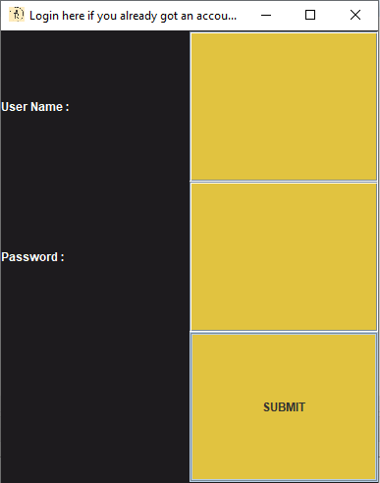Login screen where users can login with their username and password.

Frame 12: Login Screen

/* Login screen for the application

* User can type in their username and password to log into the application

* Access is given only when username and password is correct

* Things involved in independent learning:

* 1. JPasswordField

* password_text = new JPasswordField();

* - to enter password and ensure the password is not visible

* Coded by Ruban

* Aided by Xiwei to fix issues regarding screen visibility

* Aided by Kimberly to set background colors

*/

**import** java.awt.*;

**import** java.awt.event.*;

**import** javax.swing.*;

**public** **class** aa **extends** JFrame **implements** ActionListener {

JPanel panel;

JLabel user_label, password_label, message;

JTextField userName_text;

JPasswordField password_text;

JButton submit, cancel;

ImageIcon logo = **new** ImageIcon("src/applogo.png");

aa() {

Color darkGray = **new** Color (29,27,30);

Color gold = **new** Color (225,195,64);

// Username

user_label = **new** JLabel();

user_label.setText("User Name :");

user_label.setForeground (Color.***WHITE***);

userName_text = **new** JTextField();

userName_text.setBackground(gold);

setBackground(Color.***BLACK***);

setForeground(Color.***BLACK***);

// Password

password_label = **new** JLabel();

password_label.setText("Password :");

password_label.setForeground (Color.***WHITE***);

password_text = **new** JPasswordField();

password_text.setBackground(gold);

// Submit

submit = **new** JButton("SUBMIT");

submit.setBackground(gold);

panel = **new** JPanel(**new** GridLayout(3, 1));

panel.add(user_label);

panel.setBackground (darkGray);

panel.add(userName_text);

panel.add(password_label);

panel.add(password_text);

message = **new** JLabel();

message.setForeground (Color.***WHITE***);

panel.add(message);

panel.add(submit);

setDefaultCloseOperation(JFrame.***EXIT_ON_CLOSE***);

setIconImage (logo.getImage());

submit.addActionListener(**this**);

add(panel, BorderLayout.***CENTER***);

setTitle("Login here if you already got an account !");

setSize(400,500);

setVisible(**true**);

setResizable (**true**);

setLocationRelativeTo (**null**);

}

**public** **static** **void** main(String[] args) {

**new** aa();

}

**public** **void** actionPerformed(ActionEvent ae) {

String userName = userName_text.getText();

@SuppressWarnings("deprecation")

String password = password_text.~~getText~~();

**if** (userName.trim().equals("John Doe") && password.trim().equals("1234")) {

message.setText(" Welcome " + userName + "");

**new** test30();

dispose();

} **else** {

message.setText(" Invalid username or password.. ");

}

}

}

### Frame 13

Language settings so users can change the language the app is in to their preference

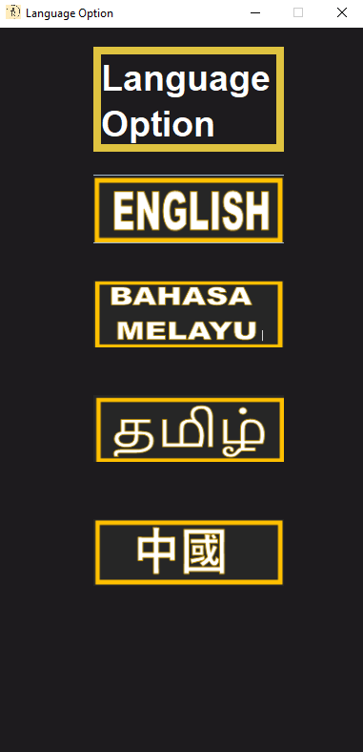

Frame 13: Languages Options

/* Language options where users can pick their desired language for the application

* 4 languages are offered to suit a wider audience

* Things involved in independent learning:

* 1. html tag

* JLabel Title = new JLabel ("<html>Language<br> Option</html>");

* - for text wrapping and formatting

* 2. setOpaque

* a.setOpaque(false)

* - toggle object transparency for designing purposes

* Coded by Ruban

* Aided by Xiwei in checking the written codes

*/

**import** java.awt.Color;

**import** javax.swing.JPanel;

**import** javax.swing.ImageIcon;

**import** javax.swing.JButton;

**import** javax.swing.JFrame;

**import** javax.swing.JLabel;

**import** javax.swing.border.LineBorder;

**import** java.awt.Font;

**import** java.awt.event.ActionEvent;

**import** java.awt.event.ActionListener;

**public** **class** test30 {

JLabel Title = **new** JLabel ("<html>Language<br> Option</html>");

JPanel Panel = **new** JPanel();

JButton a = **new** JButton(**new** ImageIcon("src/01.png"));

JFrame frame = **new** JFrame();

ImageIcon logo = **new** ImageIcon("src/applogo.png");

**public** test30() {

Title.setForeground(**new** Color(255,255,255));

Title.setFont(**new** Font("Helvetica Rounded",Font.***BOLD***,37));

Title.setBounds(100, 20, 200, 110 );

Title.setBorder((**new** LineBorder(**new** Color(223,195,64),8)));

a.setBounds(100,140,200,100);

a.setOpaque(**false**);

a.setContentAreaFilled(**false**);;

a.setBorder(**null**);

JButton b = **new** JButton(**new** ImageIcon("src/02.png"));

b.setBounds(50,200,300,200);

b.setOpaque(**false**);

b.setContentAreaFilled(**false**);;

b.setBorder(**null**);

JButton c = **new** JButton(**new** ImageIcon("src/03.png"));

c.setBounds(50,320,300,200);

c.setOpaque(**false**);

c.setContentAreaFilled(**false**);;

c.setBorder(**null**);

JButton d = **new** JButton(**new** ImageIcon("src/04.png"));

d.setBounds(50,450,300,200);

d.setOpaque(**false**);

d.setContentAreaFilled(**false**);;

d.setBorder(**null**);

Panel.add(Title);

Panel.add(a);

Panel.add(b);

Panel.add(c);

Panel.add(d);

Panel.setLayout (**null**);

Panel.setBackground(**new** Color(29,27,30));

frame.add (Panel);

frame.setTitle("Language Option");

frame.setSize(400, 800);

frame.setResizable(**false**);

frame.setLocationRelativeTo(**null**);

frame.setDefaultCloseOperation(JFrame.***EXIT_ON_CLOSE***);

frame.setVisible(**true**);

frame.setIconImage (logo.getImage());

a.addActionListener (**new** ActionListener() {

**public** **void** actionPerformed (ActionEvent press) {

**new** Home();

frame.dispose();

}

});

}

**public** **static** **void** main(String[] args) {

**new** test30();

}

}

### Frame 14

Screen where users can select the wanted mode of public transport to take.

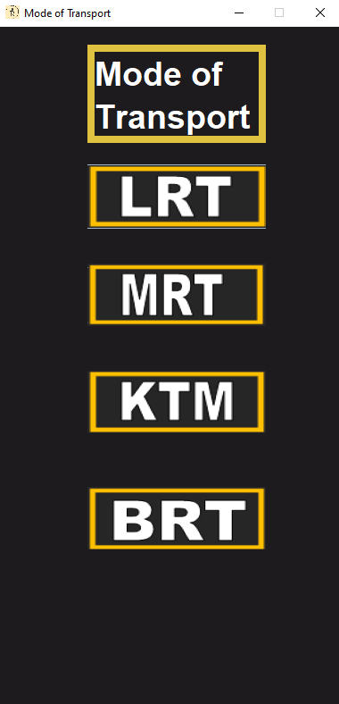

Frame 14: Mode of Transport

/* Pick mode of transport desired

* Users can pick the mode of public transport they want to board

* Things involved in independent learning:

* 1. setOpaque

* a.setOpaque(false);

* - to toggle object transparency

* 2. html tag

* JLabel Title = new JLabel ("<html>Mode of<br> Transport</html>");

* - for text wrapping and formatting

* Coded by Ruban

* Aided by Xiwei in checking the written codes

*/

**import** java.awt.Color;

**import** javax.swing.JPanel;

**import** javax.swing.ImageIcon;

**import** javax.swing.JButton;

**import** javax.swing.JFrame;

**import** javax.swing.JLabel;

**import** javax.swing.border.LineBorder;

**import** java.awt.Font;

**import** java.awt.event.ActionEvent;

**import** java.awt.event.ActionListener;

**public** **class** mode {

JLabel Title = **new** JLabel ("<html>Mode of<br> Transport</html>");

JPanel Panel = **new** JPanel ();

JFrame frame = **new** JFrame ();

JButton a = **new** JButton(**new** ImageIcon("src/05.png"));

ImageIcon logo = **new** ImageIcon("src/applogo.png");

**public** mode() {

Title.setForeground(**new** Color(255,255,255));

Title.setFont(**new** Font("Helvetica Rounded",Font.***BOLD***,37));

Title.setBounds(100, 20, 200, 110 );

Title.setBorder((**new** LineBorder(**new** Color(223,195,64),8)));

a.setBounds(100,140,200,100);

a.setOpaque(**false**);

a.setContentAreaFilled(**false**);;

a.setBorder(**null**);

JButton b = **new** JButton(**new** ImageIcon("src/06.png"));

b.setBounds(50,200,300,200);

b.setOpaque(**false**);

b.setContentAreaFilled(**false**);;

b.setBorder(**null**);

JButton c = **new** JButton(**new** ImageIcon("src/07.png"));

c.setBounds(50,320,300,200);

c.setOpaque(**false**);

c.setContentAreaFilled(**false**);;

c.setBorder(**null**);

JButton d = **new** JButton(**new** ImageIcon("src/08.png"));

d.setBounds(50,450,300,200);

d.setOpaque(**false**);

d.setContentAreaFilled(**false**);;

d.setBorder(**null**);

Panel.add(Title);

Panel.add(a);

Panel.add(b);

Panel.add(c);

Panel.add(d);

Panel.setLayout(**null**);

Panel.setBackground(**new** Color(29,27,30));

frame.add (Panel);

frame.setTitle("Mode of Transport");

frame.setSize(400, 800);

frame.setResizable(**false**);

frame.setLocationRelativeTo(**null**);

frame.setDefaultCloseOperation(JFrame.***EXIT_ON_CLOSE***);

frame.getContentPane().setBackground(**new** Color(29,27,30));

frame.setVisible(**true**);

frame.setIconImage (logo.getImage());

c.addActionListener (**new** ActionListener() {

**public** **void** actionPerformed (ActionEvent press) {

**new** SELECTION();

frame.dispose();

}

});

}

**public** **static** **void** main(String[] args) {

**new** mode();

}

}

## Map

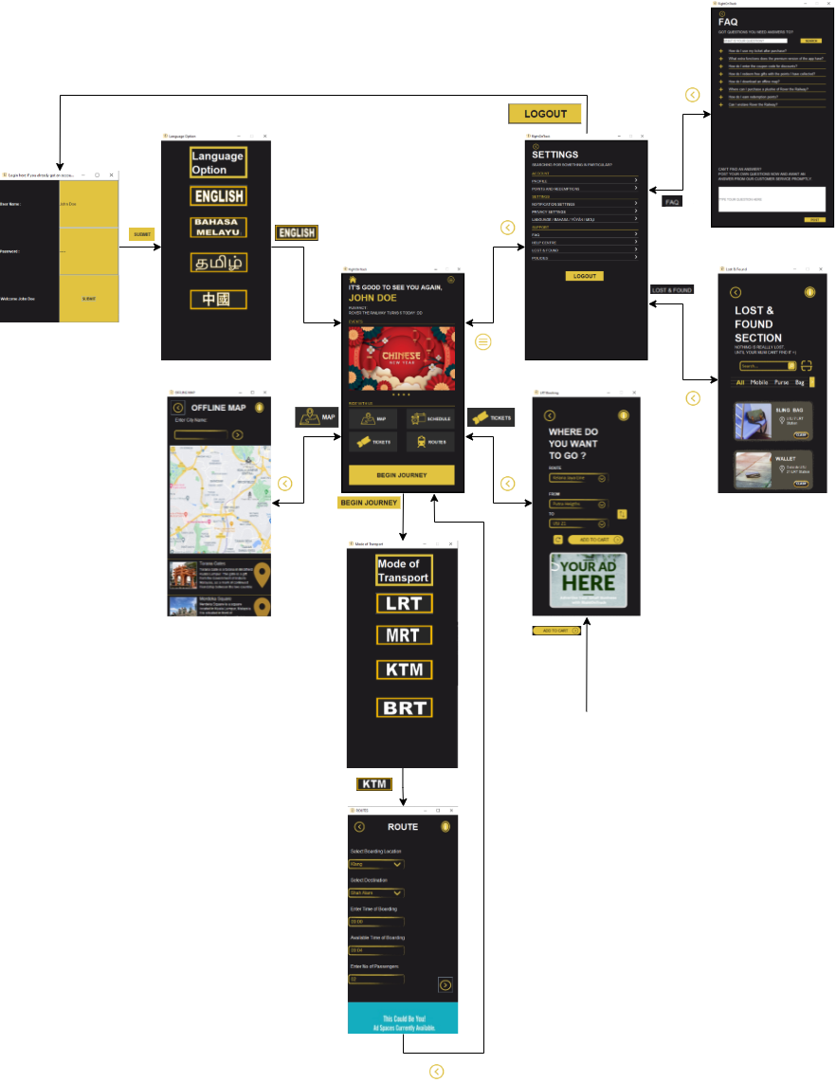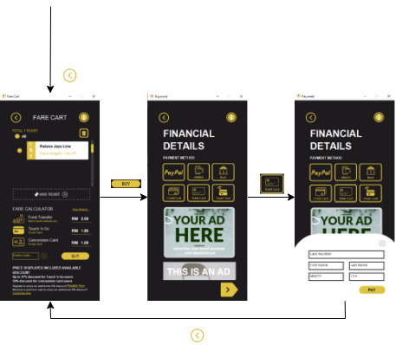

# References

Aziz, A. (18 October, 2019). *Transport policy aims 40% of public transportation usage by 2030*. Retrieved from The Malaysian Reserve: https://themalaysianreserve.com/2019/10/18/transport-policy-aims-40-of-public-transportation-usage-by-2030/

Blythe, P., Rachliff, T., Holland, R., & Mageean, J. (2000). ITS Application in Public Transport: Improving the Service to the Transport System. *Journal of Advanced Transportation*, 325-345.

Brohi, S. N., Pillai, T. R., Asirvatham, D., Ludlow, D., & Bushell, J. (2018). Towards Smart Cities Development: A Study of Public Transport System and Traffic-related Air Pollutants in Malaysia. *IOP Conference Series: Earth and Environmental Science.* IOP Publishing Ltd.

Chokkattu, J. (8 August, 2019). *How to navigate with the AR mode in Google Maps to find your way*. Retrieved from digitaltrends: https://www.digitaltrends.com/mobile/how-to-use-ar-mode-google-maps/

Google. (n.d.). *5 Monetization Strategies for your App*. Retrieved from Google AdMob: https://admob.google.com/home/resources/5-app-monetization-strategies-to-grow-and-monetize-your-app/

Haselton, T. (30 March, 2021). *Google Maps has a wild new feature that will guide you through indoor spaces like airports*. Retrieved from CNBC: https://www.cnbc.com/2021/03/30/google-maps-launches-augmented-reality-directions-for-indoor-spaces.html

Ireland, K. (n.d.). *How Does Google Maps Calculate Travel Time?* Retrieved from Techwalla: https://www.techwalla.com/articles/how-does-google-maps-calculate-travel-time

Ismail, A. (29 12, 2021). *Google Maps Directed Drivers Down Dangerous Roads During Record Lake Tahoe Snowfall*. Retrieved from Jalopnik: https://jalopnik.com/epic-lake-tahoe-snowfall-shows-why-google-maps-must-do-1848281697

Keretapi Tanah Melayu Berhad. (6 October, 2021). *KTMB Mobile*. Retrieved from Google Play: https://play.google.com/store/apps/details?id=com.ktmb.user.mobile&hl=en&gl=US

Kimp. (28 September, 2020). *Why You Should Create A Brand Mascot For Your Business*. Retrieved from Kimp.io: https://www.kimp.io/brand-mascot/#:~:text=According%20to%20Adweek%2C%20brand%20mascots,And%20increase%20brand%20recognition

KTM Berhad. (n.d.). *Introduction to KTM Berhad*. Retrieved from railtravelstation: https://railtravelstation.com/ktm-berhad/

Lee, P. (3 November, 2015). *RapidKL Train Card Users to Pay Less*. Retrieved from The Star: https://www.thestar.com.my/News/Nation/2015/11/03/RapidKL-train-card-users-to-pay-less/

Levinson, D. (12 April, 2011). *How Smartphones Can Improve Public Transit*. Retrieved from Transportist by David Levinson: https://transportist.org/2011/04/12/how_smartphones_can_improve_pu/

news.com.au. (24 March, 2017). *Relying on Google Maps got this woman stranded in the Grand Canyon for five days*. Retrieved from news.com.au: https://www.news.com.au/technology/online/relying-on-google-maps-got-this-woman-stranded-in-the-grand-canyon-for-five-days/news-story/5c0e6b404f6d24ecab7bd857ca12c722

Ngah, R., Abdullah, J., Khalique, M., & Bakhodirovich, G. S. (2020). The Influence of Socio-Economics on Travel Behavior of Public Transportation in Malaysia. *Environment-Behaviour Proceedings Journal*, 269-275.

Shpillak, A. (20 February, 2018). *7 Ways to Attract App Users*. Retrieved from Clutch: https://clutch.co/app-developers/resources/7-ways-to-attract-app-users